TEXT

PROSTHESIS

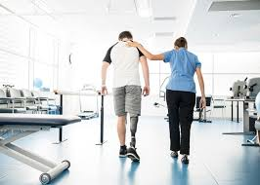
Prosthesis is artificial substitute for a missing part of the body. The artificial parts that are most commonly thought of as prostheses are those that replace lost arms and legs, but bone, artery, and heart valve replacements are common (see artificial organ), and artificial eyes and teeth are also correctly termed prostheses. The term is sometimes extended to cover such things as eyeglasses and hearing aids, which improve the functioning of a part. The medical specialty that deals with prostheses is called prosthetics. The origin of prosthetics as a science is attributed to the 16th-century French surgeon Ambroise Paré. Later workers developed upper-extremity replacements, including metal hands made either in one piece or with movable parts. The solid metal hand of the 16th and 17th centuries later gave way in great measure to a single hook or a leather-covered, nonfunctioning hand attached to the forearm by a leather or wooden shell. Improvement in the design of prostheses and increased acceptance of their use have accompanied major wars. New lightweight materials and better mechanical joints were introduced after World Wars I and II.

Types of prosthesis

Limb prostheses include:
- arm prostheses fitted at, above or below the elbow
- leg prostheses fitted at, above or below the knee
Other types of prosthesis include:
- hand, foot, finger and toe prostheses
- an artificial breast worn in the bra to replace a breast removed due to cancer
- hearing aids
- artificial eyeballs
- ear, nose or eye socket replacements
- an artificial soft or hard palate (worn like a dental plate)
One type of below-knee prosthesis is made from plastic and fits the below-knee stump with total contact. It is held on either by means of a strap that passes above the kneecap or by means of rigid metal knee hinges attached to a leather thigh corset. Weight bearing is accomplished by pressure of the prosthesis against the tendon that extends from the kneecap to the lower legbone. In addition, a foot piece is commonly used that consists of a solid foot and ankle with layers of rubber in the heel to give a cushioning effect.
There are two main types of above-knee prostheses: (1) the prosthesis held on by means of a belt around the pelvis or suspended from the shoulder by straps and (2) the prosthesis kept in contact with the leg stump by suction, the belt and shoulder straps being eliminated.
The more complicated prosthesis used in cases of amputation through the hip joint or half of the pelvis usually consists of a plastic socket, in which the person virtually sits; a mechanical hip joint of metal; and a leather, plastic, or wooden thigh piece with the mechanical knee, shin portion, and foot as described above.

A great advance in fabrication of functional upper-extremity prostheses followed World War II. Arm prostheses came to be made of plastic, frequently reinforced with glass fibres.

A great advance in fabrication of functional upper-extremity prostheses followed World War II. Arm prostheses came to be made of plastic, frequently reinforced with glass fibres.

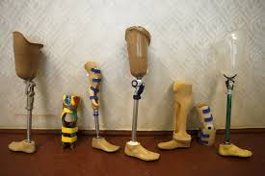

The below-elbow prosthesis consists of a single plastic shell and a metal wrist joint to which is attached a terminal device, either a hook or a hand. The person wears a shoulder harness made of webbing, from which a steel cable extends to the terminal device. When the person shrugs the shoulder, thus tightening the cable, the terminal device opens and closes. In certain cases the biceps muscle may be attached to the prosthesis by a surgical operation known as cineplasty. This procedure makes it possible to dispense with the shoulder harness and allows finer control of the terminal device. The above-elbow prosthesis has, in addition to the forearm shell, an upper-arm plastic shell and a mechanical, locking elbow joint. This complicates its use, inasmuch as there must be one cable control for the terminal device and another control to lock and unlock the elbow. The most complicated upper-extremity prosthesis, that used in cases of amputation through the shoulder, includes a plastic shoulder cap extending over the chest and back. Usually no shoulder rotation is possible, but the mechanical elbow and terminal device function as in other arm prostheses.
A metal hook that opens and closes as two fingers is the most commonly used terminal device and the most efficient. After World War II the APRL hand (from U.S. Army Prosthetic Research Laboratory) was developed. This is a metal mechanical hand covered by a rubber glove of a colour similar to that of the patient’s remaining hand. Many attempts have been made to use electrical energy as the source of hook or hand control. This is done primarily by building into the arm prosthesis electrodes that are activated by the patient’s own muscle contractions. The electric current generated by these muscle contractions is then amplified by means of electrical components and batteries to control the terminal device. Such an arrangement is referred to as a myoelectrical control system.
Breast prostheses are used after mastectomy. External prostheses may be worn, but surgical reconstruction of the breast, involving implantation of a prosthesis, became increasingly common from the 1970s.

Who can help with prostheses?

Prosthetists are health professionals who specialise in prostheses. If you need one, they will work with your medical team to design and fit your prosthesis and help you use and care for it.

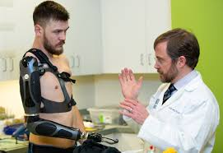

If you need an orthotic device to correct problems with posture and walking, you might also be assisted by an orthotist.

