TEXT

5 POPULAR WAYS TO TRAVEL

Traveling is an activity that many people enjoy doing. However, not all of us do it the same way. Some people travel by plane, while others prefer to take a ride in a car. Sometimes, we enjoy hitchhiking and meeting new people, only to seek comfort in loneliness the other time around. Whichever of the presented options you prefer, only a few traveling methods have a broad appeal.
Today, we take a closer look at the most popular ways to travel. If you want to learn what means of transportation people deem the most convenient and choose to get to their destinations most often, read on:

Car

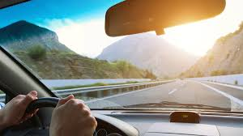

Many people choose to travel by car, mainly because it is the most convenient way of transportation, especially if you’re a fan of road trips. If you have your own vehicle, you don’t need to spend extra money on public transport or taxis in new locations and drive wherever you want at your own convenience. If you are a frequent traveler, a vehicle can also be an excellent investment, as it will save you money on tickets in the long run.
However, driving a car by yourself isn’t always a good idea. It may take longer than expected for you to arrive at your destination. Also, if you plan to visit other countries, a car might not be the best option as it will hardly take you overseas. Although you can still get to many places by car, it is much cheaper and faster than taking a plane or a train, making it one of the most popular and beneficial ways to travel.
A rental car is often helpful when you travel to your destination by other means and want flexibility once you get there, whether it be a day trip from Naples to Pompeii or exploring things to do in Christchurch.

Plane

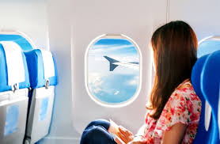

Planes are extremely popular among travelers. If you are planning to travel long distances and don’t want to spend a lot of money on train or bus tickets and tire yourself with numerous stops and transfers on the way, then taking a plane is the best option. If you take into account the short duration of the flights and their affordability, it is easy to understand why so many people choose this method of transportation.
However, some people may experience stress during flights and seek other alternatives. One of the most helpful tips that can help you deal with it is getting enough rest before the flight and staying awake until the time of the boarding – this will allow you to sleep during the flight, making it less stressful.

Train

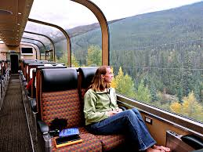

Taking a train is another popular way of traveling. Many people prefer trains over flights since they get an opportunity to enjoy the surrounding landscape without feeling like they are confined inside a limited space. Moreover, people who usually travel by train see many beautiful locations and meet interesting people along the way.
Although trains are usually slower than planes and cars, they are still a good means of transportation and, in addition, are the most environmentally-friendly option of them all. They are typically more affordable than air travel, but they can also be more comfortable. Despite being slower, trains connect many cities worldwide and don’t require many preparations before departure.

Hitchhiking

Hitchhiking is one of those rare ways of traveling that evoke positive feelings in people. Although hitchhiking has become less popular than in the past, some people still enjoy this option. The main reason for this is that hitchhiking doesn’t cost a fortune and gives you the freedom to stop wherever you want. What is more, you can meet new people and spend time with them while traveling from one destination to another.
The only negative side of hitchhiking is that it implies some risk. Although the chances of something bad happening to you are slim, you still need to take some precautions if you decide to hitchhike. First of all, it is best to travel in pairs. This way, both of you will feel safer. Secondly, trust your instincts! Don’t get in the car of strangers that do not seem credible. However, even if you exercise caution, the first impressions might be misleading, which makes it a bit of a risky method. Still, having to rely on your luck makes it also one of the most interesting ways to travel around the world.

Carpooling

Carpooling is an even more exclusive way of traveling than hitchhiking. It is an excellent way of saving money and time, and if you plan your route well, you can easily reach your destination faster than by other means of transportation. Also, carpooling allows you to meet new people and make friends along the way. You might encounter individuals with similar interests, or quite the opposite, and both of those eventualities can make your journey much more enjoyable.
If you choose to carpool, try to be as organized as possible. First of all, make sure that the person who will drive with you knows where they are going and is familiar with the route. Besides, if you are planning to share expenses, agree on everything beforehand. This will prevent future arguments and misunderstandings.

Conclusion

Traveling can be one of the most fun activities, and with thoughtful planning, it doesn’t require a lot of money. For that reason, make sure to choose the most beneficial means of transportation, considering your needs during each new trip and its purposes.
What is more, traveling is an excellent way for getting to know different people and cultures. Even if your primary goal is to see cultural heritage sites in the region, your experience is going to be much richer if you listen to the stories of locals. There’s a reason why it is said that traveling broadens your mind. Whether you prefer to travel by car, train or plane, there is no right and wrong choice. In the end, it all depends on your personal preferences and budget, which is why the best choice will vary from person to person.

