OLYMPIC SYMBOLS

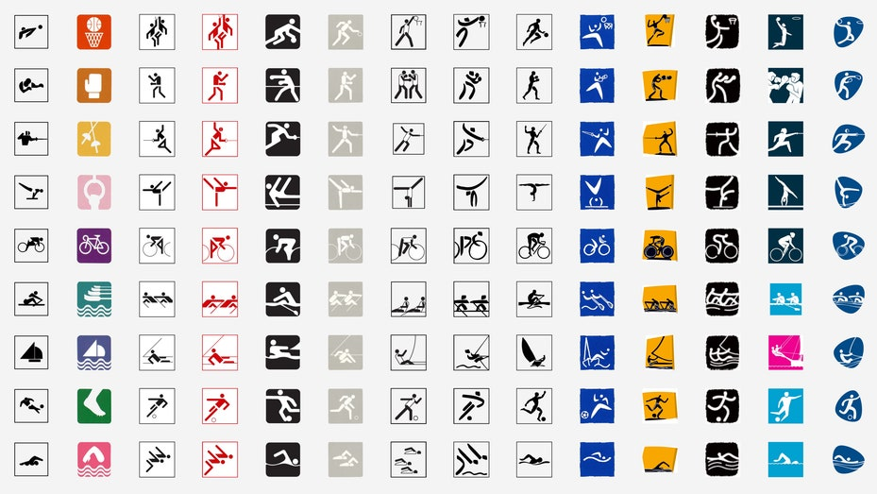

The flag

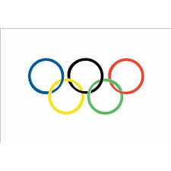

In the stadium and its immediate surroundings, the Olympic flag is flown freely together with the flags of the participating countries. The Olympic flag presented by Coubertin in 1914 is the prototype: it has a white background, and in the centre there are five interlaced rings—blue, yellow, black, green, and red. The blue ring is farthest left, nearest the pole. These rings represent the “five parts of the world” joined together in the Olympic movement.

The motto

In the 19th century, sporting organizations regularly chose a distinctive motto. As the official motto of the Olympic Games, Coubertin adopted “Citius, altius, fortius,” Latin for “Faster, higher, stronger,” a phrase apparently coined by his friend Henri Didon, a friar, teacher, and athletics enthusiast. Some people are now wary of this motto, fearing that it may be misinterpreted as a validation of performance-enhancing drugs. Equally well known is the saying known as the “credo”: “The most important thing in the Olympic Games is not to win but to participate.” Coubertin made that statement on a day when the British and Americans were bitterly disputing who had won the 400-metre race at the 1908 London Games. Although Coubertin attributed the words to Ethelbert Talbot, an American bishop, recent research suggests that the words are Coubertin’s own, that he tactfully cited Talbot so as not to appear to admonish personally his English-speaking friends.

The flame and torch relay

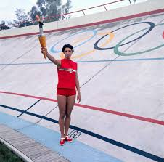

Contrary to popular belief, the torch relay from the temple of Hera in Olympia to the host city has no predecessor or parallel in antiquity. No relay was needed to run the torch from Olympia to Olympia. A perpetual fire was indeed maintained in Hera’s temple, but it had no role in the ancient Games. The Olympic flame first appeared at the 1928 Olympics in Amsterdam. The torch relay was the idea of Carl Diem, organizer of the 1936 Berlin Games, where the relay made its debut. Subsequent editions have grown larger and larger, with more runners, more spectators, and greater distances. The 2004 relay reached all seven continents on its way from Olympia to Athens. The relay is now one of the most splendid and cherished of all Olympic rituals; it emphasizes not only the ancient source of the Olympics but also the internationalism of the modern Games. The flame is now recognized everywhere as an emotionally charged symbol of peace.

Mascots

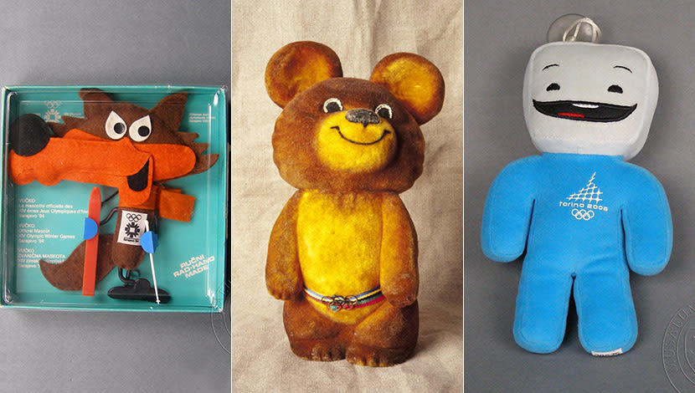

The organizers of the 1968 Winter Olympics in Grenoble, France, devised as an emblem of their Games a cartoonlike figure of a skiing man and called him Schuss. The 1972 Games in Munich, West Germany, adopted the idea and produced the first “official mascot,” a dachshund named Waldi who appeared on related publications and memorabilia. Since then each edition of the Olympic Games has had its own distinctive mascot, sometimes more than one. Typically the mascot is derived from characters or animals especially associated with the host country. Thus, Moscow chose a bear, Norway two figures from Norwegian mythology, and Sydney three animals native to Australia. The strangest mascot was Whatizit, or Izzy, of the 1996 Games in Atlanta, Georgia, a rather amorphous “abstract fantasy figure.” His name comes from people asking “What is it?” He gained more features as the months went by, but his uncertain character and origins contrast strongly with the Athena and Phoebus (Apollo) of the Athens Games of 2004, based on figurines of those gods that were more than 2,500 years old.

