TEXT

COVID VACCINES

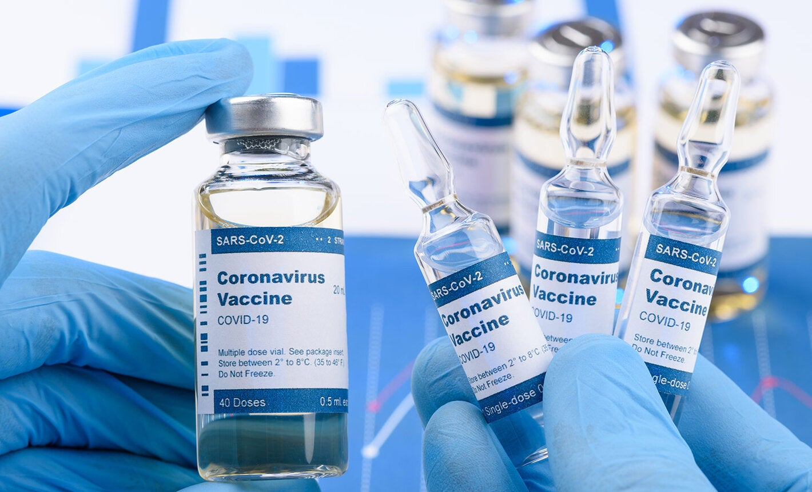

Vaccines are a way to prevent certain serious or deadly infections. When a person gets a vaccine, this is called "vaccination" or "immunization."
To understand how vaccines work, it helps to understand what happens when you get an infection. Infections are caused by germs, such as bacteria or viruses. When a germ gets into your body, it multiplies (makes copies of itself) and attacks, which can make you sick. Your "immune system," or infection-fighting system, recognizes that the germ should not be there. In response, it starts to make proteins called "antibodies" to fight the germ.
There are different types of vaccines. They all work by causing your body to make antibodies, like it would if you had an infection. This prepares your immune system to fight off germs if you come into contact with them in the future. Most vaccines are given as shots, although some come in other forms. Some require more than 1 dose in order to fully protect you from infection.
Thanks to vaccines, the number of people who die from infections has gone way down. Experts believe that vaccines are the best way to control the COVID-19 pandemic.
Multiple COVID-19 vaccines have been developed. They work in slightly different ways.
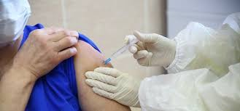

There are a few COVID-19 vaccines available. All of these have been found to work very well in preventing serious illness and death from COVID-19. They include:
●mRNA vaccines – There are 2 available "mRNA vaccines." mRNA refers to genetic material from the virus that causes COVID-19. This genetic material is used in the vaccine. It gives the body instructions to make a specific piece of protein that is normally found on the virus. In response, the immune system then makes antibodies that can recognize and attack the virus in the future.
The mRNA vaccines for COVID-19 are made by the Pfizer and Moderna companies. For most people, these require 2 doses. Depending on which vaccine you get, the doses are given either 3 or 4 weeks apart. It's important to get both doses for the vaccine to be most effective.
For people with a weak immune system who get an mRNA vaccine, experts recommend getting a third dose, too. That's because for these people, 2 doses might not give enough protection. The third dose is given at least 4 weeks after the second one. If you have a health condition or take certain medicines that might weaken your immune system, your doctor or nurse can tell if you if you should get a third dose. This is not the same as a "booster" dose. Boosters are discussed more below.
●Vector vaccine – The "vector vaccine" for COVID-19 contains a weakened version of a different virus, called an adenovirus. This virus does not make you sick, but it acts as a "vector," or a way to deliver instructions to all the cells in your body. These instructions tell your body to make the protein normally found on the virus that causes COVID-19. Then, your immune system makes antibodies that can recognize and attack the virus in the future.
The vector vaccine for COVID-19 is made by the Johnson and Johnson company. It only requires 1 dose.
It's important to know that these COVID-19 vaccines do not contain infectious SARS-CoV-2 virus. So they cannot give you COVID-19. They also do not affect your DNA.
Different COVID-19 vaccines are available in other countries.
Equitable access to safe and effective vaccines is critical to ending the COVID-19 pandemic, so it is hugely encouraging to see so many vaccines proving and going into development. WHO is working tirelessly with partners to develop, manufacture and deploy safe and effective vaccines.

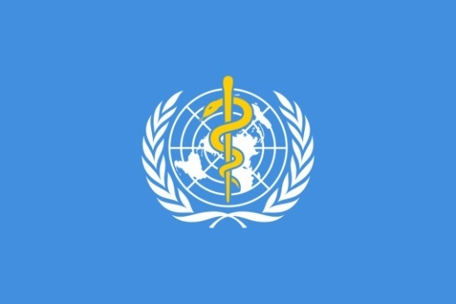

Safe and effective vaccines are a game-changing tool: but for the foreseeable future we must continue wearing masks, cleaning our hands, ensuring good ventilation indoors, physically distancing and avoiding crowds.
Being vaccinated does not mean that we can throw caution to the wind and put ourselves and others at risk, particularly because research is still ongoing into how much vaccines protect not only against disease but also against infection and transmission.
See WHO’s landscape of COVID-19 vaccine candidates for the latest information on vaccines in clinical and pre-clinical development, generally updated twice a week. WHO’s COVID-19 dashboard, updated daily, also features the number of vaccine doses administered globally, with more detail provided on the dedicated COVID-19 vaccination dashboard.

