TEXT

YOUTH SUBCULTURES

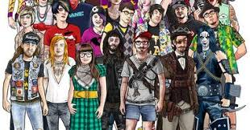

Youth subcultures encapsulate the kaleidoscope of identities and expressions that emerge within younger demographics, often challenging societal norms and providing platforms for self-discovery and communal belonging. From the vibrant streets of urban centers to the digital realms of cyberspace, these subcultures manifest through various forms of fashion, music, ideologies, and lifestyles, reflecting the ever-evolving landscape of youth culture.
The roots of youth subcultures trace back to the post-war era, where rebellious movements such as the Beat Generation in the 1950s and the hippie counterculture of the 1960s emerged as responses to the prevailing social and political norms. These movements laid the groundwork for subsequent subcultures, setting a precedent for youth to challenge authority and explore alternative ways of living and expressing themselves.

Punk Rebellion:

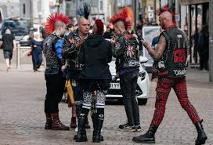

One of the most iconic youth subcultures, punk, exploded onto the scene in the mid-1970s, characterized by its anti-establishment ethos, DIY aesthetic, and raw, energetic music. Born out of the socio-economic disenchantment of working-class youth, punk rejected mainstream consumer culture and embraced individuality through distinctive fashion, often featuring leather jackets, torn clothing, and bold hairstyles. Bands like the Sex Pistols and The Clash became rallying points for disaffected youth, sparking a global movement that continues to influence music, fashion, and activism today.

Gothic Subculture:
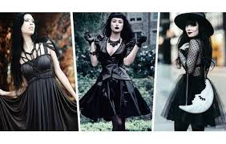
In contrast to the brashness of punk, the gothic subculture emerged in the late 1970s and early 1980s, drawing inspiration from themes of darkness, morbidity, and romanticism. With its roots in literature, art, and music, goth culture embraces a melancholic aesthetic characterized by black clothing, elaborate makeup, and an affinity for the macabre. Bands like Bauhaus and Siouxsie and the Banshees provided the sonic backdrop for goth communities to explore themes of existentialism, spirituality, and alternative beauty standards.
Rave Culture:

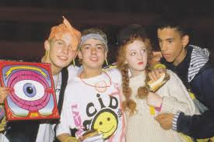

The late 1980s and early 1990s saw the rise of rave culture, a euphoric movement centered around electronic dance music, all-night parties, and communal experiences. Emerging from the underground club scenes of cities like Detroit, Chicago, and London, rave culture embodied notions of unity, peace, and transcendence through music and dance. Participants adorned themselves in colorful, often eccentric attire, embracing a philosophy of PLUR (peace, love, unity, respect) that sought to foster inclusivity and acceptance within the subculture.

Hip-Hop Evolution:

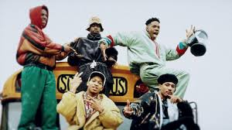

Hip-hop emerged in the Bronx during the 1970s as a cultural movement encompassing rap music, graffiti art, breakdancing, and DJing. Rooted in the experiences of African American and Latino youth, hip-hop provided a platform for marginalized communities to voice their struggles, aspirations, and resilience. From its humble beginnings in block parties to its global influence on fashion, language, and activism, hip-hop remains a dynamic force that continues to shape youth culture worldwide.
Emo Sensibility:

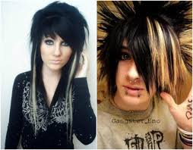

In the early 2000s, the emo subculture gained prominence, characterized by its introspective lyrics, emotional intensity, and distinctive fashion. Emo music, often associated with bands like My Chemical Romance and Dashboard Confessional, explored themes of heartache, alienation, and self-expression, resonating with a generation grappling with the complexities of adolescence and identity. Emo fashion typically featured skinny jeans, band t-shirts, and expressive hairstyles, serving as outward expressions of inner turmoil and vulnerability.

Digital Subcultures:

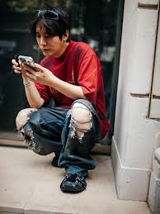

With the advent of the internet and social media, youth subcultures have transcended physical boundaries, giving rise to digital communities centered around shared interests, identities, and ideologies. Platforms like Tumblr, Reddit, and TikTok have become virtual hubs for subcultural expression, enabling young people to connect, create, and collaborate in ways previously unimaginable. From niche fandoms to meme cultures, digital subcultures continue to shape the cultural landscape, blurring the lines between online and offline identities.

Conclusion:
Youth subcultures represent the ever-changing tapestry of identities and expressions that define younger generations, offering spaces for creativity, solidarity, and resistance in the face of societal norms. From the rebellious spirit of punk to the introspective musings of emo, these subcultures serve as catalysts for cultural innovation and personal growth, reflecting the diverse experiences and aspirations of youth around the world. As society evolves, so too will the myriad manifestations of youth culture, reminding us of the enduring power of youth to challenge, inspire, and transform the world around them.

