TEXT

HUMAN BEHAVIOR

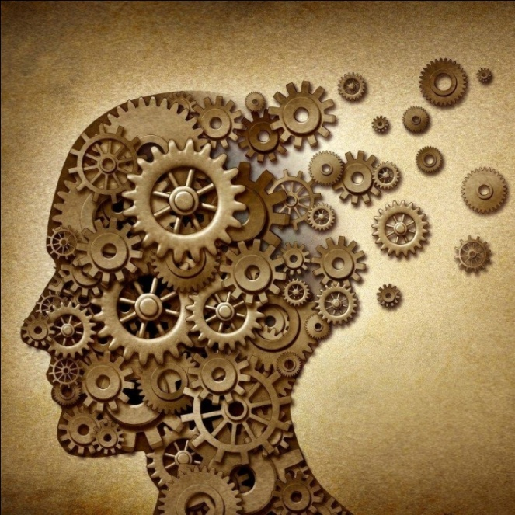

Human behavior is the potential and expressed capacity (mentally, physically, and socially) of human individuals or groups to respond to internal and external stimuli throughout their life. While specific traits of one's personality, temperament, and genetics may be more consistent, other behaviors change as one moves between life stages—i.e., from birth through adolescence, adulthood, and, for example, parenthood and retirement.
Behavior is also driven, in part, by thoughts and feelings, which provide insight into individual psyche, revealing such things as attitudes and values. Human behavior is shaped by psychological traits, as personality types vary from person to person, producing different actions and behavior. Extraverted people, for instance, are more likely than introverted people to participate in social activities like parties.
Human behavior is studied by the social sciences, which include psychology, sociology, economics, and anthropology. In sociology, behavior may broadly refer to all basic human actions, including those that possess no meaning—actions directed at no person. Behavior in this general sense should not be mistaken with social behavior. Social behavior, a subset of human behavior that accounts for actions directed at others, is concerned with the considerable influence of social interaction and culture, as well as ethics, social environment, authority, persuasion, and coercion.

