TEXT

INCLUSION IN EDUCATION

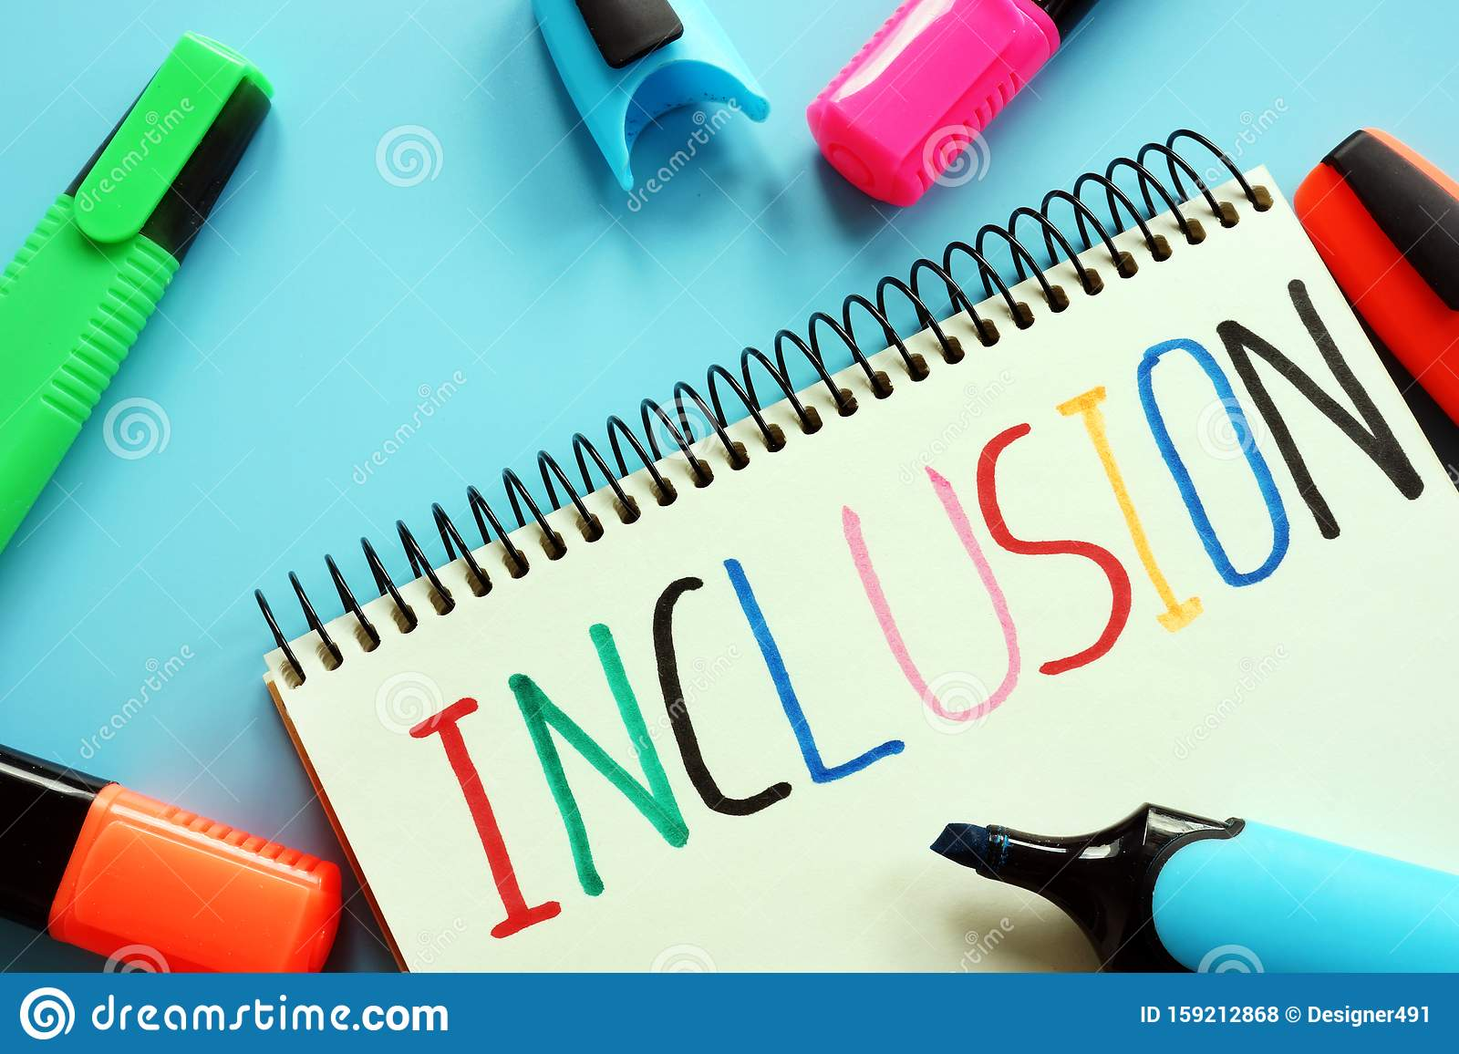

Inclusion is a broad subject and is a term that trips off the tongue of many. However, people have different understandings of what the word means.
Simply put, inclusion is about ensuring that everyone feels valued and respected as an individual.
Many people use the words inclusion, diversity, equality and even equity interchangeably.
Equality is about the fair treatment of everyone.
Equity is about creating equal possible outcomes for everyone because, despite effort and merit, people can experience substantial barriers.
Diversity is the mix of people.
Inclusion is the culture in which people can feel comfortable and confident to be themselves.
Inclusion is seen as a universal human right. The aim of inclusion is to embrace all people irrespective of race, gender, disability, medical or other need. It is about giving equal access and opportunities and getting rid of discrimination and intolerance (removal of barriers). It affects all aspects of public life.
There are an estimated 240 million children with disabilities worldwide. Like all children, children with disabilities have ambitions and dreams for their futures. Like all children, they need quality education to develop their skills and realize their full potential.
According to statistics, from 2.5 million students having home education at the institutions of I-IV levels of accreditation, 80000 are people with special needs (disabilities). At older times, the Soviet system operated on the one principle: if you are healthy, then study and work, if you’re sick – don’t bother others. Nowadays, Ukraine has done notable changes: the rights of the disabled on the development, education and rehabilitation are enshrined in many legal acts.
According to the 2017 Law on Education, persons with special education needs are those in need of additional permanent or temporary support in order to fulfil their right to education (Art. 1.20).

Education is available to all

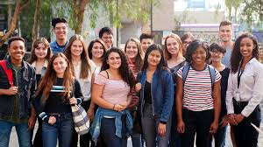

Support for teaching students with disabilities in institutions of higher education is available in all developed countries. It creates so-called barrier-free university campuses with appropriate buildings, dormitories and other facilities where these students receive technical training, help of psychologists, doctors and social workers. Thus, in Netherlands, students are, above all, equipped with all the necessary technical means which the state pays for. Germany is creating social support funds. In the UK, a special support for students with disabilities is made with the help of state grants.

Individual support

Of course, every student with disabilities have certain features and limitations that impede learning. To work with such people, specific methods, educational technology and adaptive hardware should be applied to the educational process. Typically, these students are very curious and diligent, but they have some problems like gaps in knowledge, increased fatigue, isolation, low self-esteem vulnerability. However, the pace of learning or the number of lessons can’t be reduced for them because it reduces the quality of training. Thus, the system of support is implemented to their training, comprehensive care and support.

