TEXT

THE ROLE OF YOUTH IN SOCIETY

A youth is any person between the age of 15 years and 30 years regardless of the gender. Unfortunately, the youth are the backbone of a society and hence they determine the future of any given society. This is because all other age groups, the kids, teenagers, middle aged and the senior citizens rely on the youth and expect a lot from them. This makes the youth to be an important age group in both today’s society and the future society than other age groups. Therefore, due to the high dependence on youth in the society, the youth has a role to play because the future of its families, communities and the country lies in its hands.
The role of the youth is simply to renew, refresh and maintain. Youth have a role to renew and refresh the current status of our society including leadership, innovations, skills etc. Youth are expected to advance the current technology, education, politics, peace of the country. On the other hand, youths have also to maintain the culture, all good values in the societies, development projects, etc.

Nowadays "the youth of Ukraine is experiencing all the catastrophic consequences of the war started by Russia against our country," - Deputy Chairman of the Committee on Youth and Sports Vasyl Mokan
"We are talking about the demographic situation, migration abroad, lack of work. 53% of Ukrainians are unemployed today, 60% of them are young people under 35.
According to approximate estimates provided by the relevant Ministry of Youth and Sports, 40% of youth in Ukraine were directly affected by the military aggression of the Russian Federation: more than 2 million young people have become internally displaced persons; another 2 million left the country.

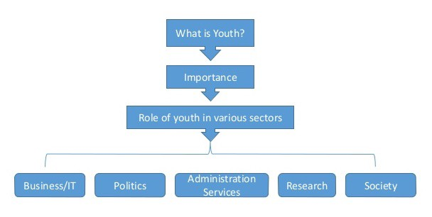

Importance of youth

Youth is the backbone of any nation. Youth can play an important role in the development of the society. This is the important segment of the society and youth can play a vital role in the development of the country. But this young and able workforce is not being given their chance to shine.
Unfortunately there is lack of opportunities, professional training institutes, awareness for youth in the country. Educated youth is unemployed, they are unable to participate in the country’s development because there is no quality education, and textbooks, policies, and curriculum differ across the country.
Youth is now becoming a depressed segment of society, there are degrees but no jobs, there are universities but no professional education, there are schools but different education systems between elite and poor, there is a government but not a proper policy as to how they can solve these issues. Government should realize the situation and take quick measures to save the future of the nation. Otherwise situation may make the youth choose more destructive paths that will be detrimental to our society.

What are the responsibilities of youth?

Youth has a very important role to play for society. For that we need to know why youth are so special. It is so because they are young, full of energy and educated with rationality as their ultimate belief. Now their role in society.
- Reproduce: reproduction here does not mean increasing the population but it means that they full fill the position left by the elder. Like son takes up the position of father in a company.
- Protection: Youth are expected to protect their culture and tradition while at the same time makes it better and embrace changes in the society. For instance it is youth only who becomes a part of political movement for a major change in a country. They becomes a part of armed forces too, to safeguard the freedom of people and so on
- Growth: The growth of a country in all the spheres like Social, political and economic spheres mostly depends on youth only. They with a fresh energy can perform better and ensure the growth of society.
There are many other roles of youth in the society. They are like the leading character of a movie. Youth also need to take care of old ones who are now going to be dependent.

