ME AND MY FAMILY
WORD LIST
- To introduce oneself – знайомити з кимось
- To leave school – закінчувати школу
- Surgeon – хірург
- Handsome – вродливий (про чоловіка)
- Sociable – комунікабельний
- To work overtime – працювати понаднормово
- Breadwinner – годувальник
- To be fond of – вподобати
- Slim – стрункий\ка
- Pretty – симпатична, вродлива (про жінку)
- Elegant – елегантний
- Smart – розумний, вишуканий
- To be in\have habit of doing smth. – мати звичку щось робити
- Senior – старший
- Junior – молодший
- To graduate from university –закінчувати університет
- To be married – бути одруженим
- Nephew –племінник
- Gaiety –веселість
- Endless –безкінечний
- To be on a pension – бути на пенсії
2. Read and translate the text.
My family
Before I start talking about my family let me introduce myself. I am Svitlana Petrenko. I am 17. I left school in June. I was born in Kyiv since my childhood.
And now I am going to tell you about my family. We are a family of five. We think we are a large and friendly family. So we are happy to be living together and are getting all right.
To begin with I am going to talk about my father. His name is Sergiy Petrovych, he is 45. He works as a surgeon at a hospital. He is neither old, nor young. He is a good - looking man, handsome, rather thin with dark brown hair just beginning to go grey. He is a very sociable person. What I don’t like about my dad is that he is always busy. Very often he works overtime. He is a breadwinner in our family. He is fond of going to the country at weekends, because he enjoys working in the garden.
My mother’s name is Halyna Mykholayivna. She is three years younger than my father. She works as a teacher at a nursery school. My mother is rather slim and pretty woman. She is always elegant and smart. In short, she is a pleasant-looking woman of about 40. She always has a lot of work to do both at school and about the house. She is fond of her work and spends a lot of time there. But she has to cook food for the whole family at home. Shopping and cooking is nearly half of a day’s work for her. But my granny and I are in the habit of helping her about the house.
Boris is my elder brother. He is six years senior to me. So he is 23 already. He has graduated from University and he is an economist by profession now. Boris is married. His wife is a journalist. They have got a child, my nephew. He is a lovely little boy of two with golden hair and dark brown eyes and a spirit that is always bright and happy, full of joy and gaiety.
And finally a few words about my granny. To tell you the truth, she is my best friend. She always listens to my endless stories about my friends and my school life. She is on a pension now but in her youth and her older age she worked as a teacher in school. I must admit, she is a very understanding person.
To put it into a few words, we are a united and friendly family.
Relatives by marriage
- Husband – чоловік
- Wife – дружина
- Father-in – law – тесть, свекор
- Mother -in-law – теща, свекруха
- Son-in-law – зять (чоловік дочки)
- Daughter-in-law – невістка (дружина сина)
- Brother-in-law – дівер (чоловік сестри)
- Sister-in-law – зовиця (дружина брата)
- Stepfather – вітчим
- Stepmother – мачуха
- Adopted child – прийомне дитя
- Orphan – сирота
- Widower – вдівець
- Widow – вдова
- Twins – близнята
- To be married – бути одруженим
- To get married – одружитися
- Divorce – розлучення
- Divorcee – розлучення
- Single – неодружений
- Descendant – нащадок
- Direct descendent – прямий нащадок
- Hereditary – родовий, спадковий
- Heir – спадкоємець
- Progeny – генерація, потомство
- Relatives – родичі
- Flesh and blood - родич

ADDITIONAL WORDS AND EXPRESSIONS
HE \SHE
- Energetic – енергійний
- Sharp-minded – тямущий
- Absent –minded – неуважний
- Aggressive – агресивний
- Talented – талановитий
- Sensitive – чутливий
- Generous – щедрий
- Good-hearted – добросердечний
- Simple-hearted – простодушний
- Empty-headed – пустоголовий
- Cheerful – веселий
- Intelligent – розумний
- Educated – освічений
- Awkward – незграбний
- Shy – сором’язливий
- Easy-going – лагідний
- Brave – хоробрий
- Stubborn – впертий
- Envious – заздрісний
- Sophisticated – з витонченим смаком

The Royal Family

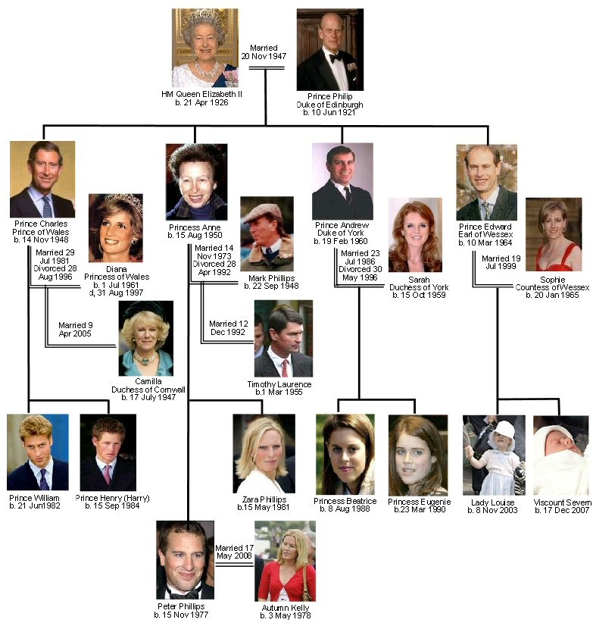

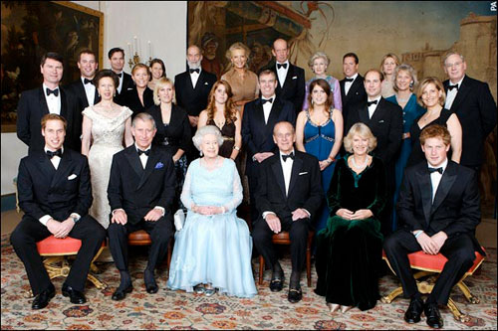

At present the British royal family is headed by Queen Elizabeth. When the Queen was born on the 21st of April 1926, her grandfather, King George V, was on the throne and her uncle was his heir. The death of her grandfather and the abdication of her uncle brought her father to the throne as King George VI.
As a child she studied constitutional history and law as well as art and music. In addition she learned to ride and acquired her enthusiasm for horses. As she grew older she began to take part in public life, making her first broadcast at the age of 14.
The marriage of the young Princess Elizabeth to Philip, Duke of Edinburgh took place in November 1947. She came to the throne after her father's death in 1952 and was crowned in Westminster Abbey in June 1953.
Among Queen Elizabeth's many duties are the regular visits she makes to foreign countries, and especially those of the Commonwealth, whose interests and welfare are very important to her. The Queen has allowed the BBC to make a documentary film about the every day of the royal family. She also started the tradition of the "walkabout", an informal feature of an otherwise formal royal visit, when she walks among the public crowds and stops to talk to some people.
The annual Christmas broadcast made by the Queen on radio and television has become a traditional and popular feature of the season, and there were widespread celebrations and special programmes of events in 1977 to mark her Silver Jubilee.
The Queen's husband, Duke of Edinburgh, was born in 1926 and served in the Royal Navy. He takes a great deal of interest in industry, in the achievements of young people (he founded Duke of Edinburgh's Award Scheme in 1956) and in saving raise wild animals from extinction.
The Queen's heir is Charles, Prince of Wales, who was born in 1948, married Lady Diana Spencer and has two children, Prince William and Prince Harry. The Prince of Wales is well-known as a keen promoter of British interests.
In recent years he has become outspoken on such controversial topics as modern architecture, violence in films and on television, and the standard of English teaching in schools. His wife Diana, Princess of Wales (often called in mass media Princess Di), won the affection of many people by her modesty, shyness and beauty. Unfortunately, she died in a car accident in August, 1997.
The Queen's other children are Princess Anne (born in 1950), Prince Andrew (born in 1960) and Prince Edward (born in 1964). Anne, Princess Royal, has acquired a reputation for being arrogant, but in recent years has become quite popular with the general public.
The Queen is widely known for her interest in horses and horse-racing. She is now president of the Save the Children Fund, Chancellor of the University of London and carries out many public engagements.
Prince Andrew, Duke of York, served as a helicopter pilot in the Royal Navy. In 1986 he married Miss Sarah Ferguson (Fergie, for short) and has two daughters.
Prince Edward is keen on the theatre. This interest began while he was at university. He quit the Royal Marines, and is now pursuing a career with a theatrical company.
The Queen Mother, the widow of the late King George VI, celebrated her one hundred birthday in 2 000 and died in 2002. The Queen's only sister, Princess Margaret, Countess of Snowdon, is well-known for her charity work.
Questions:
1. By whom is the British royal family headed at present?
2. When was the Queen Elizabeth crowned?
3. What did the Queen Elizabeth study as a child?
4. What tradition did she start?
5. When was the Queen's husband born?
6. What does he take a great interest in?
7. Who did Prince Charles marry?
8. What are the names of the Queen's other children?
Vocabulary:
heir — нащадок
abdication — відречення
enthusiasm — захоплення
to grow older — дорослішати
to make one's broadcast — виступати в радіопередачі
duke — герцог
to crown — коронувати
welfare — добробут
to signify — виражати
monarchy — монархія
feature — важлива прикмета
annual — річний
widespread — розповсюджений
the Royal Navy — Королівський флот
keen promoter — відданий захисник
outspoken — відкритий, прямий
controversial — суперечливий
for short — скорочено

MEETING PEOPLE
SOME USEFUL FORMS AND EXPRESSIONS

- Let me introduce myself
My wife, my friend…..
- Have you met each other before?
You have met Mr.Smith, haven’t you?
I don’t think you have met each other before….
- How are you?
I am very glad to meet you
Glad to meet you
Pleased to meet you
Nice to meet you
I am sorry. I didn’t quite catch your name
- How are you? - Quite well, thank you
How are you getting on? - And how are you?
How’s your father (mother ets)? – Very well indeed, thank you.
How’s your business? – Well, not too good, I am afraid.
Going from bad to worse.
Pretty good, thank you.
And how are things with you?
How’s your sister (brother) getting on?
Give her (him) my regards, please.
Explanation:
- “Glad to meet you”, “Nice to meet you”, “Pleased to meet you” –an elliptical sentence the first word of which are omitted. It is a formula which may be used alternatively with “How do you do?” byy people who have been introduced to other people. On parting, who have been introduced to each other usually say: “Glad to have met you” or “I am very glad to have met you”.
- “Going from bad to worse” – means “ Things are getting worse; expresses a rapid degeneration.
- “To take a call” – to answer the telephone. “Take the call for me, will you?” means “Please do me a favour and answer the telephone for me”.
- “How are you?” – if you really want to ask about your friend’s health you must use this phrase. And the reply is” Quite well, thank you. How are you?”
- “Not so bad”, “Not too bad”, “pretty fair” all have abot the same meaning as “I am fairly well”
- “Fine”
“First rate”
“Never better” means “excellent”
“As fit as a fiddle”
- “I am in the pink” means “I am quite well”
- “OK” means “all right”
“Not so well”
“Not too well”
“Out of sorts” means “you are not very well”
“I am a bit of color”
- “I am more dead than alive” – means “to feel very bad”
- “I am as sound as a bell” – means “to be in a good health”
- “I am run down” – means “to be tired or ill, in poor health”
- “I am jumpy” means “to be excited or nervous”

Exercise 1 based on the topic “My family”
- I was born________________________________________
- We are a family of__________________________________
- We are happy to be living together and are_______________
- My father is a very _____________person_______________
- My father often works________________________________
- He is the___________________________in our family_____
- My mother is rather__________________________

