TEXT
THE BIGGEST INTELLIGENCE LEAKS IN HISTORY
Throughout history, there have been several notable instances of intelligence leaks that have shaken governments, sparked international controversies, and reshaped public perceptions of privacy and security. From whistleblowers to hacking scandals, these leaks have provided unprecedented insights into the inner workings of governments and intelligence agencies. Here, we explore some of the most significant intelligence leaks in history and their far-reaching consequences.
Edward Snowden and the NSA Surveillance Program
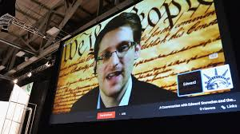
In 2013, Edward Snowden, a former CIA employee and contractor for the National Security Agency (NSA), leaked classified documents revealing the extent of the NSA's global surveillance programs. Snowden's disclosures exposed the agency's mass collection of metadata from phone calls and internet communications, raising concerns about government overreach and violation of privacy rights.

Chelsea Manning and WikiLeaks
Chelsea Manning, a former intelligence analyst for the United States Army, leaked hundreds of thousands of classified documents to WikiLeaks in 2010. The documents, which included diplomatic cables, military logs, and video footage, shed light on controversial military operations and diplomatic activities. Manning's actions sparked debates about government transparency, whistleblowing, and the role of the media in holding institutions accountable.
The Panama Papers
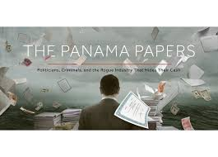
In 2016, the International Consortium of Investigative Journalists (ICIJ) released the Panama Papers, a massive trove of leaked documents exposing the offshore financial activities of politicians, celebrities, and business leaders around the world. The documents revealed the use of offshore tax havens for tax evasion, money laundering, and other illicit purposes, leading to resignations, investigations, and calls for reform in numerous countries.

The Snowden Effect
The revelations made by Edward Snowden and other whistleblowers have had a profound impact on public awareness of government surveillance and data privacy. The "Snowden effect" refers to the increased scrutiny of government surveillance practices and the push for legislative reforms to protect individual privacy rights. Snowden's leaks sparked global debates about surveillance, security, and civil liberties, prompting changes in laws and policies related to surveillance oversight and data protection.

The Vault 7 Leak
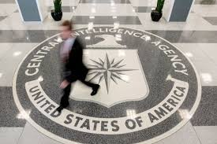
In 2017, WikiLeaks published a series of documents known as "Vault 7," which exposed the CIA's hacking tools and cyber capabilities. The leaked documents detailed the agency's ability to exploit vulnerabilities in smartphones, computers, and other electronic devices for surveillance purposes. The Vault 7 leak raised concerns about the proliferation of cyberweapons and the potential for misuse by intelligence agencies and malicious actors.
Conclusion:
The biggest intelligence leaks in history have had far-reaching consequences, shaping public discourse, influencing policy decisions, and challenging the norms of government secrecy. While whistleblowers like Edward Snowden and Chelsea Manning have faced legal repercussions for their actions, their disclosures have sparked important debates about government transparency, surveillance, and individual privacy rights. As technology continues to evolve, the risk of future intelligence leaks remains a significant concern, underscoring the need for robust oversight, accountability, and protection of whistleblowers.

