PRESENT PERFECT TENSE
PRESENT PERFECT TENSE expresses an action which took place before the present moment. It is also used with such words as: already, just, recently, ever, never, yet, since: also with: this morning (week, month, year).
Affirmative form
I  WE  YOU  THEY | HAVE | SEEN
SHE  HE  IT | HAS | SEEN

- They have put off the meeting for a while.
- I have known her for many years.
- I have already translated the text.
- He has gone to work.
- They have never been to the zoo.
- We have recently seen a new film.
- She has locked the door and left.
- I have had a talk with him already.
- I think he has told the truth.

Question form
HAVE | I  WE  YOU  THEY | SEEN
HAS | SHE  HE  IT | SEEN

- Have you seen her recently?
- Have you ever thought about it?
- Has she turned off the gas?
- Where have you been all this time?
- Who has read this book?
- Have you been to the museum this week?
- What have you seen there?
- Have you heard what the doctor said?
- How many exams have you taken this summer?
- Have you heard anything about him lately?

Negative form

I  WE  YOU  THEY | HAVE+not=haven’t | SEEN
SHE  HE  IT | HAS+not= hasn’t | SEEN

- I have not (never) seen her before.
- They haven’t come yet.
- We haven’t seen them since they left for Canada.
- They haven’t been here since 1970.
- You haven’t shown me your room yet.
- The train hasn’t yet arrived.
- I haven’t been to London yet.
- I haven’t seen this film.
- I have never thought you wouldn’t accept the invitation to the dinner party.
- We haven’t been to this city yet.

- Common question
STRUCTURE

HAVE+ SUBJECT+PREDICATE+ SECONDARY PARTS OF SEN
HAS

For example:
Have they ever been to London?

- Alternative question
STRUCTURE

HAVE+ SUBJECT+PREDICATE+ SECONDARY PARTS OF SEN
HAS + OR……..

For example:
Have they ever been to London or not?

- Disjunctive question 1.

STRUCTURE

SUBJECT +HAVE+ +PREDICATE+ SECONDARY PARTS OF SEN. + HAVEN’T\HASN’T + SUBJECT EXPRESSSED BY PREPOS.

For example:
They have ever been to London, haven’t they?

- Disjunctive question 2.

STRUCTURE

SUBJECT +HAVEN’T \HASN’T + +PREDICATE+ SECONDARY PARTS OF SEN. + HAVE\HAS + SUBJECT EXPRESSSED BY PREPOS.

For example:
They haven’t ever been to London, have they?

- NEGATIVE_QUESTION FORM

STRUCTURE

HAVEN’T \HASN’T +SUBJECT +PREDICATE+ SECONDARY PARTS OF SEN.

For example:
Haven’t they ever been to London?
- WHY QUESTION \ SPECIAL QUESTION

STRUCTURE

WH\Q+ HAVE \HAS +SUBJECT +PREDICATE+ SECONDARY PARTS OF SEN.

For example:
They have ever been to London.

- Who has ever been to London?
- Where have they been?
- When have they been?
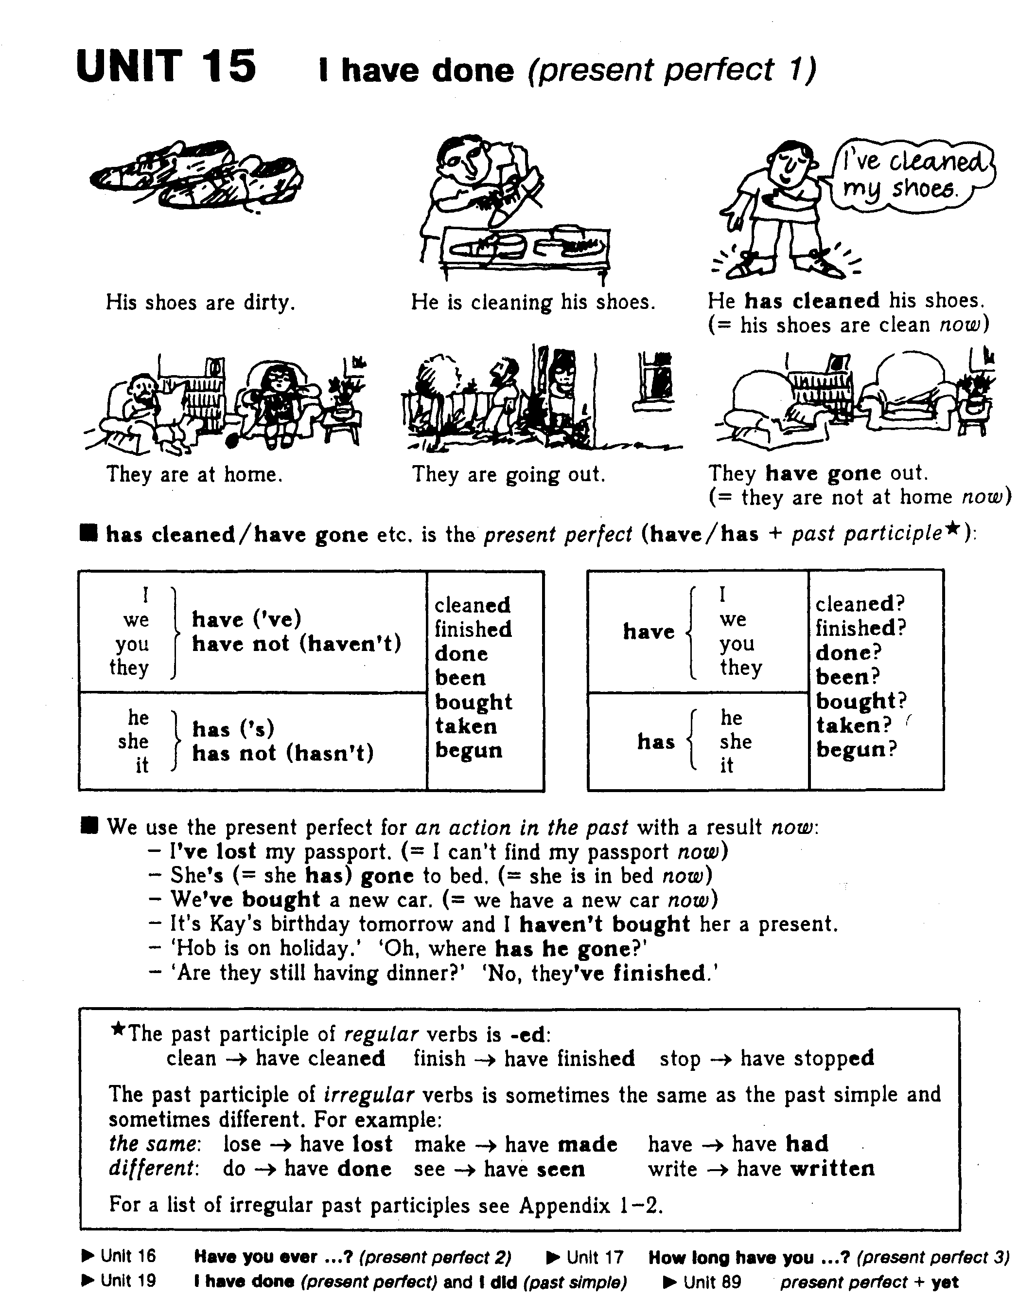
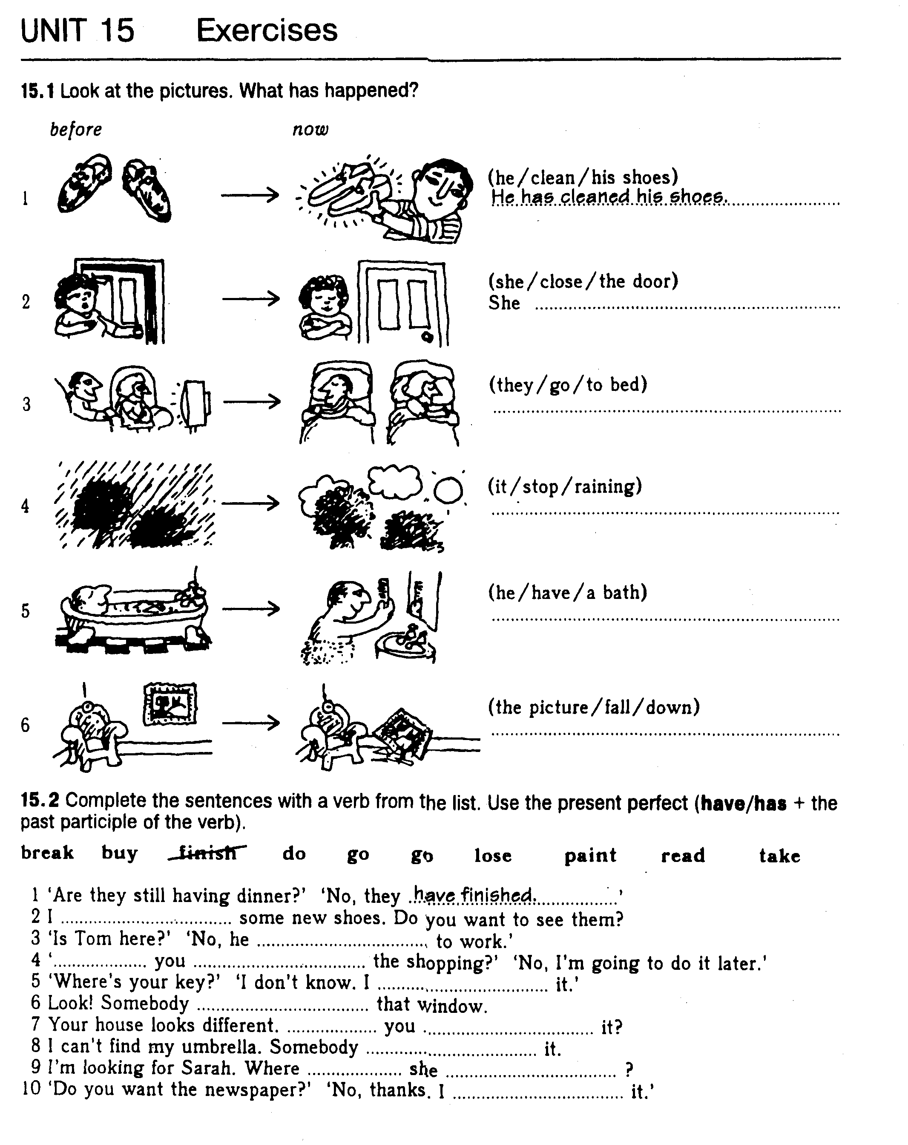
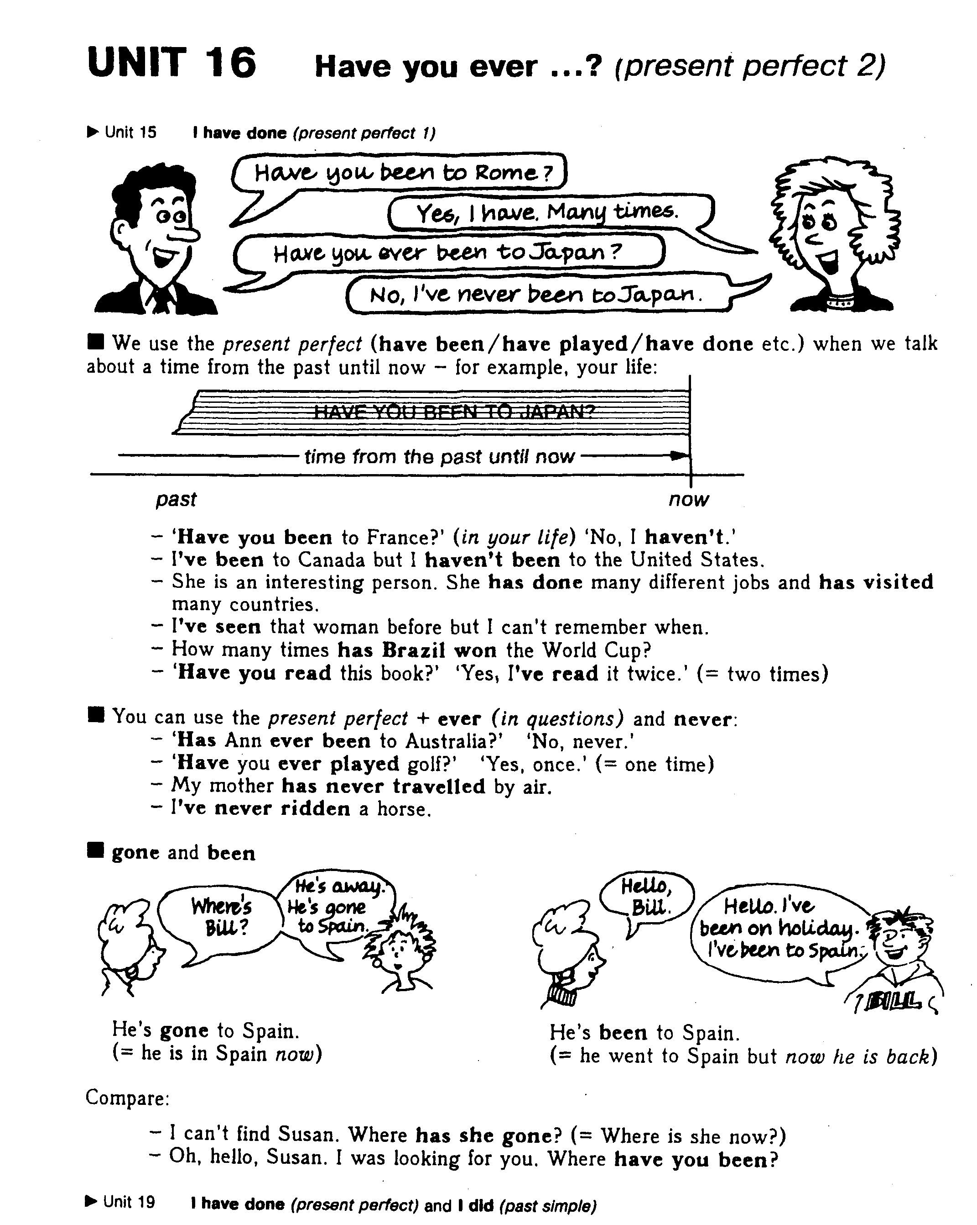
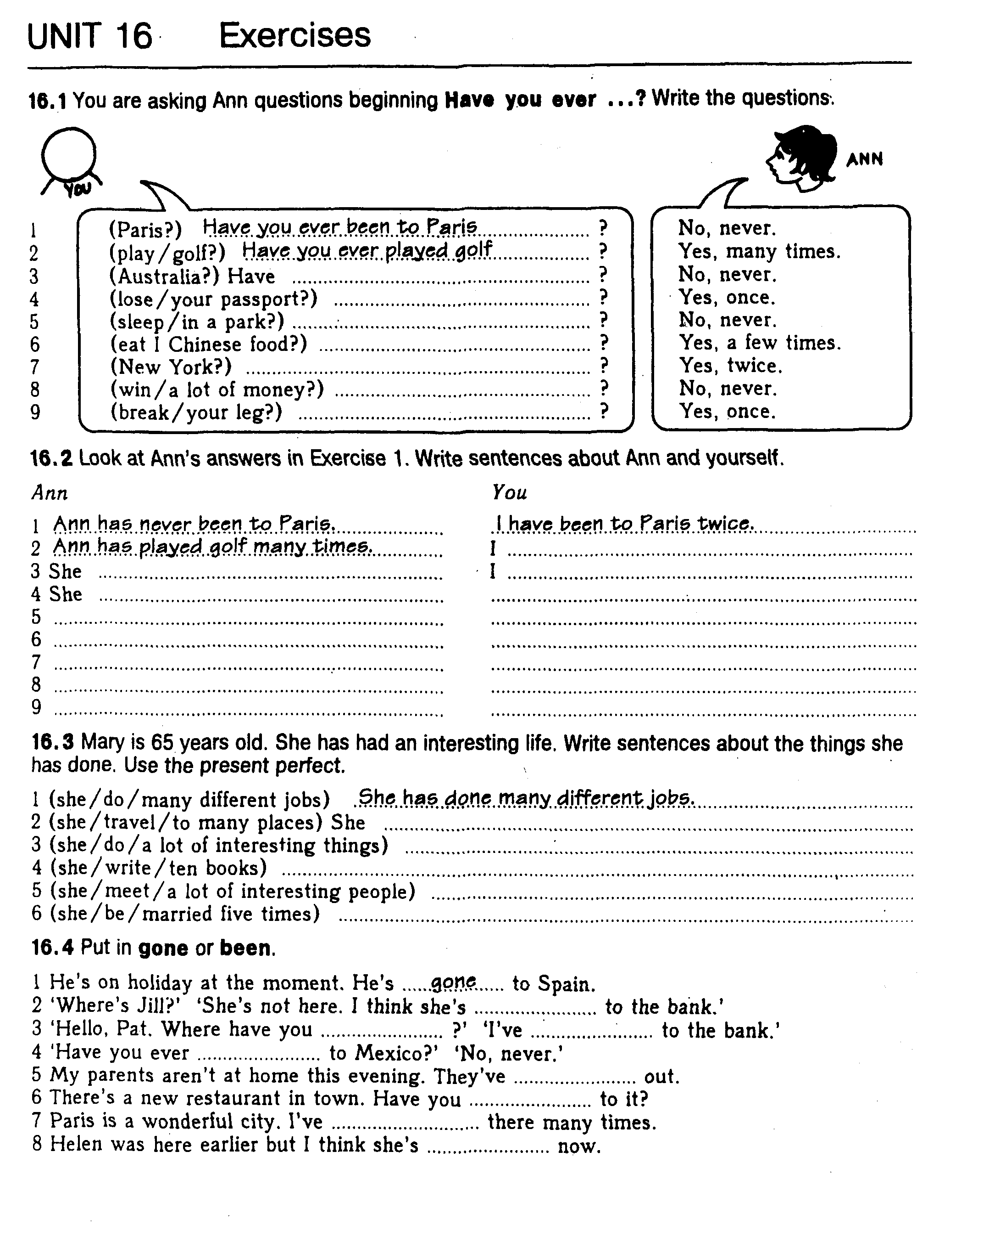

Present perfect (1) (I have done)
A. Study this example situation:
Tom is looking for his key. He can't find it. He has lost his key. 'He has lost his key' = He lost it and he still hasn't got it.
Have/has lost is the present perfect simple:
I/we/they/you have (= I've etc.) finished/lost/done/been etc.
he/she/it has (= he's etc.) finished/lost/done/been etc.
The present perfect simple is have/has + past participle. The past participle often ends in -ed (finished/decided etc.), but many important verbs are irregular (lost/done/been/written etc.). For a list of irregular verbs, see Appendix 1.

B. When we use the present perfect there is always a connection with now. The action in the past has a result now:
* 'Where's your key?' J don't know. I've lost it.' (I haven't got it now)
* He told me his name but I've forgotten it. (I can't remember it now)
* 'Is Sally here?' 'No, she's gone out.' (she is out now)
* I can't find my bag. Have you seen it? (do you know where it is now?)
We often use the present perfect to give new information or to announce a recent happening:
* Ow! I've cut my finger.
* The road is closed. There's been (= there has been) an accident.
* (from the news) The police have arrested two men in connection with the robbery.

C. You can use the present perfect with just, already and yet:
Just = a short time ago:
* 'Would you like something to eat?' 'No, thanks. I've just had lunch.'
* Hello. Have you just arrived?
We use already to say that something happened sooner than expected (see also Unit 110D).
* 'Don't forget to post the letter, will you?' 'I've already posted it.'
* 'What time is Mark leaving?' 'He's already gone.'
Yet = 'until now' and shows that the speaker is expecting something to happen. Use yet only in questions and negative sentences (see also Unit 110C):
* Has it stopped raining yet?
* I've written the letter but I haven't posted it yet.

D. Note the difference between gone (to) and been (to):
* Jim is away on holiday. He has gone to Spain. (= he is there now or on his way there)
* Jane is back home from holiday now. She has been to Italy. (= she has now come back from Italy)

EXERCISES
1. You are writing a letter to a friend. In the letter you give news about yourself and other people. Use the words given to make sentences. Use the present perfect.
Dear Chris,
Lots of things have happened since I last wrote to you.
1. I/buy/a new car
I've bought a new car.
2. my father/start/a new job
3. I/give up/smoking
4. Charles and Sarah/go/to Brazil
5. Suzanne/have/a baby

2. Read the situations and write sentences. Choose one of the following:

arrive break go up grow improve lose

1. Mike is looking for his key. He can't find it. He has lost his key.
2. Margaret can't walk and her leg is in plaster. She ---
3. Maria's English wasn't very good. Now it is much better. ---
4. Tim didn't have a beard last month. Now he has a beard. ---
5. This morning I was expecting a letter. Now I have it. ---
6. Last week the bus fare was 80 pence. Now it is 90. ---

3. Complete Bs sentences. Use the verb in brackets + just/already/yet (as sbown).
1. A: Would you like something to eat?
B: No, thanks. I've just had lunch. (just/have)
2. A: Do you know where Julia is?
B: Yes, I --- her. (just/see)
3. A: What time is David leaving?
B: He --- (already/leave)
4. A: What's in the newspaper today?
B: I don't know. I --- (not/read/yet)
5. A: Is Ann coming to the cinema with us?
B: No, she --- the film. (already/see)
6. A: Are your friends here yet?
B: Yes, they --- (just/arrive)
7. A: What does Tim think about your plan?
B: I --- (not/tell/yet)

4. Read the situations and write sentences with just, already or yet.
1. After lunch you go to see a friend at her house. She says 'Would you like something to eat?'
You say: No, thank you. I've just had lunch. (have lunch)
2. Joe goes out. Five minutes later, the phone rings and the caller says 'Can I speak to Joe?'
You say: I'm afraid --- (go out)
3. You are eating in a restaurant. The waiter thinks you have finished and starts to take your plate away.
You say: Wait a minute! --- (not/finish)
4. You are going to a restaurant this evening. You phone to reserve a table. Later your friend says 'Shall I phone to reserve a table?'
You say: No --- it. (do)
5. You know that a friend of yours is looking for a job. Perhaps she has been successful. Ask her.
You say: ---? (find)
6. Ann went to the bank, but a few minutes ago she returned. Somebody asks 'Is Ann still at the bank?'
You say: No, --- (come back)

5. Put in been or gone.

1. Jim is on holiday. He's gone to Italy.
2. Hello! I've just --- to the shops. I've bought lots of things.
3. Alice isn't here at the moment. She's --- to the shop to get a newspaper.
4. Tom has. --- out. He'll be back in about an hour.
5. 'Are you going to the bank?' 'No, I've already --- to the bank.'

A. Study this example conversation:
DAVE: Have you travelled a lot, Jane?
JANE: Yes, I've been to lots of places.
DAVE: Really? Have you ever been to China?
JANE: Yes, I've been to China twice.
DAVE: What about India?
JANE: No, I haven't been to India.

When we talk about a period of time that continues from the past until now, we use the present perfect (have been/have travelled etc.). Here, Dave and Jane are talking about the places Jane has visited in her life (which is a period that continues until now).
* Have you ever eaten caviar? (in your life)
* We've never had a car.
* 'Have you read Hamlet?' 'No, I haven't read any of Shakespeare's plays.'
* Susan really loves that film. She's seen it eight times!
* What a boring film! It's the most boring film I've ever seen.
In the following examples too the speakers are talking about a period that continues until now (recently/in the last few days/so far/since breakfast etc.):
* Have you heard from George recently?
* I've met a lot of people in the last few days.
* Everything is going well. We haven't had any problems so far.
* I'm hungry. I haven't eaten anything since breakfast. (= from breakfast until now)
* It's nice to see you again. We haven't seen each other for a long time.

B. We use the present perfect with today/this morning/this evening etc. when these periods are not finished at the time of speaking.
* I've drunk four cups of coffee today. (perhaps I'll drink more before today is finished)
* Have you had a holiday this year (yet)?
* I haven't seen Tom this morning. Have you?
* Ron hasn't worked very hard this term.

C. Note that we say 'It's the first time something has happened' (present perfect). For example:
Don is having a driving lesson. He is very nervous and unsure because it is his first lesson.
* It's the first time he has driven a car. (not 'drives') or He has never driven a car before.
* Linda has lost her passport again. It's the second time this has happened. (not 'happens')
* This is a lovely meal. It's the first good meal I've had for ages. (not 'I have')
* Bill is phoning his girlfriend again. That's the third time he's phoned her this evening.

EXERCISES
1. You are asking somebody questions about things he or she has done. Make questions from the words in brackets.
1. (ever/ride/horse?)
Have you ever ridden a horse?
2. (ever/be/California?)
3. (ever/run/marathon?)
4. (ever/speak/famous person?)
5. (always/live/in this town?)
6. (most beautiful place/ever/visit?) What

2. Complete answers. Some sentences are positive and some negative. Use a verb from this list:
be be cat happen have meet play read see see try
1 A: What's George's sister like?
B: I've no idea. I've never met her.
2. A: How is Amy these days?
B: I don't know. I --- her recently.
3. A: Are you hungry?
B: Yes. I --- much today.
4. A: Can you play chess?
B: Yes, but --- for ages.
5. A: Did you enjoy your holiday?
B: Yes, it's the best holiday --- for a long time.
6. A: What's that book like?
B: I don't know ---
7. A: Is Brussels an interesting place?
B: I've no idea --- there.
8. A: Mike was late for work again today.
B: Again? He --- every day this week.
9. A: Do you like caviar?
B: I don't know ---
10. A: The car broke down again yesterday.
B: Not again! That's the second time --- this week.
11. Who's that woman by the door)
B: I don't know --- before.)

3. Complete these sentences using today/this year/this term etc.
1. I saw Tom yesterday but I haven't seen him today.
2. I read a newspaper yesterday but I --- today.
3. Last year the company made a profit but this year ---
4. Tracy worked hard at school last term but ---
5. It snowed a lot last winter but ---
6. Our football team won a lot of games last season but we ---

4. Read the situations and write sentences as shown in the examples.

1. Jack is driving a car but he's very nervous and not sure what to do.
You ask: Have you driven a car before?
2. Len is playing tennis. He's not very good and he doesn't know the rules.
You ask: Have ---
3. Sue is riding a horse. She doesn't look very confident or comfortable.
You ask: ---
She says: ---
4. Maria is in London. She has just arrived and it's very new for her.
You ask: ---
She says: ---

Open the brackets using verbs in appropriate form for getting sentences in Present Contenuous or Present Perfect.
1. What are you (to do) here? — I am (to write) a letter to my friends. 2. Who has (to write) this article? 3. What language are you (to study)? 4. We have already (to learn) a lot of English words. 5. What is she (to teach) them? 6. Who has (to teach) you to do it? 7. He has just (to do) something for us. 8. Have you (to find) the book? 9. What are you (to look) for? 10. What are you (to talk) about? 11. We have just (to talk) about it. 12. He has just (to say) something about it. 13. She is (to tell) them some interesting story. 14. He has (to tell) us nothing about it. 15. She has (to tell) them some stories about dogs. 16. We have (to have) two lessons today. 17. They are (to have) a meeting. 18. She has not (to speak) yet. 19. They have (to ask) me several questions. 20. He has already (to learn) the rule. 21. I am (to write) an exercise. 22. What is he (to do)? — He is (to read) a newspaper. 23. Have you (to read) any stories by Jack London? 24. I am (to answer) the telephone right now. 25. He has (to fix) his car and now he is (not to have) any trouble with the brakes anymore. 26. You have just (to hear) tomorrow's weather forecast.

