MEALS
The hospitality of Ukrainian people is well-known throughout the world.
When a foreigner sets foot in Ukraine first he gets acquainted with our cookery – national dishes and mealtimes. Frequently he gets to know that in this country they are not the same as in his. But he has to do in Ukraine as the Ukrainians do.
The usual meals in Ukraine are breakfast, lunch, dinner and supper. Sanatoriums, rest-homes and other public establishments follow the generally accepted order of meals.
Breakfast is the first meal of the day. Lunch is a light meal usually in the middle of the day.
Dinner is the chief and the most substantial meal. It isn’t served at a definite hour in our country. When it is in the middle of the day, the lighter evening meal is called supper.
Working people usually have a break for dinner at their place of employment. During the break they have either dinner or lunch.
In a great many Ukrainian homes dinner is followed by a cup of tea with a slice of lemon, jam or home-made pastry.
If you have a special dinner, a housewarming party, for example, you should know how to lay the table on such an occasion.
First you spread the tablecloth and put out the table mats to protect the table from hot dishes; a tureen of soup, a bowl of hot vegetables, a platter of meat, a boat of sauce ets. Then you take out of the drawer in the sideboard soup spoons for the soup, spoons for the sweet and all the cutlery – knives and forks, including a small knife for the butter, a small knife and a fork for the hors’ d’oeuvres for dessert.
You should put the knives and the soup spoon on the right-hand side and the fork on the left, except the spoon for the sweet which you should put across the top. Then you put out the breadboard and a knife to cut the bread.
On the left of each guest you put a small plate for bread and on the right a wine glass. Don’t forget to put out table napkins for each guest and place several salt sellers.
Once again have a look at the table and see if it is laid for each person. Then you are ready for friends to come and don’t forget to put a bowl of beautiful flowers on the dinner table.
I remember my last receiving the guests. It was my birthday party. I had thought over the menu of that dinner party before the guests come to my place. I began with hors’ d’oeuvres followed by clear soup with meat pasties, the second course included a chicken with rice and vegetables, salad and so on. Then ice – cream for the sweet and fruit for dessert. And of course, there was a nice cake with candles lighted.
What a lovely birthday party I had!
WORD LIST
- Hospitality - ˌhɒspɪˈtælɪti - гостинність
- Foreigner - fɒrɪnə - іноземець
- To set foot in - ступати на
- To get acquainted - əˈkweɪntɪd - знайомитися з
- Cookery - kʊkəri - кулінарія, кухня
- National dishes – національні блюда
- Establishment - ɪsˈtæblɪʃmənt - заклад
- Substantial - səbˈstænʃəl - істотний, важливий, значний
- Employment - ɪmˈplɔɪmənt - робота, служба, заняття
- Home made pastry - ˈpeɪstri – домашня випічка
- To lay the table - накривати стіл
- Occasion - əˈkeɪʒən - випадок
- To spread - sprɛd - накривати
- To protect - prəˈtɛkt - захищати
- Tureen - təˈriːn - супниця
- Platter - plætə - дерев’яна тарілка
- Sauce - sɔːs - соус, приправа
- Cutlery - kʌtləri - ножові вироби
- Hors d’oeuvre - o: dɜːvr - закуска
- Dessert - dɪˈzɜːt - десерт

At the bakers У хлібному магазині
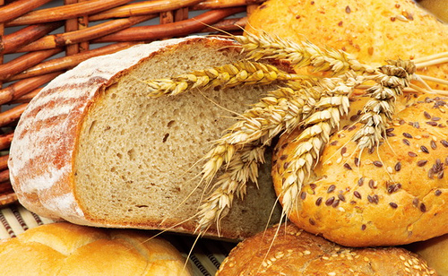

- Bread brɛd хліб
- Loaf of bread ləʊf brɛd буханка хліба
- Roll rol булочка
- Bublic bablik бублик
- Pie paɪ пиріг
- Pudding ˈpʊdɪŋ пудинг
- Baking beɪkɪŋ випічка
- Biscuits bɪskɪts печиво
- Sponge cake spʌnʤ keik бісквіт торт
- Cake keik торт
- Plum cake plʌm keik кекс
- Pastry peɪstri кондитерські вироби
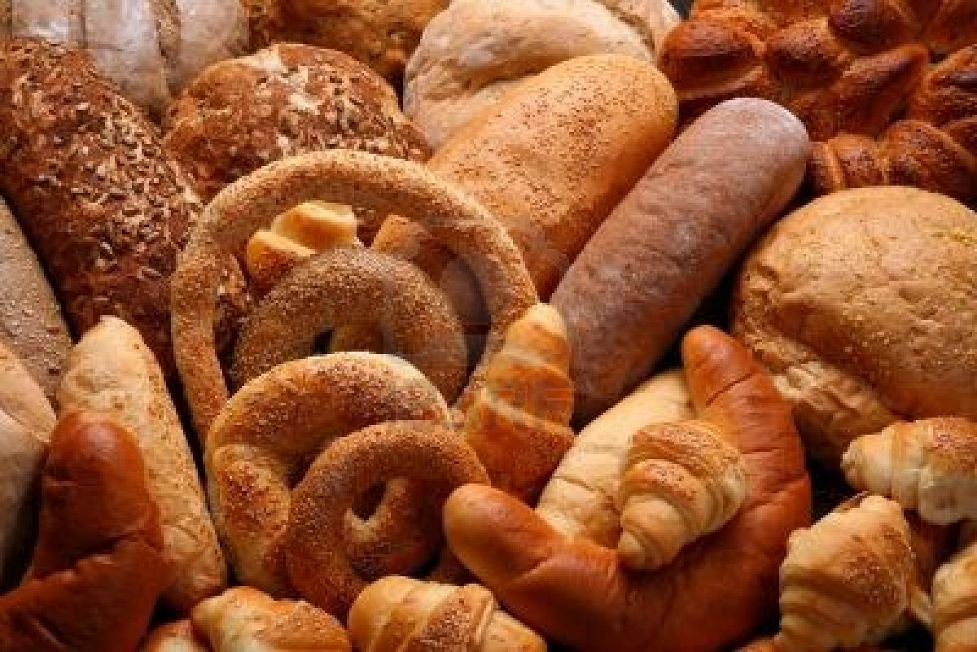
Read and translate the text
At the bakers У хлібному магазині

Modern life is very colorful. You can find any shop. The most popular in nowadays are Supermarkets where you can buy mostly
such as: brown bread, white bread, different rolls, bublics. For those who likes pastry there is a choice of different baking. You can find pie with curds, apples, cherries, bananas, everything you want. There are many Departments at the Supermarket and firstly you have to choose those you need for buying necessary list of products.
Lets go through the Bakers Department. Here you can find a wide choice of bread pudding with jam on the top.
Many shelves are full of different biscuits and you can choose any on your taste. Lovers of cakes can enjoy themselves by cakes with different kinds of creams, plums and sponge cakes.

DRINKS
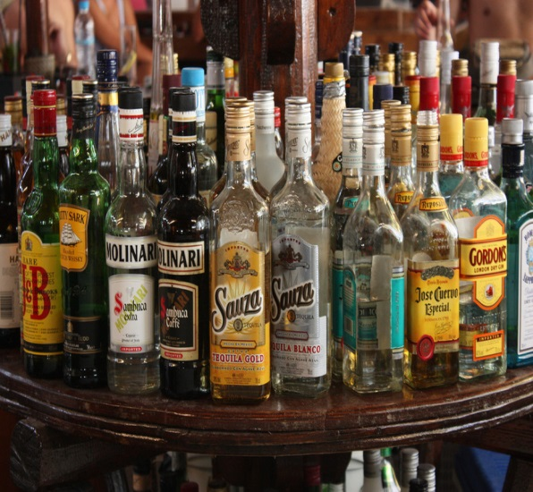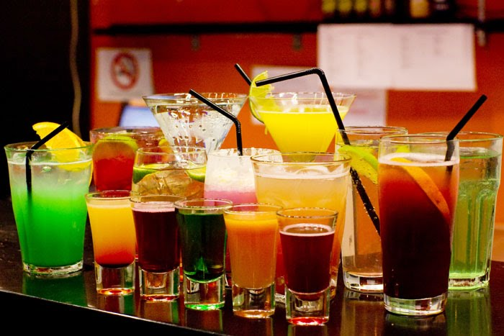
- White wine – біле вино
- Sparkling wine – ігристе вино
- Red wine – червоне вино
- Whisky – віскі
- Vodka – горілка
- Brandy – кон’як
- Liqueur - лікер
- Champagne – шампанське
- Rum- ром
- Beer – пиво
- Gin and tonic – джинтонік
- Sherry – херес
- Vintage wine – вино вищого гатунку
- Gin and lime – коктейль (джин із цитрусовим соком)
- Sweet wine – солодке вино
- Fortified wine – кріплене вино
- Dry wine - сухе вино

SOFT DRINKS
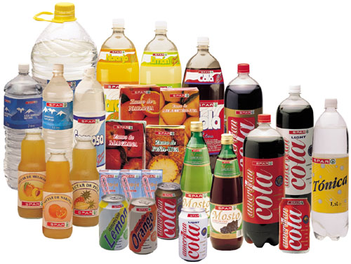
- Lemonade – лимонад
- Coca – Cola – кока-кола
- Pepsi – пепсі
- Juice – сік
- Stewed fruit – фруктовий узвар
- Jelly – кисіль
- Cocktail – коктейль
- Milk cocktail – молочний коктейль
- Mineral water – мінеральна вода
- On the rocks – із льодом

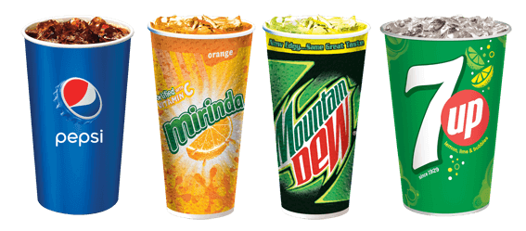

At the butcher’s У м’ясному магазині
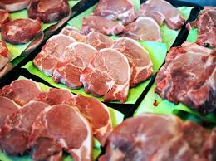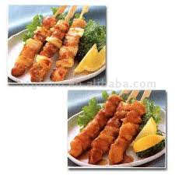
- Meat miːt м‘ясо
- Ham hæm гав‘ядина
- Bacon beɪkən бекон
- Pork po:k свинина
- Mutton mʌtn баранина
- Rump steak rʌmp steik вирізка
- Beefsteak biːfˈsteɪk біфштекс
- Minced meat minst mi:t фарш
- Sausage ˈsɒsɪʤ ковбаса
- Fat fæt сало
- Frankfurter ˈfræŋkfətə сосиска
- Hot dogs hɒt dogs гаряча сосиска
- Chop ʧɒp відбивна
- Cutlet ˈkʌtlɪt котлета
- Liver ˈlɪvə печінка
- Heart hɑːt серце
- Tongue tʌŋ язик
- Tender meat tend ə mi:t ніжне мясо
- Hamburger ˈhæmbɜːgə гамбургер
- Stew meat stjuː mi:t тушене мясо

Poultry poultri Птиця

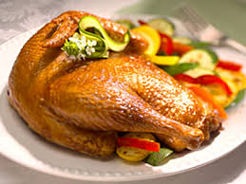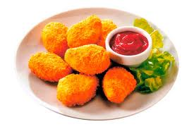

- Turkey ˈtɜːki індичка
- Broiler ˈbrɔɪlə бройлер
- Chicken ˈʧɪkɪn ціпля
- Duck dʌk качка
- Goose guːs гуся

Dairy [ˈdɛərɪ] products - Молочні продукти

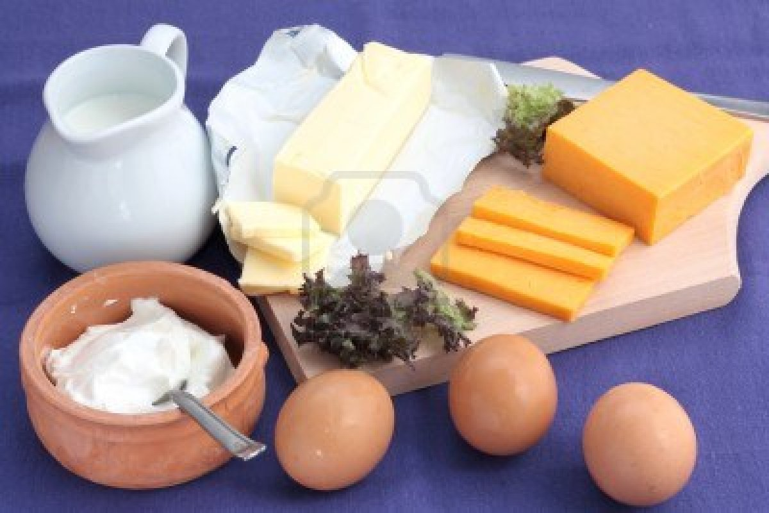

- Sour cream ˈsauə сметана
- Milk milk молоко
- Cream kri:m вершки
- Whipped cream wɪp kri:m збиті сливки
- Curds kə:ds творог
- Cheese tʃi:z сит (твердий)
- Eggs eg яйце
- Omelette ˈɔmlɪɪ омлет
- Yoghurt ˈjɔɡə:t йогурт
- Butter ˈbʌtə масло
- Mayonnaise ˌmeɪəˈneɪz майонез
- Margarine ˌmɑ:dʒəˈri:n маргарин

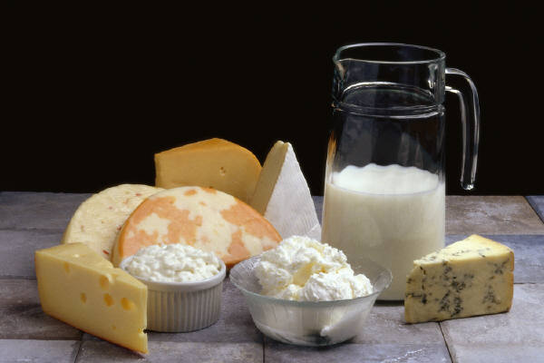

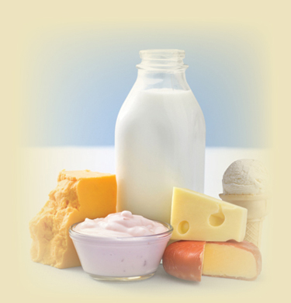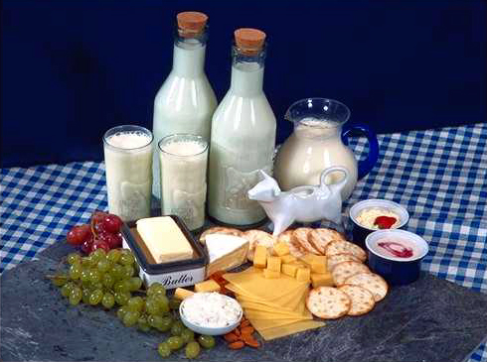

Grocers [ˈɡrəusə] Бакалія
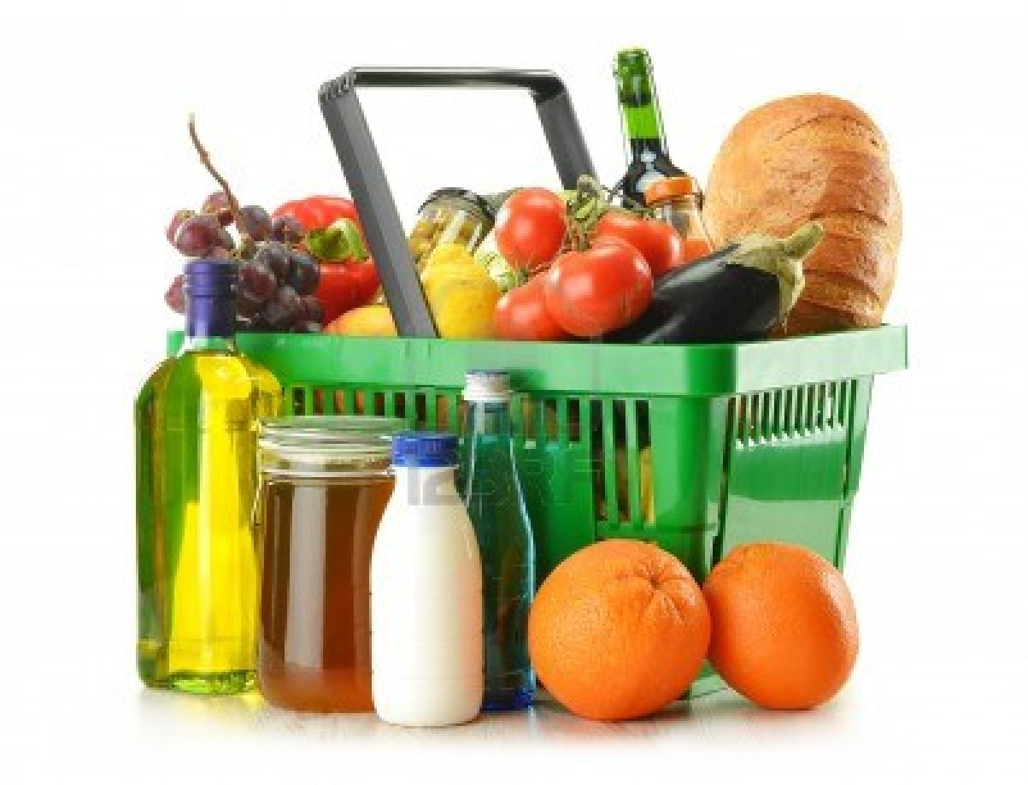
- Cereal [ˈsɪərɪəl] Крупа
- Sugar [ˈʃuɡə] Цукор
- Buckwheat [ˈbʌkwi:t] гречка
- Makaroni [ˌmækəˈrəunɪ] макарони
- Noodles [ˈnu:dl] лапша
- Rice [raɪs] рис
- Spaghetti [spəˈɡetɪ] спагеті
- Millet [ˈmɪlɪt] пшоняна каша
- Flour [ˈflauə] мука
- Oats [əut] вівсяна каша
- Porridge [ˈpɔrɪdʒ] вівсяна каша з молоком
- Salt solt сіль
- Sauce [sɔ:s] соус
- Castor sugar [kɑ:stə ˈʃuɡə] цукрова пудра
- Granulated sugar [ˈɡrænjuleɪt ˈʃuɡə] цукровий пісок
- Loaf sugar [ləuf] цукор-рафінад
- Lump sugar [lʌmp колений цукор
- Tea ti: чай
- Coffee [ˈkɔfɪ] кава
- Black coffee [blæk ˈkɔfɪ] чорна кава
- White coffee wait ˈkɔfɪ кава з молоком
- Ready ground coffee redi ɡraɪnd ˈkɔfɪ мелена кава
- Instant coffee ˈɪnstənt ˈkɔfɪ розчинна кава
- Cocoa [ˈkəukəu] какао
- Pepper [ˈpepə] перець
- Vinegar [ˈvɪnɪɡə] уксус
- Sunflower oil [ˈsʌnˌflauə oil] соняшникова олія
- Olive oil [ˈɔlɪv] оливкова олія
- Spice spais спеції
- Mustard [ˈmʌstəd] гірчиця

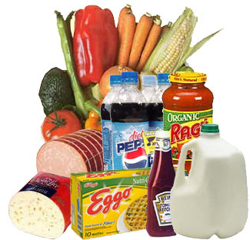

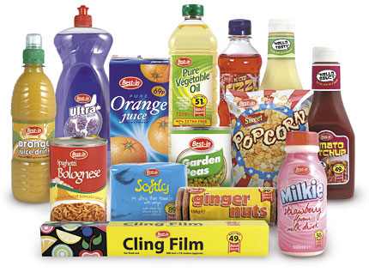
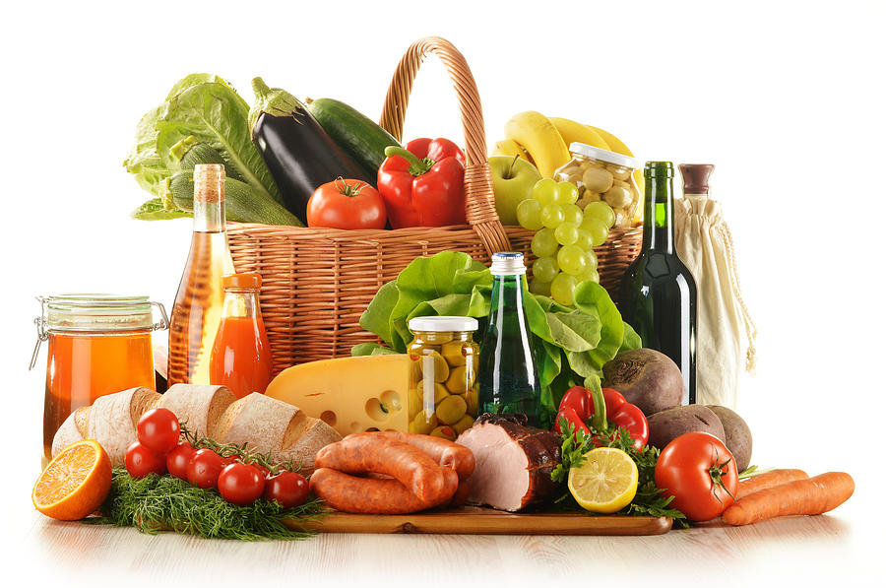
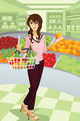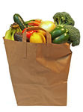
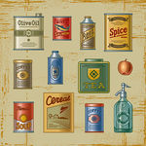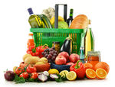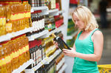
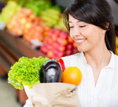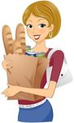

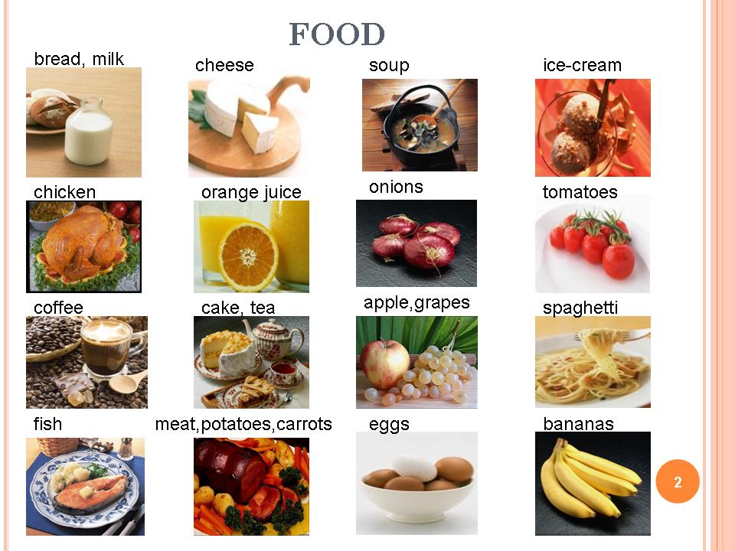

Meals
Morning:
In the morning you can take a cup of black (green) tea, cup of coffee, glass of juice.
Sandwich with butter, egg, bacon.
Sweets, chocolate.
Lunch:
At lunch you can take different kinds of soup, tomato soup (borsch),
Mashed potato, salads, fried meat, cutlets, fish, bread.

Supper:
At supper you can eat cottage, sour cream, milk, bread, butter, tea with lemon.

At the Fishmongers
- Fish [fɪʃ] риба
- Herring [ˈherɪŋ] оселедець
- Shrimps [ʃrɪmp] креветки
- Lobster [ˈlɔbstə] омар
- Perch [pə:tʃ окунь
- Pike paik щука
- Plaice [pleɪs] камбала
- Trout [traut] форель
- Cod kod тріска
- Sprats [spræt] шпроти
- Caviar [ˈkævɪɑ: ікра
- Crucian kru ʃ en] карась
- Fish dish fiʃ di ʃ рибне блюдо
- Fried fish fraid fiʃ жарена риба
- Broiled fish broild fiʃ риба, запечена в духовці
- Smoked fish [sməukt fiʃ копчена риба
- Marinated fish [merineitid fiʃ маринована риба
- Stuffed fish staft fiʃ фарширована риба

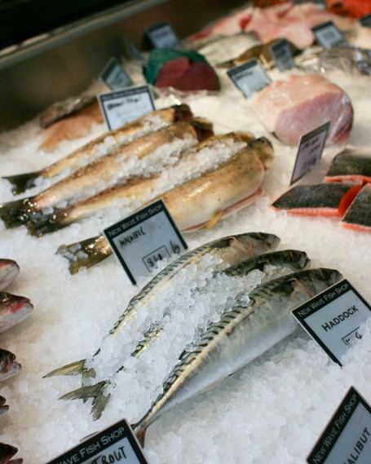

ADDITIONAL EXPRESSIONS
- Breakfast may consist of – сніданок може складатися з…..
- Lunch may include – ланч може включати….
- Dinner consists of – обід складається із…
- Menu includes \ consists of – меню включає….
- For the first \ second course – на першу \ другу страву
- For dessert – на десерт
- What do you recommend? – Що Ви порадите взяти?
- What’s your favorite dish? – Яке у вас улюблене блюдо?
- Where can we get a quick meal? – Де можна швидко поїсти?
- Excuse me, can you tell me, if there’s a restaurant round here? –Пробачте, чи не могли б ви мені сказати, чи є тут неподалік ресторан?
- Is the service at this restaurant good? – Чи у цьому ресторані гарне обслуговування?
- I am hungry \I am starving – Я голодний
- I am thirsty – Я хочу пити
- Can I reserve the table for two for 12 o’clock today? – Чи можу я замовити стіл на двох сьогодні на 12 годину?
- Menu, please – Меню, будь-ласка
- What’s the house speciality? – Які у вас фірмові блюда?
- What shall we start with? –З чого ми почнемо?
- What wine do you recommend to go with meat? – Яке вино ви б порадили до м’яса?
- Would you like a refill? –Чи налити ще?
- Won’t you have some more? – Чи не хочете ще?
- Help yourself – Пригощайтеся
- Help yourself to some more – Візьміть ще
- With pleasure – з задоволенням
- Please pass me the salt – Будь-ласка, передайте мені сіль
- The meal is delicious \tasty – Все дуже смачно
- I am satisfied \full – Я ситий \ а
- May I have the bill? – Чи можна рахунок?
- I’ll treat you – Я вас пригощаю
- It’s on me – Я сплачую
- Have a pleasant meal – Приємного апетиту!
- To your health! – За ваше здоров’я!
- I don’t care of fish (meat) in any shape or form – Я не їм рибу чи м’ясо ні в якому вигляді
- I am an immense \ great eater – У мене хороший апетит
- I am a small eater – У мене поганий апетит
- Who’s going to stand treat?- Хто пригощає?
- I’d like to have a bite – Я б хотів перекусити
- Would you like some more gravy? Чи ви б хотіли ще підливи?
- How is it cooked? –Як це приготовлено?
- This meat dish is perfectly cooked – Ця м’ясна страва чудово приготовлена
- It is overdone \ underdone – Це пережарено
- Cake is fatting – Від торту поправляються
- I will die from overeating – Я помру від переїдання
- The butter is bitter – Масло гірке
- The juice is sour – Сік кислий
- The meat is salted – М’ясо солоне
Read and translate the dialogue.

A restaurant kitchen
Waitress: Hurry up, Chef! I have 12 customers, and they all want today’s specialities. Some of them have been waiting for 15 minutes. They are getting upset.
Chef: I know, I know, but I have only two hands. You’ll have to help me.
Waitress: Help you? That’s not my job. I am a waitress, not a cook.
Chef: Well, one of my assistant is off today, and the other is out sick.
Waitress: Oh, ok. What do I do first?
Chef: Well, start putting the meat on the plates, please, and I’ll finish these vegetables.
Waitress: Ok, is it enough meat?
Chef: Hmm… That’s a little too much. Take some off.
Waitress: What about potatoes?
Chef: Oh, put on plenty of potatoes – they’re cheap – and lots of peas.
Waitress: All right. Can I take them out now?
Chef: Have you put the gravy on yet?
Waitress: Huh? Oh, no, I haven’t. Where is it?
Chef: Here it is.
Waitress: Oh, there isn’t enough gravy.
Chef: There’s plenty in that pot over there.
Waitress: Here? Ok, I’ve got it.
Chef: Fine. Now you can begin taking the plates out to the customers.
Waitress: Wow! They are hot.
Chef: Well, use a dish towel. And don’t carry too many plates. You might drop them.
Waitress: Oh, I won’t drop them. I have never dropped a plate in my life!
(Crash!)
(from American Streamline)

IN A RESTAURANT
Waiter: Good evening. Two for dinner?
Boris: Yes, that’s right.
Waiter: You can leave your coats here. Where would you like to sit?
Boris: Thank you. Where would you like to sit Natalie?
Waiter: Would you like this table near the window?
Boris: Yes, that’s nice. Could we see the menu?
Waiter: Certainly. Here it is. Shall I give you a few minutes to look at it?
Boris: Yes, we’ll order in a few minutes. Do you want an appetizer?
Natalie: Hm…. I think I ‘ll have a shrimp cocktail. I am crazy about shrimps. What about you?
Boris: I’m not sure. I can’t decide.
Natalie: Oh, if I were you, I’d have a smoked salmon. You always say you like smoked salmon, and you haven’t had any for a long time.
Waiter: Are you ready to order now?
Boris: Yes, one shrimp cocktail and one smoked salmon, please.
Waiter: Fine. And the entrée?
Boris: Well, we can’t decide between the veal and the chicken. What do you recommend?
Waiter: Both are good, but if I were you I’d better have the veal. It’s the speciality of the house. What would you like with the veal? May be some vegetables?
Natalie: Yes, some zucchini, some carrots and some boiled potatoes.
Waiter: And a salad?
Natalie: Bring me a mixed salad with the entrée, please.
Waiter: All right. Will you want a dessert?
Natalie: Can we order that later?
Waiter: Of course. Would you like a bottle of red wine? May I suggest something?
Boris: Sure.
Waiter: Why don’t you have a carafe of our house wine? It’s Chilean. You’ll like it.
Boris: That’s sounds fine. Let’s try it.
(from American Streamline)

Read and translate the text.

English Meals (1)
The English proverb says: every cook praises his own broth. One can not say English cookery is bad, but there is not a lot of variety in it in comparison with European cuisine. The English are very particular about their meals. The usual meals in England are breakfast, lunch, tea and dinner.
Breakfast time is between seven and nine a.m. A traditional English breakfast is a very big meal. It consists of juice, porridge, a rasher or two of bacon and eggs, toast, butter, jam or marmalade, tea or coffee. Marmalade is made from oranges and jam is made from other fruit. Many people like to begin with porridge with milk or cream and sugar, but no good Scotsman ever puts sugar on it, because Scotland is the home of porridge. For a change you can have sausages, tomatoes, mushrooms, cold ham or perhaps fish.
But nowadays in spite of the fact that the English strictly keep to their meals many people just have cereal with milk and sugar or toast with jam or honey.
The two substantial meals of the day are lunch and dinner. Lunch is usually taken at one o'clock. For many people lunch is a quick meal. Office workers usually go to a cafe at this time. They take fish, poultry or cold meat (beef, mutton, veal and ham), boiled or fried potatoes and all sorts of salad. They may have a mutton chop or steak and chips, followed by biscuits and a cup of coffee. Some people like a glass of light beer with lunch. Pubs also serve good, cheap food. School children can have a hot meal at school. Some of them just bring a snack from home.
Tea is very popular among the English; it may almost be called their national drink. Tea is welcome in the morning, in the afternoon and in the evening. The English like it strong and fresh made. The English put one tea-spoonful of tea for each person. Tea means two things. It is a drink and a meal. Some people have afternoon tea, so called «high tea» with sandwiches, tomatoes and salad, a tin of apricots, pears or pineapples and cakes, and, of course a cup of tea. That is what they call good tea. It is a substantial meal.
Cream teas are also popular. Many visitors, who come to Britain, find English instant coffee disgusting. Dinner time is generally between six and eight p.m. The evening meal is the biggest and the main meal of the day. Very often the whole family eats together. They begin with soup, followed by fish, roast chicken, potatoes and vegetables, fruit and coffee.
On Sundays many families have a traditional lunch consisting of roast chicken, lamb or beef with salads, vegetables and gravy.
The British enjoy tasting delicious food from other countries, for example, French, Italian, Indian and Chinese food. Modern people are so busy that they do not have a lot of time for cooking themselves. So, the British buy the food at the restaurant and bring it home already prepared to eat. So we can conclude that take-away meals are rather popular among the population. Eating has become rather international in Britain lately.

Questions:
1. What are the usual meals in England?
2. What time do they have breakfast?
3. What is a traditional English breakfast?
4. What are the two substantial meals of the day?
5. When is lunch usually taken?
6. What does lunch include?
7. Is tea popular among the English?
8. When do they usually have dinner?
9. Do the British enjoy tasting delicious food from other countries?

