TEXT

SPORTS: TYPES AND DIVERSITY

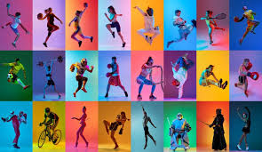

Sports have been an integral part of human civilization since ancient times, evolving from simple physical activities to organized competitions with diverse disciplines. The wide array of sports reflects the diversity of human interests, physical abilities, and cultural traditions. From traditional team sports to individual pursuits, each type of sport offers unique challenges, opportunities for personal growth, and avenues for entertainment. In this essay, we will explore various types of sports, highlighting their characteristics, popularity, and significance in contemporary society.

Team Sports

Team sports involve cooperation and coordination among a group of individuals working towards a common goal. Team sports are an integral part of human culture. These sports foster camaraderie, teamwork, and strategic thinking, making them popular choices for both participants and spectators. Examples of team sports include:
1. Football (Soccer): Football is the world's most popular sport, with millions of players and fans worldwide. It requires teamwork, agility, and skill, as players work together to score goals and defend against their opponents.
2. Basketball: Basketball is known for its fast-paced action, high-flying dunks, and intense competition. Played on a rectangular court, teams aim to score points by shooting the ball through the opponent's hoop while preventing them from doing the same.
3. Hockey: Hockey encompasses several variations, including field hockey, ice hockey, and roller hockey. In each version, two teams compete to score goals by maneuvering a ball or puck into the opponent's net using sticks. Hockey requires speed, skill, and teamwork and is popular in both amateur and professional leagues worldwide.

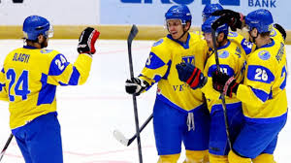

Individual Sports

Individual sports focus on personal performance and skill development, challenging athletes to push their limits and achieve excellence on their own. These sports offer opportunities for self-discipline, concentration, and self-improvement. Examples include:
1. Tennis: Tennis is a racket sport played between two individuals or teams on a rectangular court. Players use a racket to hit a ball over a net, aiming to outmaneuver their opponent and win points.
2. Swimming: Swimming is a full-body workout that involves moving through water using various strokes and techniques. It is not only a competitive sport but also a popular recreational activity for people of all ages.

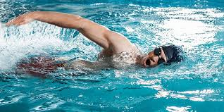

3. Athletics: Athletics, also known as track and field, encompasses a wide range of individual events such as running, jumping, throwing, and walking. Athletes compete in races, jumps, and throws to achieve the best performance in their respective disciplines.

Combat Sports

Combat sports involve physical contact between opponents, emphasizing skill, strategy, and discipline. While these sports can be intense and demanding, they also promote respect, sportsmanship, and self-defense. Examples include:
1. Boxing: Boxing is a combat sport in which two opponents fight using only their fists while adhering to strict rules and regulations. Matches are typically divided into rounds, with points awarded for clean punches landed.

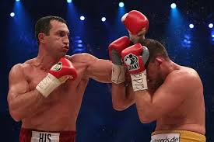

2. Mixed Martial Arts (MMA): MMA combines techniques from various martial arts disciplines, including boxing, wrestling, Brazilian Jiu-Jitsu, and Muay Thai. Fighters compete in a cage or ring, using a combination of striking and grappling techniques to defeat their opponents.
3. Judo: Judo is a Japanese martial art that focuses on throws, joint locks, and submissions to overcome opponents. Practitioners learn to use leverage and timing to control and subdue their opponents without causing injury.

Extreme Sports

Extreme sports push the boundaries of physical and mental endurance, involving high risk and adrenaline-pumping activities. While these sports are not for the faint of heart, they offer thrills, excitement, and a sense of adventure. Examples include:
1. Snowboarding: Snowboarding involves descending a snow-covered slope on a board attached to the rider's feet. It combines elements of surfing, skateboarding, and skiing, requiring balance, agility, and courage to navigate challenging terrain and perform tricks.
2. Rock Climbing: Rock climbing challenges individuals to ascend natural or artificial rock formations using hands, feet, and specialized equipment. It requires strength, technique, and problem-solving skills to overcome obstacles and reach the summit safely.

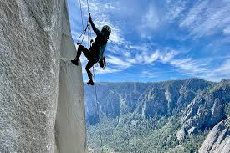

3. Skydiving: Skydiving is the sport of jumping from an aircraft and freefalling through the sky before deploying a parachute to slow descent and land safely. It offers a unique sensation of flight and exhilaration, making it a popular choice for thrill-seekers and adrenaline junkies.
Over the past decades, sport development in Ukraine has experienced both progress and challenges. Prior to the war that began in 2014, Ukraine had been making significant strides in various sports disciplines, with athletes achieving notable success on the international stage. Investment in sports infrastructure, training programs, and grassroots initiatives contributed to the growth of sports participation across the country.

Sport development in Ukraine over the past decades

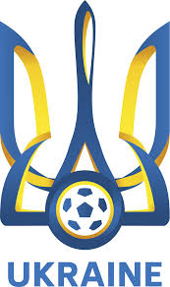

However, the outbreak of war in 2014 brought about disruptions and setbacks to the sports sector. Conflict-affected regions faced difficulties in maintaining sports facilities, organizing competitions, and supporting athletes amidst the broader humanitarian crisis. Despite these challenges, many athletes demonstrated resilience and determination, continuing to train and compete despite the adversity.
In recent years, efforts have been made to revive and rejuvenate the sports sector in Ukraine. Reconstruction of damaged sports facilities, provision of support for athletes affected by the conflict, and initiatives aimed at promoting sports as a means of social cohesion and rehabilitation have been underway. While progress may have been slower than desired due to ongoing challenges, the resilience and passion for sports among Ukrainians remain strong, pointing towards a hopeful future for sport development in the country.
In conclusion, the world of sports is incredibly diverse, encompassing a wide range of activities that cater to different interests, abilities, and preferences. Whether participating as athletes or cheering as spectators, sports bring people together, promote physical and mental well-being, and inspire individuals to strive for excellence. Regardless of the type of sport, the essence remains the same: the pursuit of passion, competition, and the relentless pursuit of victory.

