TEXT
A NEW HUMAN CHALLENGE: COVID-19

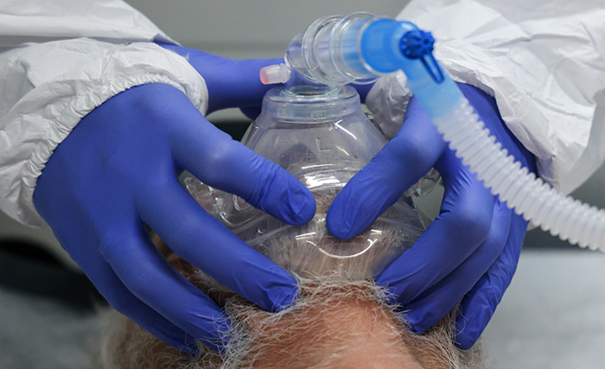

A new respiratory virus called the 2019 Novel Coronavirus, or COVID-19 is making headlines for causing an outbreak of respiratory illness throughout the world. The outbreak began in Wuhan, Hubei Province, China and quickly spread internationally. Thousands of people have become sick and public health officials are keeping a close watch on how the virus is spreading.
Here’s what you need to know about coronavirus (COVID-19):
- What is a coronavirus?
- What's different about the coronavirus (COVID-19)?
- How are coronaviruses spread?
- What are the signs and symptoms of coronaviruses?
- How can I protect myself from coronaviruses?
- What do I do if I'm sick and think I've been exposed to coronavirus (COVID-19)?
- Additional resources about coronavirus (COVID-19) and other coronaviruses?

What is a coronavirus?

Coronaviruses are a large family of viruses that are actually common throughout the world and can cause respiratory illness in people and animals. There are several known coronaviruses that infect people and usually only cause mild respiratory disease, such as the common cold. However, at least two previously identified coronaviruses have caused severe illness — Severe Acute Respiratory Syndrome (SARS) coronavirus and Middle East Respiratory Syndrome (MERS) coronavirus.

What's different about coronavirus (COVID-19)?

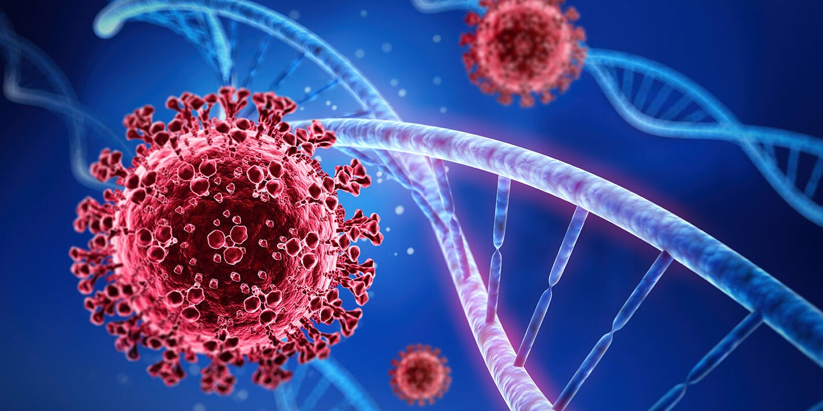

While coronaviruses are common, coronavirus (COVID-19) is a new strain of coronavirus that had previously not been identified in humans. The key features of COVID-19 are respiratory symptoms with a fever and cough. Like all new infections, understanding COVID-19 is important and changes rapidly. The.

How are coronaviruses spread?

Human coronaviruses are spread through person-to-person contact. Similar to cold and flu, a person becomes sick through close contact with an infected person. The virus is spread through respiratory droplets produced by an infected person through coughing and sneezing or by touching surfaces with the virus on them.

What are the signs and symptoms of coronaviruses?

In confirmed cases of COVID-19 infections, symptoms include fever, cough, and shortness of breath and the severity has ranged from mild to people being severely ill. In other coronaviruses, common signs of infection include:
- runny nose
- headache
- cough
- sore throat
- fever
- a general feeling of being unwell

How can I protect myself from coronaviruses?

The best way to protect yourself from contracting coronaviruses is by using the same daily habits that help prevent the spread of many viruses, including the common cold and the flu. To help prevent the spread of disease always:
- Avoid close contact with people who are sick.
- Wash your hands with soap and water frequently. Wash with soap and warm water for 20 seconds. If soap and water aren't available, use an alcohol-based hand rub.
- Avoid touching your eyes, nose, and mouth with unwashed hands.
- Stay home when you’re sick (and keep sick children home from school).
- Cover your cough or sneeze with a tissue, then throw the tissue in the trash and wash your hands. If you don't have a tissue, cough or sneeze into your upper sleeve or elbow, not your hands.
- Clean and disinfect frequently touched objects and surfaces.
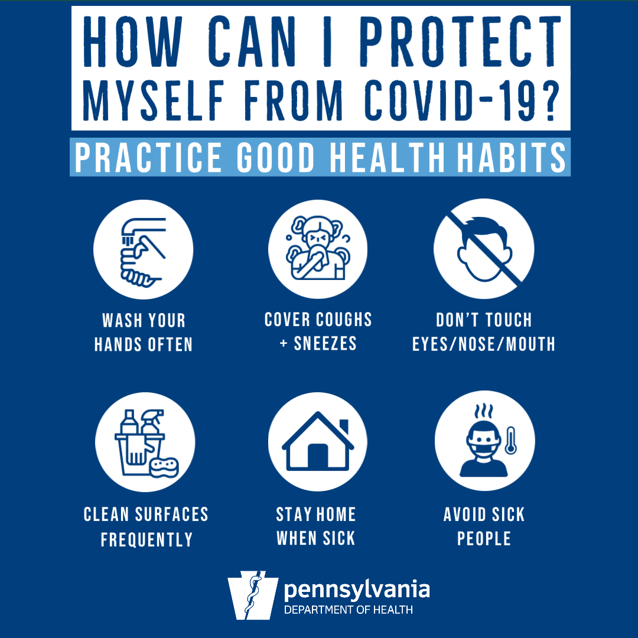

What do I do if I'm sick and think I've been exposed to coronavirus (COVID-19)?

If you begin to feel sick with fever, cough, or shortness of breath, please stay home. Call your primary care provider.
Please wear a mask in our facilities and around other people if you have a fever, are coughing, sneezing, have a runny nose, or are having difficulty breathing.

