The Olympic Games:
A Journey Through History, Symbolism, Venues, Ceremonies, and Controversies

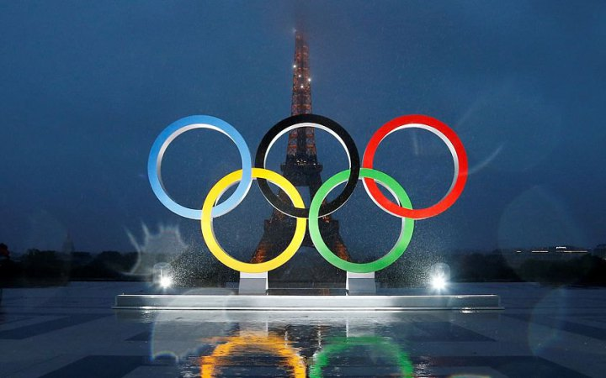

The Olympic Games stand as a testament to human athleticism, camaraderie, and cultural exchange. Originating in ancient Greece around the 8th century BCE, these games were held in Olympia, dedicated to the worship of Zeus. Over time, they grew in significance, becoming a symbol of unity among Greek city-states. However, the ancient Olympics were not without their controversies, including allegations of cheating and bribery.
Fast forward to the modern era, where the idea of reviving the ancient Olympics was proposed by Baron Pierre de Coubertin in the late 19th century. In 1896, the first modern Olympic Games took place in Athens, Greece, marking the beginning of a new era in international sports. Since then, the Olympics have evolved into the largest and most prestigious sporting event in the world, encompassing a wide range of sports and attracting athletes from every corner of the globe.
The Olympic rings, designed by Coubertin, symbolize the unity of the five continents through sport. Each ring represents a different continent: blue for Europe, yellow for Asia, black for Africa, green for Australia, and red for the Americas. This symbol has become synonymous with the Olympic Games and is instantly recognizable worldwide.
The Olympic flame, another iconic symbol, has its roots in ancient Greece. It represents the eternal flame that burned on the altar of Zeus in Olympia. Today, the Olympic flame is lit several months before the start of the Games in Olympia, Greece, using a parabolic mirror to focus the sun's rays. It is then carried by a relay of torchbearers to the host city, where it ignites the cauldron during the opening ceremony, symbolizing the continuity between the ancient and modern Games.
Speaking of host cities, the selection process for hosting the Olympics is highly competitive and often controversial. Cities vie for the opportunity to showcase their culture, infrastructure, and hospitality on the world stage. However, hosting the Olympics comes with its own set of challenges, including the financial burden of building stadiums and infrastructure, concerns about displacement of local residents, and environmental impact.
The opening ceremony of the Olympic Games is a grand spectacle, featuring music, dance, and theatrical performances that celebrate the culture and history of the host country. It is attended by heads of state, dignitaries, and millions of viewers around the world. The highlight of the opening ceremony is the Parade of Nations, where athletes from participating countries march into the stadium, proudly carrying their nation's flag.

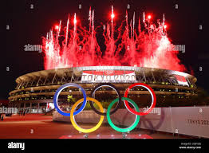

Despite its grandeur, the Olympics have not been immune to controversy. Over the years, there have been numerous scandals involving doping, bribery, and corruption. One of the most notorious scandals occurred during the 2002 Salt Lake City Winter Olympics, where officials were found guilty of accepting bribes in exchange for votes to secure the host city bid.
Doping, the use of performance-enhancing drugs, has also tarnished the reputation of the Olympics. Athletes who are caught doping face sanctions and disqualification, but the issue persists, casting a shadow over the integrity of the Games.
In recent years, there has also been growing concern over the environmental impact of the Olympics. The construction of stadiums and infrastructure often leads to deforestation, pollution, and habitat destruction. Additionally, the carbon emissions generated by transporting athletes, officials, and spectators to the host city contribute to climate change.
Despite these challenges, the Olympic Games continue to captivate audiences around the world, inspiring millions of people to pursue their dreams and celebrate the power of sport to unite nations. As we look to the future, it is imperative that we address the issues facing the Olympics and work towards creating a more sustainable and inclusive Games for generations to come.

