TEXT

STRESS SYMPTOMS:

EFFECTS ON YOUR BODY AND BEHAVIOR

Stress symptoms may be affecting your health, even though you might not realize it. You may think illness is to blame for that irritating headache, your frequent insomnia or your decreased productivity at work. But stress may actually be the cause.

Common effects of stress

Indeed, stress symptoms can affect your body, your thoughts and feelings, and your behavior. Being able to recognize common stress symptoms can help you manage them. Stress that's left unchecked can contribute to many health problems, such as high blood pressure, heart disease, obesity and diabetes.
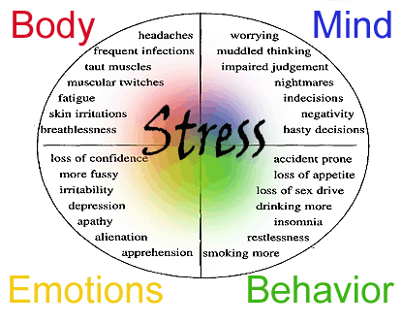

Common effects of stress
On your body | On your mood | On your behavior
Headache | Anxiety | Overeating or undereating
Muscle tension or pain | Restlessness | Angry outbursts
Chest pain | Lack of motivation or focus | Drug or alcohol misuse
Fatigue | Feeling overwhelmed | Tobacco use
Change in sex drive | Irritability or anger | Social withdrawal
Stomach upset | Sadness or depression | Exercising less often
Sleep problems

Act to manage stress

If you have stress symptoms, taking steps to manage your stress can have many health benefits. Explore stress management strategies, such as:
- Getting regular physical activity
- Practicing relaxation techniques, such as deep breathing, meditation, yoga, tai chi or massage
- Keeping a sense of humor
- Spending time with family and friends
- Setting aside time for hobbies, such as reading a book or listening to music
Aim to find active ways to manage your stress. Inactive ways to manage stress — such as watching television, surfing the internet or playing video games — may seem relaxing, but they may increase your stress over the long term.
And be sure to get plenty of sleep and eat a healthy, balanced diet. Avoid tobacco use, excess caffeine and alcohol, and the use of illegal substances.

When to seek help

If you're not sure if stress is the cause or if you've taken steps to control your stress but your symptoms continue, see your doctor. Your healthcare provider may want to check for other potential causes. Or consider seeing a professional counselor or therapist, who can help you identify sources of your stress and learn new coping tools.
Also, get emergency help immediately if you have chest pain, especially if you also have shortness of breath, jaw or back pain, pain radiating into your shoulder and arm, sweating, dizziness, or nausea. These may be warning signs of a heart attack and not simply stress symptoms.

