OLYMPIC CEREMONIES

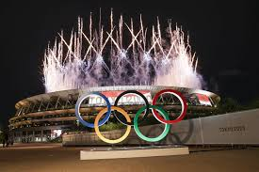

The opening ceremony
The form of the opening ceremony is laid down by the IOC in great detail, from the moment when the chief of state of the host country is received by the president of the IOC and the organizing committee at the entrance to the stadium to the end of the proceedings, when the last team files out.
When the head of state has reached the appointed place in the tribune and is greeted with the national anthem, the parade of competitors begins. The Greek team is always the first to enter the stadium, and, except for the host team, which is always last, the other countries follow in alphabetical order as determined by the language of the organizing country. Each contingent, dressed in its official uniform, is preceded by a shield with the name of its country, while an athlete carries its national flag. At the 1980 Games, some of the countries protesting the Soviet Union’s invasion of Afghanistan the previous year carried the Olympic flag in place of their national flag, in deference to a boycott of those Games by other countries. The competitors march around the stadium and then form in groups in the centre facing the tribune.
The president of the OCOG then delivers a brief speech of welcome, followed by another brief speech from the president of the IOC, who asks the chief of state to proclaim the Games open.
A fanfare of trumpets sound as the Olympic flag is slowly raised. The Olympic flame is then carried into the stadium by the last of a series of runners who have brought the torch on a very long journey from Olympia, Greece. The runner circles the track, mounts the steps, and lights the Olympic fire that burns night and day during the Games.

The medal ceremonies

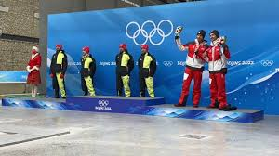

In individual Olympic events, the award for first place is a gold (silver-gilt, with six grams of fine gold) medal, for second place a silver medal, and for third place a bronze medal. Solid gold medals were last given in 1912. The obverse side of the medal awarded in 2004 at Athens was altered for the first time since 1928 to better reflect the Greek origins of both the ancient and modern Games, depicting the goddess Nike flying above a Greek stadium. The reverse side, changed for each Olympiad, often displayed the official emblem of the particular Games. At the 2004 Athens Games, athletes received authentic olive-leaf crowns as well as medals. Diplomas are awarded for fourth, fifth, sixth, seventh, and eighth places. All competitors and officials receive a commemorative medal.

Medals are presented during the Games at the various venues, usually soon after the conclusion of each event. The competitors who have won the first three places proceed to the rostrum, with the gold medalist in the centre, the silver medalist on his or her right, and the bronze medalist on the left. Each medal, attached to a ribbon, is hung around the neck of the winner by a member of the IOC, and the flags of the countries concerned are raised to the top of the flagpoles while an abbreviated form of the national anthem of the gold medalist is played. The spectators are expected to stand and face the flags, as do the three successful athletes.

The closing ceremony

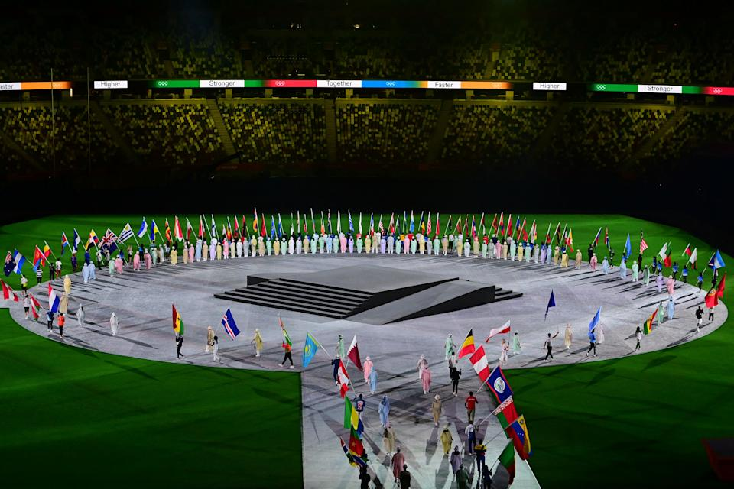

The closing ceremony takes place after the final event, which at the Summer Games is usually the equestrian Prix des Nations. The president of the IOC calls the youth of the world to assemble again in four years to celebrate the Games of the next Olympiad. A fanfare is sounded, the Olympic fire is extinguished, and, to the strains of the Olympic anthem, the Olympic flag is lowered and the Games are over. But the festivities do not end there. The 1956 Olympics in Melbourne introduced one of the most important and effective of all Olympic customs. At the suggestion of John Ian Wing, a Chinese teenager living in Australia, the traditional parade of athletes divided into national teams was discarded, allowing athletes to mingle, many hand in hand, as they move around the stadium. This informal parade of athletes without distinction of nationality signifies the friendly bonds of Olympic sports and helps to foster a party atmosphere in the stadium.

