TEXT

WHAT IS VIRTUAL TOURISM?

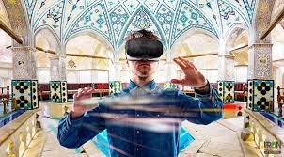

Virtual tourism is one of the types of tourism that arose thanks to modern information and computer technologies, electronic means of communication and the possibilities of the Internet.
Virtual tourism involves virtual excursions, and virtual tours, virtual acquaintances, where ordinary reality is replaced by a virtual one.
The main purpose of creating such tours was to provide an opportunity for everyone to "travel" to interesting regions and objects without any significant additional costs. The traveler becomes a passive spectator. Virtual trips to notable historical, cultural and architectural monuments and objects of the nature reserve fund can be viewed on many web pages of the Internet presented in the form of described tours with numerous photo and video materials. Virtual experience helps to get closer to reality.
With the help of 3D technologies and opportunities provided by services similar to Google Earth, you can visit the most remote corners of the planet and even outer space. The CGI tool, developed by tech brand 3RD Planet, allows users to take a realistic walk through city streets.
It is also a big advantage that before the trip it is possible to review those interesting and interesting sights that you plan to see soon, orient yourself with their location. When choosing a place to rest or visit, visual information is an important factor. And after the trip, there is an opportunity to immerse yourself again in the impressions and memories of the trip that took place.
Specialists in the field of tourism and geography are engaged in such interesting developments. This is one of those professions that are in demand on the labor market and always remain relevant.
Virtual tourism is quite versatile and includes the following: ordinary visits to sites with photos, articles and videos, following online diaries, participation in virtual tours (walking around a city or museum) or immersion in virtual worlds ("virtual realities")
Virtual tourism is characterized by the following features:
- overcoming the boundaries of time and space (the world is presented outside of time and space, virtual tourism makes it possible for visitors to appear in one part of the world while actually being in another);
- interactivity (refers to communication between people and computers. Virtual tourism uses a variety of sensors to interact with a multidimensional information space);
- high technologies (virtual tourism is the result of combining tourism with information and technologies of virtual reality, and therefore this type of tourism cannot exist without high technologies);
- economy (virtual tourism makes travel cheaper);
- versatile sensations (the ability of visitors of virtual tours, worlds to perceive images, sounds, experience and other components of perception).
Virtual tourism has strengths as well as limitations. Virtual tourism makes travel easier and more accessible. It is much cheaper to take a virtual tour than to buy a ticket (for a plane, train, bus, etc.) and pay for a hotel. Moreover, tourists no longer need to spend either money or time on obtaining a visa. In addition, virtual travel is safer: for the tourist, if he wants to visit a dangerous place (territories of military operations, emergency situations, etc.), and for the ecological state of the environment (virtual tourist does not pollute the natural environment).

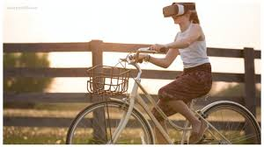

Another positive side of virtual tourism is comfort: it is much more convenient to travel in a chair than to spend 15 hours on a plane. The tourist can also control the time when it is more convenient for him to connect to the virtual world, pause or watch a replay. But the biggest advantage is that people who would never be able to travel in the real world (people with disabilities, the elderly, the seriously ill, the poor) can travel with the help of virtual tourism. The question arises, why this type of tourism will not completely replace the traditional one?
Firstly, virtual tourism is not able to provide all five senses (smell, touch, taste, sound and visual perception) at the same time as traditional types of tourism. In virtual tourism, the emphasis is on visual perception, while for many people it is important to feel by touch. Moreover, the "picture" in virtual space (even if we are talking about a 3D image, where not only color, but also volume is transmitted) is not one hundred percent identical to what people observe in reality when they are in a particular city of travel . In addition, there is a difference between virtual and traditional tourism in terms of emotional perception. Of course, emotions (joy, surprise, etc.) are present in both cases, but the emotional level is different. An example can be a safari tour in Africa, or a flight in a hot air balloon, where a real tourist, in addition to positive emotions, may feel fear of heights, death or injury. At the same time, a virtual tourist may be impressed, satisfied, but definitely not think about the possibility of his own death or injury.

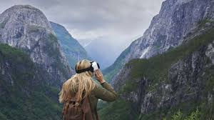

Virtual tourism is a type of tourism with the help of which people, using high technologies, travel to different countries, attractions or newly created worlds, but not in real space, but in virtual (imaginary) space. Having many strengths: cheaper travel, lack of visa formalities, savings and time management, etc., virtual tourism is characterized by certain limitations that limit its possibilities. That is why virtual tourism cannot replace real (traditional) tourism, and is only an application that expands tourist opportunities, destinations and audiences. However, it is possible that it is only a matter of time.

