TEXT

UKRAINIANS WHO CHANGED THE WORLD

PART I

Being a Ukrainian today means moving forward, being active and purposeful, striving to rebuild and defend the native country, learning the Ukrainian language and wanting to speak it, having an interest in Ukraine's cultural heritage, history, and traditions. And also, finally getting rid of the inferiority complex, because Ukraine, which, in fact, has never been on the world's sidelines, has given humanity more than one famous name. Our compatriots influence the course of history, make scientific discoveries, create literary and artistic masterpieces, conquer the world of music and television, outer space, and sports heights.

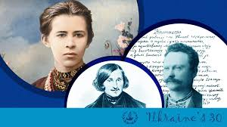

1. Volodymyr the Great
Ruler and Baptist of Kyivan Rus' (960/963−July 15, 1015)

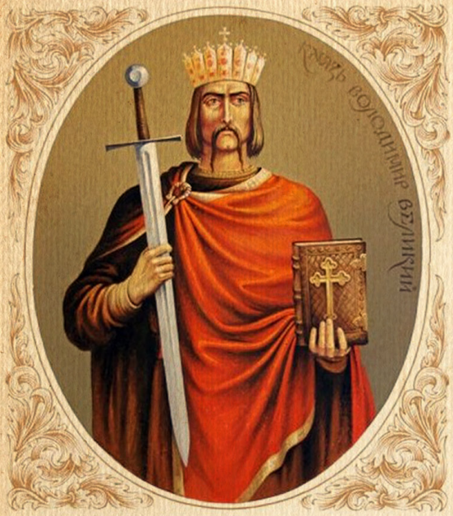

Grand Prince of Kyiv, ruler, and baptizer of Kyivan Rus, one of the most prominent state leaders of Ukraine-Rus. Also known as St. Volodymyr, Volodymyr the Baptizer, and Volodymyr the Red Sun. His reign in 980-1015 is considered the beginning of the prosperity of Kyivan Rus, and the prince is called one of the brightest politicians in Europe at that time. He amassed indivisible power, introduced a fresh approach to governing the state, carried out administrative reform, and strengthening the borders of Kyivan Rus also contributed to fortifying the state, raising its status. Prince Volodymyr Sviatoslavych was the first of the Kyivan princes to start minting his own money, and the "trident" symbol depicted on them became the emblem of Ukraine in the 20th century.

2. Anna Yaroslavna (Anna of Kyiv)
Ukrainian princess, queen of France (born about 1032)

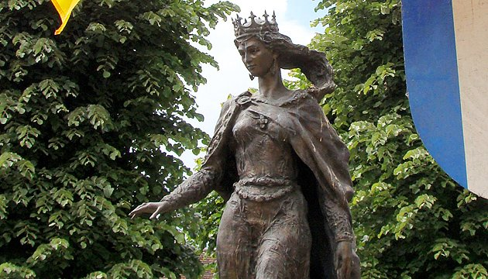

The Ukrainian princess, the daughter of the Grand Prince of Kyiv Yaroslav the Wise, is one of the most prominent women of the Middle Ages, who glorified Ukraine throughout Europe. Educated and brilliant Anna, who was fluent in 5 languages, became not only another wife of King Henry I of France and the mother of the future King Philip I, but also a prominent political figure of the time. Queen Anne influenced the foreign and domestic policy of France, was a member of the royal council, took care of churches and monasteries, was the only woman who corresponded with Pope Nicholas II. In European history, Anna Yaroslavna remained the great-grandmother of almost 30 French kings.

3. Roksolana (Hurrem Sultan – "the cheerful one")
Ukrainian queen of the Ottoman Empire (born about 1502)

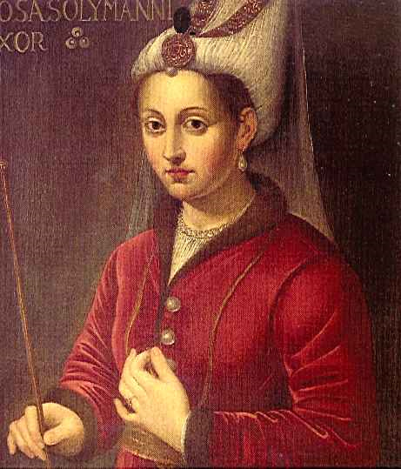

The Ukrainian queen of the Ottoman Empire, Anastasia Lisovska, the daughter of a priest from the town of Rohatyn in Galicia, entered the history of Turkey under the name of Roksolana and stayed forever. The woman, who went from prisoner to one of the most influential rulers in the world, became the first and the only woman in the history of the Ottoman Empire awarded the official title. Hurrem Haseki Sultan was her husband's adviser in public affairs, received foreign ambassadors, responded to letters from foreign rulers, influential nobles, and artists. She built mosques, schools, caravanserais, and hospitals in Istanbul, Edirne, Jerusalem, Mecca, and Medina at her own expense. She also contributed to her son's, Selim II, accession to the Ottoman throne. Roksolana has been repeatedly praised in literature, fine arts, music, and cinema and is one of the most famous women of ancient and modern Ukraine.

4. Bohdan Khmelnytskyi
Hetman (1595−1657)

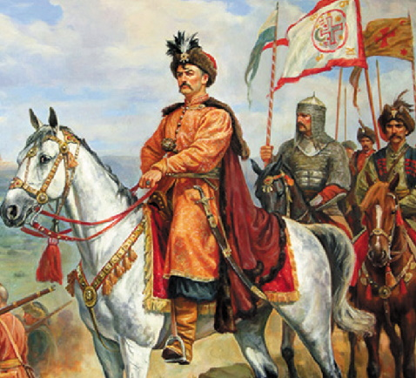
Hetman of the Zaporozhian Army, a fighter for the independence of the Ukrainian people, the founder of the first Ukrainian state in history, the Hetmanate. Bohdan Khmelnytskyi, who was born Zinovii, was an educated man: he knew Latin, French and Turkish. Although Khmelnytskyi was educated at a Jesuit school, the future hetman remained faithful to Orthodoxy. Bohdan Khmelnytskyi became famous as a talented military leader, an outstanding reformer, and the founder of Ukrainian statehood. The reign of the legendary hetman (1648-1657) brought Ukraine not only domestic political power but also recognition in the international arena.

5. Hryhorii Skovoroda
Philosopher (1722−1794)

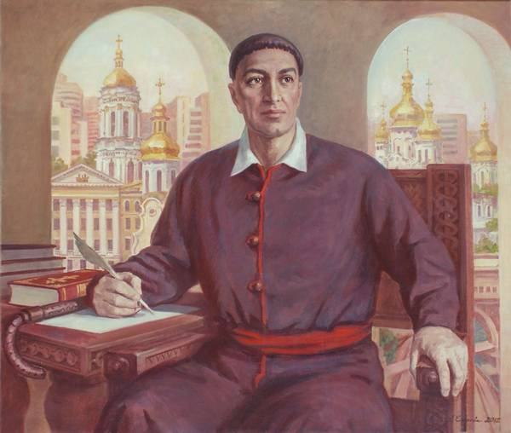

Hryhorii Skovoroda, an outstanding Ukrainian philosopher, theologian, poet, pedagogue, and translator, was perhaps the most interesting figure in the history of the Ukrainian spirit. He extremely valued personal physical and spiritual freedom, so he didn't even bow to the queen. He devoted his philosophical treatises mainly to ethics and considered self-knowledge to be the main meaning of human existence. The mystic traveler was independent and free all his life. They say he could predict fate and knew the exact date of his death. "The world tried to catch me, but didn't manage…": such words are carved on the grave of "Ukrainian Socrates."

6. Taras Shevchenko
Poet, novelist, artist (1814−1861)

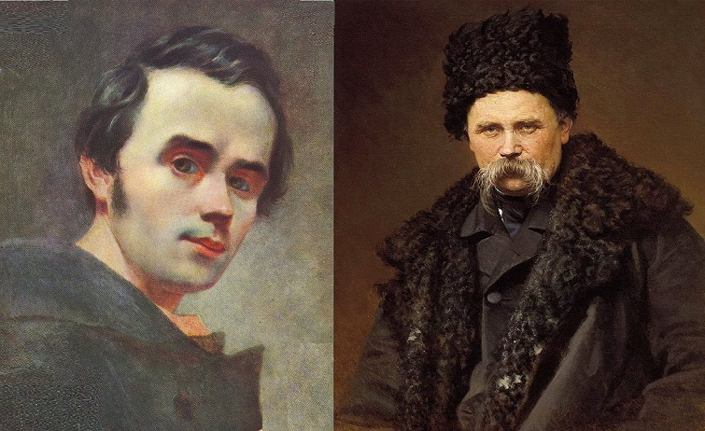

National pride, Taras Shevchenko was a man of universal talents and interests. While still alive, the former serf became a recognized poet, prose writer, playwright, artist, politician, and public figure. But most of all, Shevchenko dreamed of a time when his country would be an independent sovereign state when Ukraine's language, culture, and history would be respected, and the people would be united in their actions and thoughts. "Love your Ukraine. Love it… In times of rage. At the last difficult moment, pray to the Lord for it." Today Shevchenko is one of the most published authors in the world. The poet's poems have been translated into more than a hundred languages ​​and even Esperanto. One of Mercury's 300 craters is named after him, and there are almost 1,400 monuments to the Ukrainian genius on Earth in 35 countries.

7. Mykola Hohol
Writer (1809−1852)

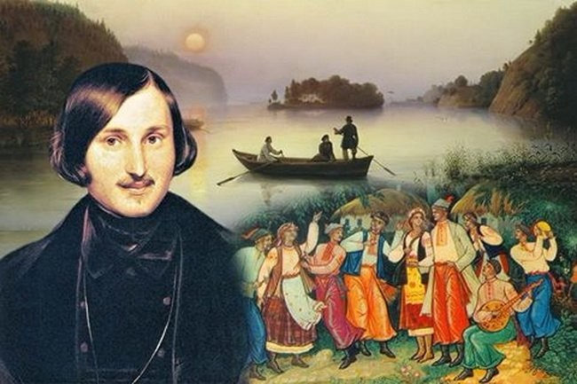

The canonical writer, who was born in the Poltava region and wrote in Russian, was able to make hundreds of millions of readers around the world fall in love with Ukraine. No one, before and after Mykola Hohol, spoke so widely, convincingly, fascinatingly, and vividly about Ukrainian life. Although many of the writer's works are associated with St. Petersburg, one of the first places in his work was given to Ukrainian reality, traditions, folklore, and history. In his letters to his mother, who lived in a Ukrainian village, Hohol asked her to tell him about the traditions, rites, and customs of his native people, which he later used actively in his St. Petersburg period. The author's famous works "Taras Bulba," "Myrhorod," "Evenings on a farm near Dykanka" have been translated into almost all languages ​​on the planet. For almost two centuries, the world has known our country, the original character and soul of the Ukrainian people through the work of a brilliant writer with Ukrainian roots.

8. Ivan Franko
Writer, publicist, public figure (1856–1916)

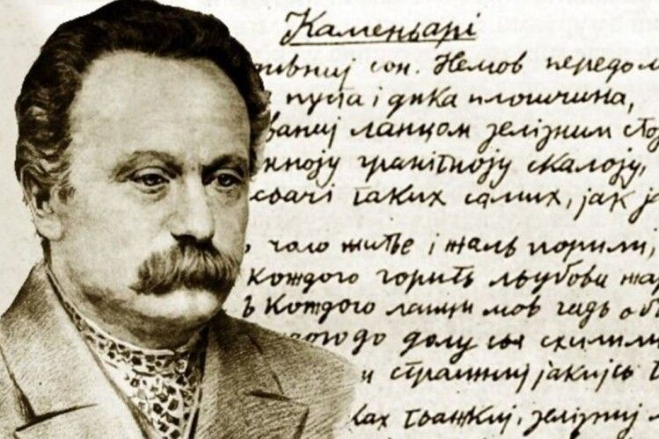

The talented prose writer and playwright, the only Ukrainian poet nominated for the Nobel Prize in Literature, was notable for his tremendous efficiency. In the forty years of his career, Franko has published eleven collections of poetry, more than a hundred short stories, nine short stories, and more than ten plays. He became the first professional Ukrainian writer who didn't have a state job but earned his living by writing. He survived three arrests. After the second (1880) he almost died of starvation, but he didn't give up his views; ten years later he became a co-founder of the first Ukrainian political party, the Ruthenian-Ukrainian Radical Party, and its first chairperson in 1898. Frank's journalistic activity was also fruitful: more than two thousand publications. As an ethnographer, Franko organized a vast amount of folklore, published several important works on the theory of literature, history, Ukraine's economics, and philosophy.

9. Volodymyr Vernadskyi
Natural historian, philosopher (1863−1945)

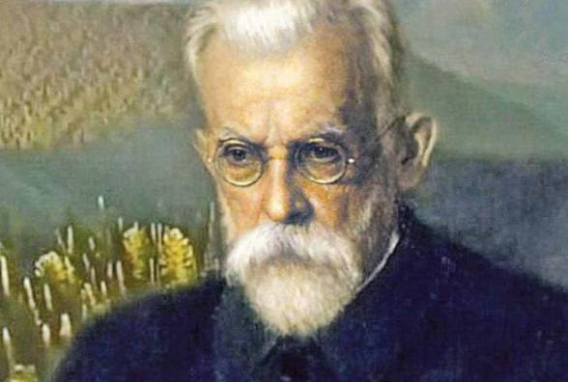

Volodymyr Vernadskyi became the first president of the Ukrainian Academy of Sciences (UAS), established in 1918 in Kyiv under Hetman Pavlo Skoropadskyi. He headed the Ukrainian Academy of Sciences for three years. During this time, the main institutes of the academy and the scientific library were established, the largest one in present-day Ukraine. Vernadskyi organized many geological expeditions, from the Urals to southern Ukraine, to study natural resources. He was the first in the Russian Empire to draw attention to the need for research into radioactive minerals, so he's considered the ideologist and founder of nuclear energy in Ukraine and Russia.
Volodymyr Vernadskyi is named a scientist-prophet. His ideas were ahead of his time. The pinnacle of Vernadskyi's scientific research is the doctrine of the biosphere as a whole natural system, and of the noosphere, the sphere of influence of the human mind on the surrounding world.

10. Lesia Ukrainka
Poet (1871–1913)

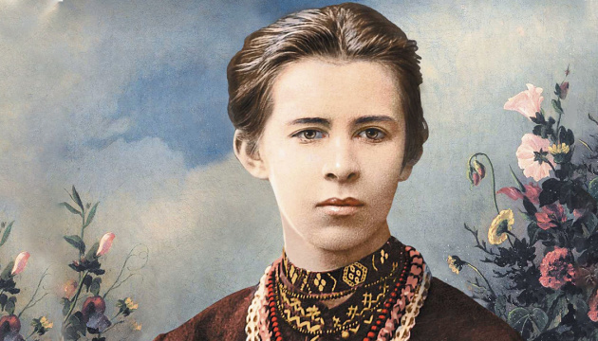

Contemporaries loved Lesia Ukrainka for her thirst for life, and her descendants were left with her work. The poet, given only 42 years of her life by fate, enriched Ukrainian poetry with the absolute perfection of form, a variety of universal themes, and many poetic genres. Her dramatic poems, "Stone Master," "Obsessed," "Cassandra" and others, don't leave theater stages, and the famous drama extravaganza "Forest Song" has become a real classic of Ukrainian literature. Lesia Ukrainka is the only woman in the national culture who discovered the translation art secrets of one of the most outstanding monuments of humanity, the Rigveda. She also translated Heinrich Heine, Adam Mickiewicz, Victor Hugo, and Homer. Despite a serious illness, bone tuberculosis, the fragile woman had a tremendous ability to work and strength of spirit, which became one of the main motives of her lyrics. Lesia Ukrainka put the following idea about herself into Mavka from "Forest Song": "No! I'm alive. I will live forever. I have something in my heart that does not die…"

11. Ivan Piddubnyi
Wrestler, athlete (1871–1949)

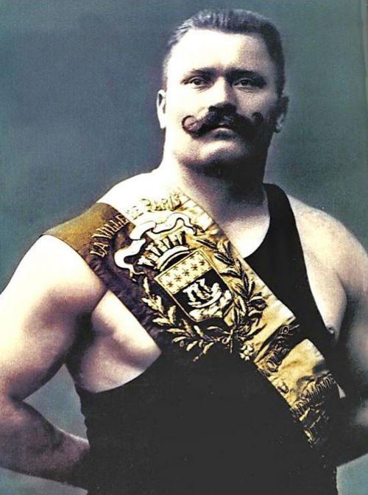

A native of the Zaporozhian Cossacks, Ivan Piddubnyi glorified his ancestors all over the planet. An epic hero, wrestler, strongman (he bent iron rods and carried a bandstand with pianos and dancers), the "champion of champions" was a real Ukrainian. The name of Ivan Piddubnyi became a symbol of invincible strength, unique power, and brilliant skill. For 40 years, the strongman from Poltava fought about two thousand fights, the vast majority of which he won. He differed from other wrestlers by fast orientation, excellent coordination of his movements, and incredible strength. He performed in 100 cities of the Russian Empire and 50 foreign countries. When asked about the secret of victories, Piddubnyi replied: "Going on stage, I prayed for Ukraine. That's why he won."

12. Solomia Krushelnytska
Opera singer (1872–1952)

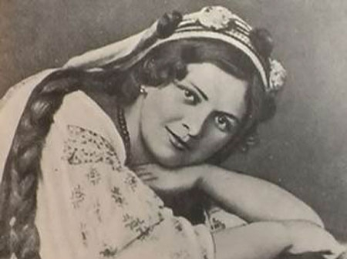

Solomia Krushelnytska received the title of the world's outstanding singer during her lifetime. Viewers in a huge number of European cities admired her opera parts, and Krushelnytska was awarded the title of "Wagnerian diva of the 20th century." Singing on the same stage with a native of a small Ukrainian village was considered a great honor by the most famous performers of the 20th century. In 1904, Krushelnytska saved the famous Madame Butterfly of Giacomo Puccini; after her debut failure on stage, the composer completed the opera and entrusted the main part to the Ukrainian singer. For the second time the work was a tremendous success and since then hasn't left the world stage. Acquaintances of the composer said that the only portrait in Puccini's office was the image of a Ukrainian singer.

13. Mykola Leontovych
Композитор (1877–1921)

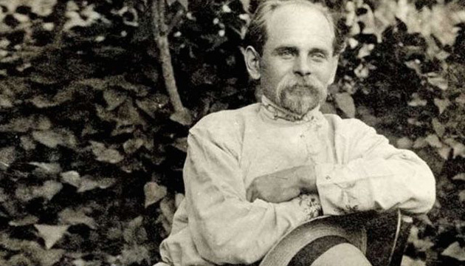

The Ukrainian carol "Shchedryk," also known as "Carol of the Bells," is recognized and sung on Christmas on all continents. Today there are over 1000 versions of this popular song. The melody of "Shchedryk" consists of 4 notes, and the words of the song have pagan roots, from the time when the New Year was celebrated in the spring. In total, Leontovych's musical heritage is about 150 works. He published two "Collections of Songs from Podillia" in his own arrangement. In 1917, with the establishment of the Ukrainian People's Republic, Leontovych moved to Kyiv. Here he created his first symphonic works, began to write the opera "On the Mermaid's Easter." But after the Bolsheviks came to power, he returned to his native Vinnytsia region, to Tulchyn, where he founded a music school. In 1921, his life was tragically cut short: a Chekist who asked to spend the night at Leontovych's house robbed him and shot the host. The world learned the name of the composer's killer only in the 1990s, thanks to the opening of archives. The good news is that Shchedryk, edited by Mykola Leontovych, is to be included in the UNESCO list of intangible cultural heritage.

14. Oleksandr Arkhypenko
Sculptor (1887−1964)

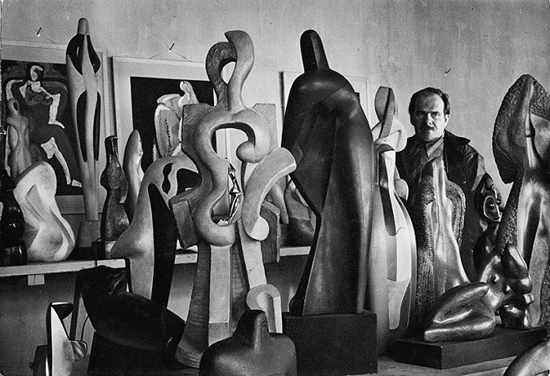

Oleksandr Arkhypenko, Ukrainian and American sculptor and artist, is one of the founders of Cubism in sculpture, founder of the art school. He became the first Ukrainian to take part in the Venice Biennale (1920). His name holds a worthy place among such masters of the twentieth century as Matisse, Picasso, Braque, Leger, Malevich. In 1923, Arkhypenko emigrated to the United States. There he received citizenship in 1929 and worked as an artist, sculptor, and decorator. In 1934 he decorated Ukraine's pavilion at the exhibition "Century of Progress" in Chicago. In America, he proved himself as an inventor, creating a device that allows drawings made of plexiglass to move. Advertising billboards with variable images now run on this principle.

