МЕТОДИЧНІ РЕКОМЕНДАЦІЇ

ДО САМОСТІЙНОЇ ТА ІНДИВІДУАЛЬНОЇ РОБОТИ СТУДЕНТІВ
ІЗ ДИСЦИПЛІНИ «ВСТУП ДО ПЕРЕКЛАДОЗНАВСТВА»

для студентів ІІ курсу спеціальності 035.041 Філологія (Германські мови та літератури (переклад включно)), перша - англійська

Київ-2023

СONTENTS
Season 1, episode 1 "A Study in Pink” 4
Season 1, episode 2 "The Blind Banker" 12
Season 1, episode 3 "The Great Game" 19
Season 2, episode 1 "A Scandal in Belgravia" 27
Season 2, episode 2 "The Hounds of Baskerville" 35
Season 2, episode 3 "The Reichenbach Fall" 43
Season 3, episode 1 "The Empty Hearse" 50
Season 3, episode 2 "The Sign of Three" 58
Season 3, episode 3 "His Last Vow" 65
Literature 73

“Sherlock” Season I

Ep. 1: A Study in Pink

Find out the meaning of the following words:
  - out of town -

  - get off on -

  - drive off -

  - leap -

  - mortuary -

  - remarkable -

  - assume -

  - brilliant -

  - vicious -

  - dull -

  - cab -

  - invisible -

  - proper -

  - confession -

  - lunatic -

  - chase -

  - branch out –

  - buzz in –

Describe the episode, using words from Activity 1:

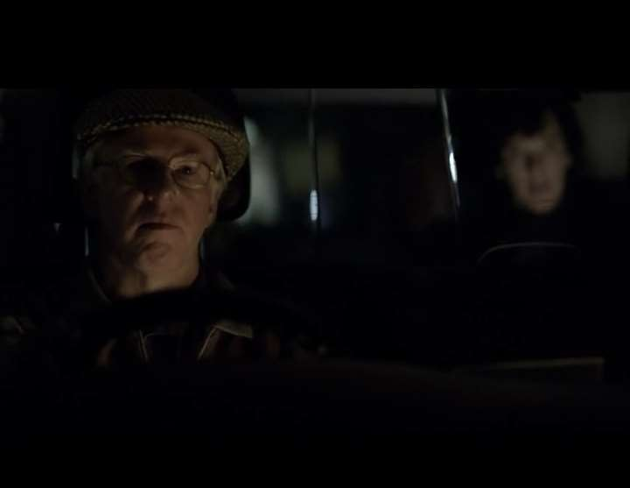

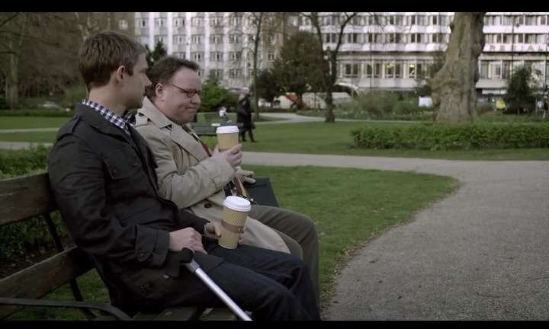

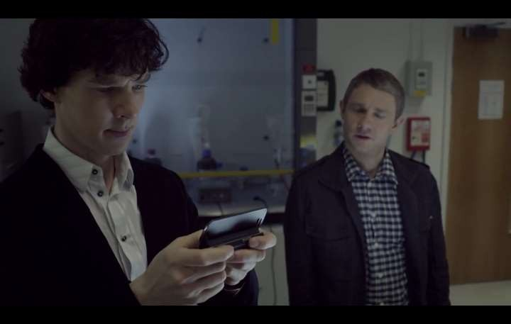

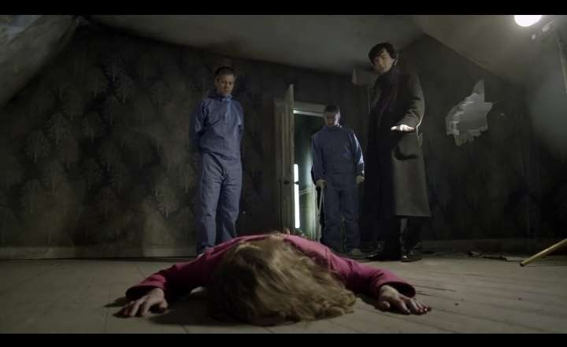

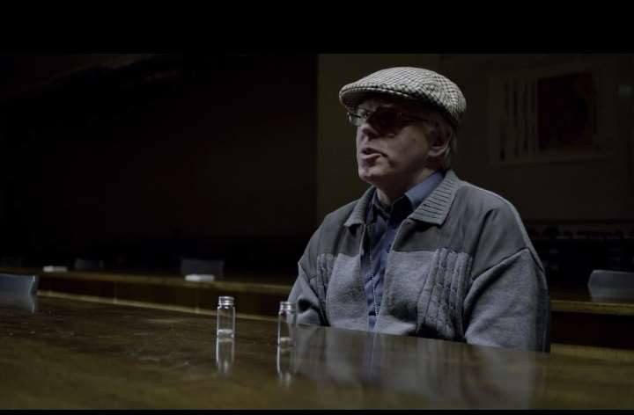

- Remember all the characters in the series and complete the table:

Сharacter | Аppearance | Тemper | Рrofession | Your attitude
Sherlock Holmes
Dr. John Watson
Greg Lestrade
Mrs. Hudson
Taxi driver

Find out whom the following words belong to:
1…………………&………………….

-Afghanistan or Iraq?
-Sorry? - Which was it, in Afghanistan or Iraq?
-Afghanistan. Sorry, how did you...?
-Ah, Molly, coffee, thank you.

2…………………&…………………

-Look at him, dashing about My husband was just the same. But you're more the sitting-down type, I
can tell. I'll make you that cuppa, you rest your leg.
-Damn my leg! Sorry, I'm so sorry. It's just sometimes this bloody thing...
-I understand, dear, I've got a hip.
-Cup of tea'd be lovely. Thank you.
-Just this once, dear, I'm not your housekeeper.
-Couple of biscuits too, if you've got 'em.
-I am not your housekeeper!

3.…………………&…………………

-What is your connection to Sherlock Holmes?
-I don't have one. I barely know him. I met him yesterday.
-Mmm, and since yesterday, you've moved in with him and now you're solving crimes together. Might we expect a happy announcement by the end of the week?
- Who are you?
- An interested party.
-Interested in Sherlock? Why? I'm guessing you're not friends.
-You've met him. How many friends do you imagine he has? I am the closest thing to a friend that Sherlock Holmes is capable of having.
- And what's that?
- An enemy.

4.…………………&…………………

-There's a good bottle and a bad bottle. You take the pill from the good bottle, you live. You take the pill from the bad bottle you die. Both bottles are of course identical.
- In every way.
- And you know which is which.
- Of course I know.
- But I don't.
- Wouldn't be a game if you knew
- You're the one who chooses.
-Why should I? I've got nothing to go on. What's in it for me?
-I haven't told you the best bit yet. Whatever bottle you choose, I take the pill from the other one. And then together we take our medicine. I won't cheat. It's your choice. I'll take whatever pill you don't.

Match the following words with the characters they belong to:

- Sherlock Holmes
- Dr. John Watson
- The psychologist
- Mycroft Holmes
- Greg Lestrade
- Mrs. Hudson
- Jeff Hope, cabdriver-killer
- John, you’re a soldier, and it’s going to take you a while toad just to civilian life, and writing a blog about everything that happens to you will honestly help you.
- I’m a consultative detective. Only one in the world. I invented the job.
- It’s an unusual situation. We’ve got our best people investigating.
- We have more in common that you’d like to believe.
- You risky our life to prove you’re clever.
- If you get the corpses now, I’ll promise you one thing. I will never tell you what I said.
- My husband was just the same. But you’re more the sitting-down type, I can tell.

5. Match the following words with their description:

- Arch-enemy
- Assumption
- Forensic
- To condemn
- To master mind
- To drive off in a car

- Damn it!
- Stay away!
- Piss off!
- I biding my time.
- He lived his life to the full.
- I was warned about you.
- to express very strong disapproval of somebody/something, usually for moral reasons
- to leave
- relating to the certain methods used for finding out about crime
- to think of, plan, and organize a large, important, and difficult operation
- something that you think is true although you have no define proof
- the main enemy

- I gain the time.
- He lived to the fullest.
- Off with you!, Scat!
- I’ve heard something about you.
- Darn!, Craps!
- Stay aside!

Write your impression of the episode using at least 3 of the words from Activity 1. (10 sentences)

- Answer the following questions:

- Where did John Watson serve as a military doctor?

- What is the address of Sherlock’s apartment?

- What’s the name of Sherlock’s landlord?

- What is Watson’s medical condition?

- Whom does Sherlock call his “arch-enemy?”

- What did Sherlock’s “arch-enemy” offer Watson money for?

- What word was written on the floor next to the first victim?

- Who turned out to be the killer?

- Where did the killer take Sherlock to?

- How did the killer murder people?

- What was Sherlock and killer’s conversation about?

- How did the killer die?

- Who was the killer working for?

“Sherlock” Season I

Ep. 2: The Blind Banker

Describe the following episode:

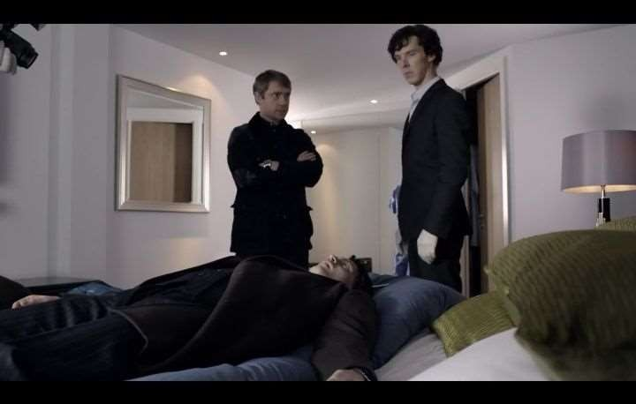
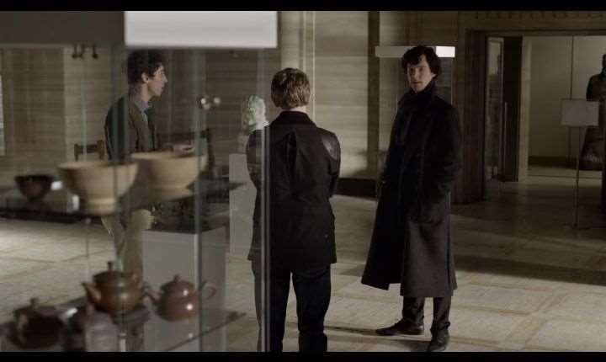

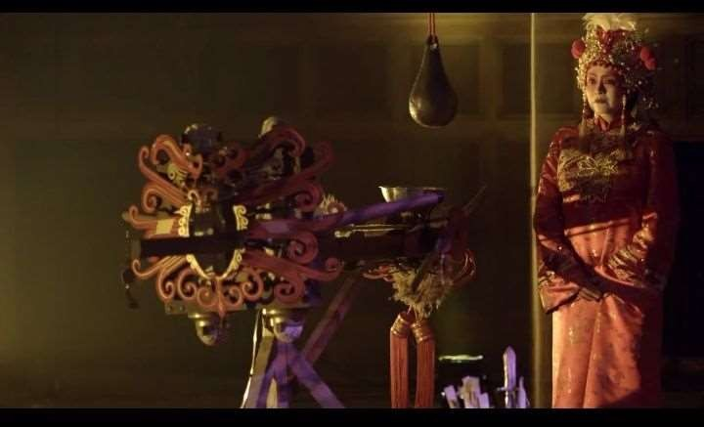

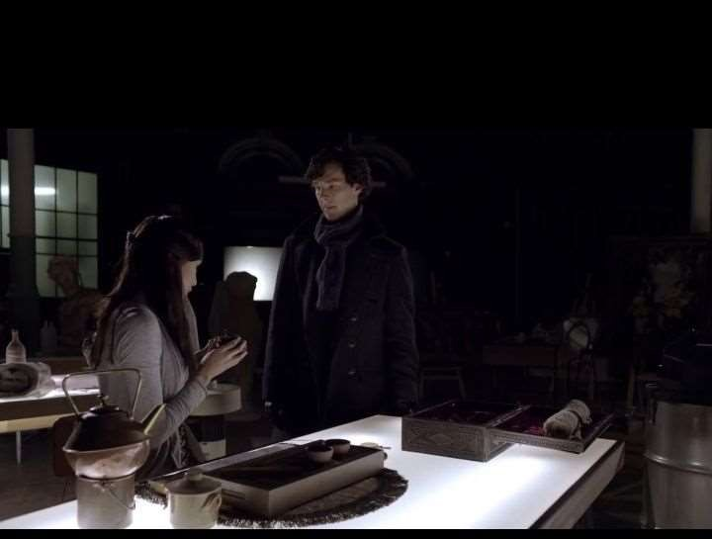

- Remember all the characters in the series and complete the table:

Сharacter | Аppearance | Тemper | Рrofession | Your attitude
Mycroft
Soo Lin Yao
Inspector Dimmock
Amanda
Sarah

Find out whom the following words belong to:
1.…………………&…………………

-And what happened about that case you were offered.
- The Jaria diamond? - Not interested. I sent them a message.
-Don't worry about me, I can manage.- Is that my computer?
- Of course.
- What?
- Mine was in the bedroom.
-What? And you couldn't be bothered to get up? It's password protected.
-In a manner of speaking. Took me less than a minute to guess yours, not exactly Fort Knox.
-Right. Thank you.

2.…………………&…………………

-We don't know that it was suicide.
- Come on. The door was locked from the inside, you had to climb down the balcony.
-Been away three days judging by the laundry. Look at the case, there was something tightly packed inside it.
- Thanks. I'll take your word for it.
- Problem?
-Yeah, I'm not desperate to root around some bloke's dirty underwear.
-Those symbols at the bank, the graffiti, why were they put there?
- Some sort of code?
- Obviously. Why were they painted? Want to communicate, why not use e-mail?
-Well, maybe he wasn't answering.
-Oh, good, you follow.

3.…………………&…………………

-Centuries old. Don't want to break that. Hello.
-You saw the cipher. Then you know he is coming for me.
-You've been clever to avoid him so far.
-I had to finish. To finish this work .It's only a matter of time. I know he will find me.
-Who is he? Have you met him before?
-When I was a girl, we met in China. I recognised his signature.
- The cipher?
-Only he would do this. Zhi Zhu.
- Zhi Zhu?
- The spider.
-You know this mark?
-Yes. It's the mark of a Tong.
- Huh? - Ancient crime syndicate, based in China.

4.…………………&…………………

- What are you thinking? Pork or pasta?
- Oh, it's you.
-I suppose it's never going to trouble Egon Ronay, is it? I'd stick with the pasta. Don't want to be doing roast pork, not if you're slicing up cadavers.
-What are you having?
-I don't eat when I'm working. Digesting slows me down.
-So you're working here tonight?
- Need to examine some bodies. Eddie Van Coon and Brian Lukis.
-They're on my list.
-Could you wheel them out again for me?
-Well their paperwork's already gone through.
- You changed your hair. The style. It's usually parted in the middle.
-Yes, well...

Match the following words with the characters whom they belong to:

  - Sherlock
  - Dr. Watson
  - Soo Lin Yao
  - Dimmock
  - Sarah Sawyer
  - The opera singer (general Shan)
  - Amanda
- Please, please. Listen to me. I’m not Sherlock Holmes. You have to believe me.
- When I was a girl, we met in China. I recognized his signature.
- The book, John. The book. The key to cracking the cipher.
- You and John, you solve puzzles for a living.
- A book is like a magic garden, carried in your pocket.
- Look, it wasn’t serious between us. It was over in a flash, it couldn’t last. He was my boss.
- You’re not serious?! Like Spider-Man?

Match the following words with their description:

  - Smuggler
  - Heard
  - Bond
  - Jade
  - Pin
  - Threaten
- a secret warehouse
- a type of a text
- to say that you will cause someone harm or trouble if they do not do what you want
- a hard, usually green, stone often used to make jewelry
- someone who takes something illegally from one country to another
- a written agreement to do something, that makes you legally responsible for doing it

- Grab
- Resign
- Mundane
- Peckish
- Arrogant
- Puppet

- earthy
- get a job
- humble
- set free
- real
- sated

Write your impression of the episode. (10 sentences)

- Answer the following questions:

- What was the first location in the episode?

- What was the name of the potter?

- Where did Sherlock take John?

- What happened there?

- What appeared on the wall?

- Where did Sherlock go then?

- Who was the second victim?

- What united these two crimes?

- What did they find next?

- What job did Watson find?

- What was the name of the criminal ring that killed people?

- What did they do?

- Where did Watson take his girlfriend to?

- What happened there?

- What stolen treasure did he find?

“Sherlock” Season I

Ep. 3: The Great Game

Find out the meaning of the following words:

  - saliva -

  - hard drive -

  - inflict -

  - hellish -

  - trace the call -

  - fishy -

  - sample -

  - contradict -

  - fruitful -

  - rifle -

  - loony -

  - dazzling -

  - obstacle -

  - affirm -

  - make up -

  - postpone -

  - goofy -

  - corpse -

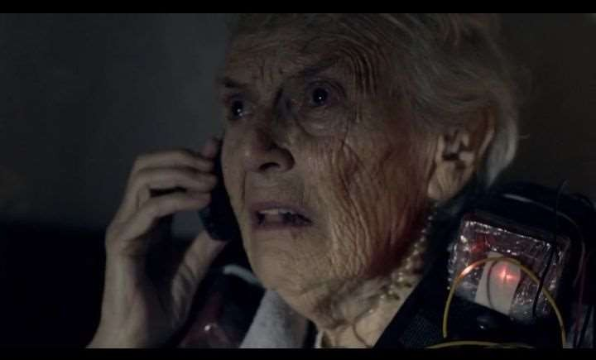
Describe the following episode:

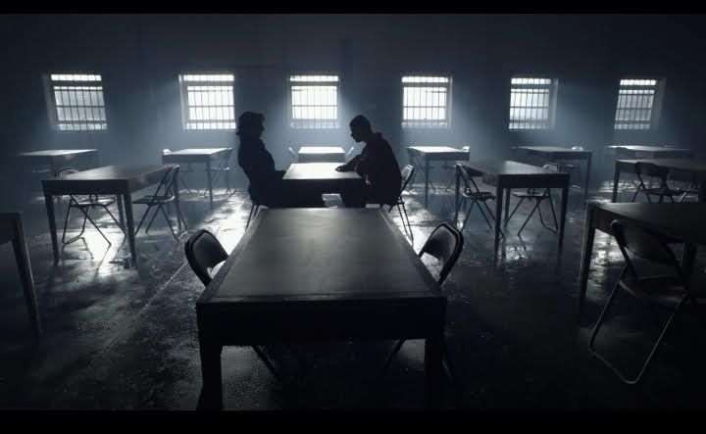

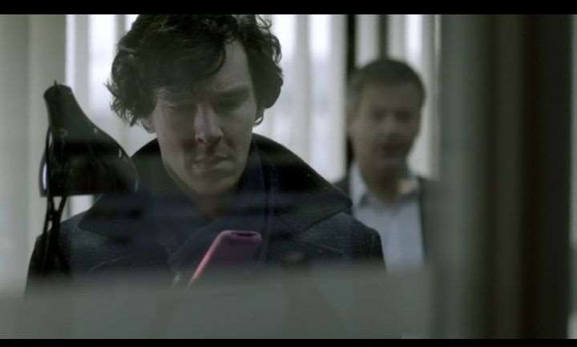

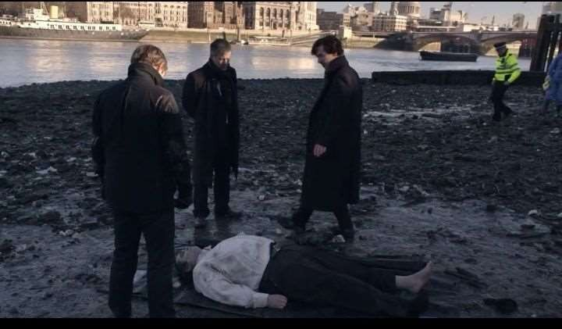

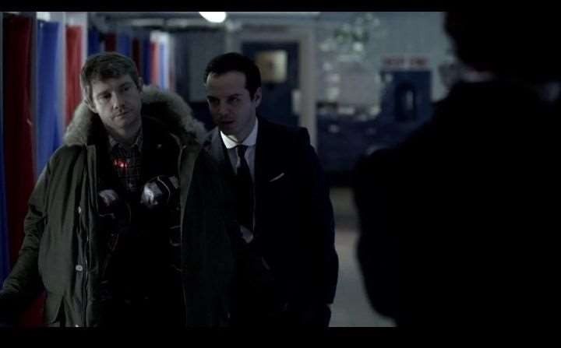

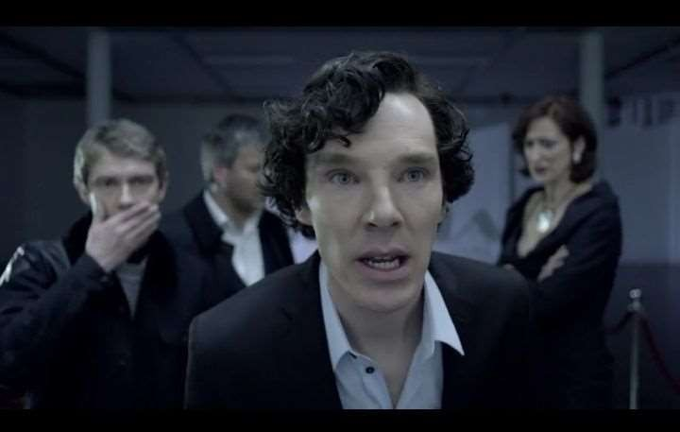

Find out whom the following words belong to:

1.…………………&…………………
-Oh, they're just a pair of shoes. Trainers!
-Good.
-They're in good nick. I'd say they were pretty new, except the sole has been well worn, so the owner must have had them for a while. Er, very '80s. Probably one of those retro designs.
-You're on sparkling form. What else?
-They're quite big. A man's.
-But there's traces of a name inside in felt-tip.
-Adults don't write their names inside their shoes, so these belong to a kid.
-Excellent. What else?
- That's it.

2.…………………&…………………

-Hello.
-The clue's in the name - Janus Cars.
-Why would you be giving me a clue?
-Why does anyone do anything? Because I'm bored. We were made for each other, Sherlock.
- Then talk to me in your own voice.
- Patience.

3.…………………&…………………

-Yes! Ooh, yes!
-You think it was the cat. It wasn't the cat.
-What? Yes. Yeah, it is.
-It must be. It's how he got the tetanus into her system. Its paws stink of disinfectant.
- Lovely idea.
-No, he coated it onto the claws of her cat. It's a new pet, bound to be a bit jumpy around her. A scratch is almost inevitable. She wouldn't...
-I thought of it the minute I saw the scratches on her arm, but it's too random and too clever for the brother.
-He murdered his sister for her money.
- Did he?
- Didn't he? Nope. It was revenge.

- Rev...? Who wanted revenge?
- Raoul, the house boy. Kenny Prince was the butt of his sister's jokes week in, week out.

4.…………………&…………………

-Don't you have something to do?
-Just admiring the view.
-Yes. Lovely. Now go back to work - we open tonight.
- Doesn't it bother you?
-That the painting's a fake. It's a fake. It has to be. It's the only possible explanation. You are in charge, aren't you, Miss Wenceslas?
-Who are you?
-Alex Woodbridge knew that the painting was a fake, so somebody sent the Golem to take care of him. Was it you?
-Golem? What the hell are you talking about?
-Are you working for someone else? Did you fake it for them? It's not a fake.
-It is a fake.

5.…………………&…………………

-Oh, did I really make such a fleeting impression? But then, I suppose, that was rather the point. Don't be silly. Someone else is holding the rifle. I don't like getting my hands dirty. I've given you a glimpse, , just a teensy glimpse of what
I've got going on out there in the big bad world. I'm a specialist, you see. Like you.
-Dear….please will you fix it for me to get rid of my lover's nasty sister? Dear …., please will you fix it for me to disappear to South America?

Match the following words with the characters whom they belong to:

- Sherlock
- Dr. Watson
- Jim Moriarty
- Mycroft
- Mrs. Monkford
- Molly Hooper
- Mrs. Wenceslas
- What do you mean, gay? We’re together.
- Well, there was never any real contact. Just messages, whispers.
- My patience is wearing thin.
- Sorry, boys. I’m so changeable!
- Bought you a little getting-to-know-you present. That’s what it’s all been for, isn’t it? All your little puzzles, making me dance. All to distract me from this.
- Sorry... My husband has been depressed for months. Who are you?
- If your sniper pulls that trigger, MrMoriarty, then we both go up.

Match the following words with their description:

  - Tetanus
  - Pal
  - Geek
  - Affair
  - Revenge
  - Lark
- a secret sexual relationship between two people, when at lea stone of the miscarried to someone else
- a close friend
- something that you do to amuse yourself or as a joke
- something you do in order to punish someone who has harmed or offended you
- the prolonged contraction of a muscle caused by rapidly repeated stimuli
- someone who is not popular because they wear unfashionable clothes, do not know how to behave in social situations, or do strange things

- Fruitful
- Puton
- Flatter
- Naughty
- Corpse
- Traitor

- obedient
- a true man
- unsuccessful
- stringency
- an alive man
- slim

Write your impression of the episode using at least 3 of the words above. (10 sentences)

- Answer the following questions:

- What does Sherlock do in the beginning?

- What happens on Baker Street in the beginning?

- What is in the fridge?

- What happens to their apartment then?

- What happens afterwards?

- How did Sherlock get the messages?

- What was the first message?

- What does Molly Hooper do?

- What was the second message?

- What was the third message?

- What was the fourth message?

- Who was the last –potential- victim?

- What happens in the end?

“Sherlock” Season II

Ep. 1: A Scandal in Belgravia

Describe the following episode:
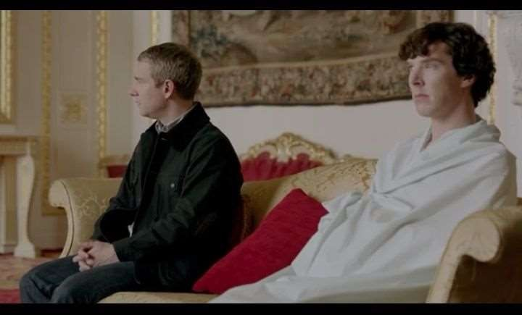
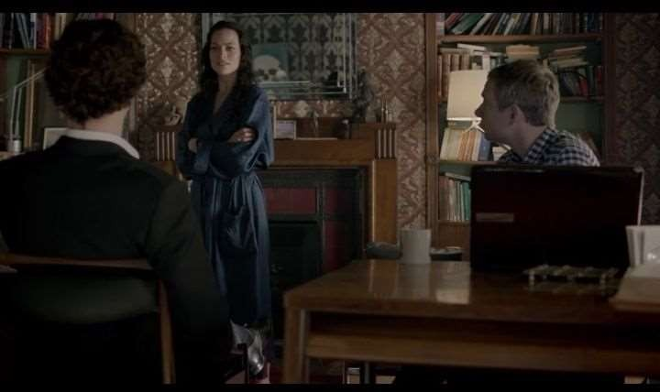

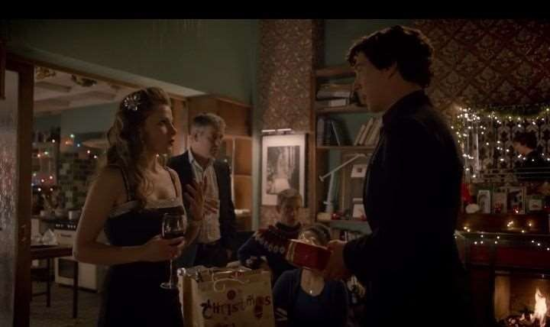

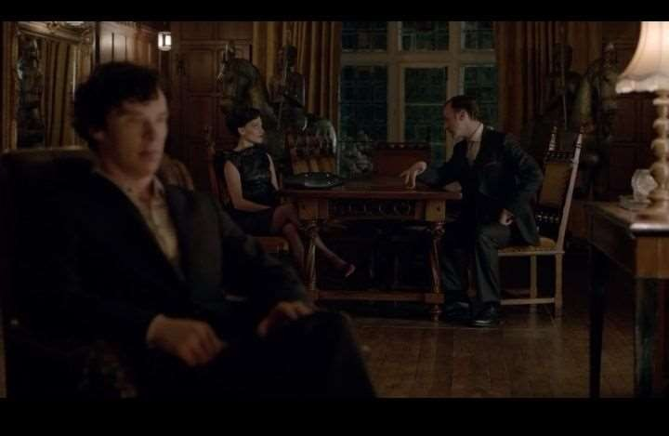

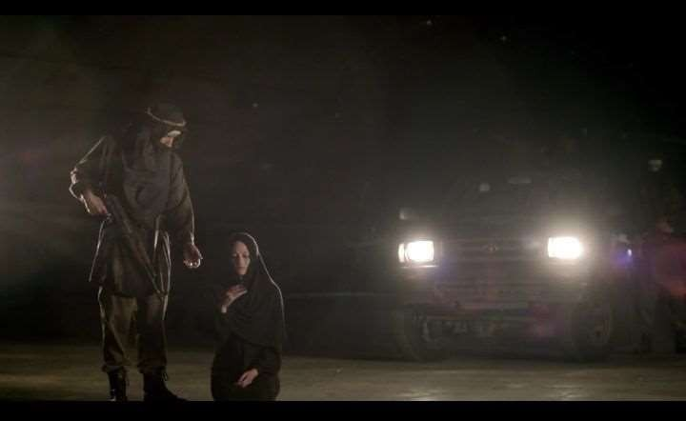

Find out the meaning of the following words:

  - Blunt -

  - self-esteem -

  - hold out -

  - transparent -

  - tremendous -

  - crutch -

  - sub-text -

  - disguise -

  - sequence -

  - arduous -

  - antlers -

  - bashed-up -

  - tar -

  - blur -

  - neat -

  - elevated -

  - impede -

  - hart-warming -

Find out whom the following words belong to:

1………………………..&.....................................

-Consulting criminal.
-'I have loved this, this little game of ours. '
-People have died.
-That's what people DO!'
-' I will stop you.'
-If you don't stop prying I'll burn you. I will burn the heart out of you.
-Catch you later.
-No, you won't! Sorry, boys! I'm SO changeable! It is a weakness with me, but to be fair to myself, it is my only weakness. You can't be allowed to continue. You just can't.
I would try to convince you, but everything I have to say has already crossed your mind.
-Probably my answer has crossed yours.

2.………………………..&.....................................

-Make sure he doesn't choke on his own vomit, it makes for a very unattractive corpse.
-What's this? What have you given him? Sherlock?
-He'll be fine. I've used it on loads of my friends.
-Sherlock, can you hear me?
-You know, I was wrong about him. He did know where to look.
-For what? What are you talking about?
-The key-code to my safe. What was it?
-Shall I tell him? My measurements.

3.………………………..&.....................................

-The photographs are perfectly safe. In the hands of a fugitive sex worker?
-She's not interested in blackmail. She wants protection, for some reason. I take it
you've stood down the police investigation into the shooting at her house?
-How can we do anything while she has the photographs? Our hands are tied.

-She'd applaud your choice of words. You see how this works? The camera-phone is her get out of jail free card. You have to leave her alone. Treat her like royalty.
-Though not the way she treats royalty.

4.………………………..&.....................................

-Listen, has he ever had any kind of girlfriend, boyfriend, a relationship, ever?
-I don't know.
-How can we not know?
-He's Sherlock. How will we ever know what goes on in that funny old head?

5………………………..&.....................................

-I make my way in the world, I misbehave like to know people will be on my side exactly when I need them to be.
-So how do you acquire this information?
-I told you I misbehave.
-But you've acquired something more danger than protection. Do you know what it is?
-Yes…but I don't understand it.
-I assumed. Show me. The passcode. It's not working.
-No, because it's a duplicate I had made into which you just entered the numbers 1058.I assumed you'd choose something more specific than that, but thanks, anyway.
-I told you that camera-phone was my life. I know when it's in my hand.
-You're rather good.

Match the following words with the characters whom they belong to:

- Sherlock
- Dr. Watson
- Moriarty
- Iren Adler
- Greg Lestrade
- Mycroft Holmes
- Mrs. Hudson
- Oh, um, sorry to disturb you. Um, I’ve just been attacked. Um, and I think they took my wallet and um, and my phone. Um, please, could you help me?
- There was a plane crashing Dusseldorf yesterday. Everyone dead.
- Oh, dear! Thumbs?
- I wasn’t even at home yesterday, I was in Dublin.
- Look at those cheekbones. I could cut myself slapping that face.
- You’ve been very thorough. I wish our lot were half as good as you.

a) I’ll burn you. I will burn the heart out of you.

5. Match the following words with their description:

- Pattern
- Self-esteem
- Audacious
- Mastermind
- Transparent
- Marginally
- Someone who plans and organizes a complicated operation, especially a criminal operation.
- Not enough to make an important difference
- The regular way in which something happens, develops, or is done
- Showing great courage or confidence in a way that is impressive or slightly shocking
- You can see through it
- The feeling of being satisfied with your own abilities, and that you deserve to be like do respect.

- Prominent
- Precaution
- Despise
- Thrive
- Posh
- Havoc
- Nameless
- Decline
- Order
- Respect
- Miserable
- Negligence

Write your impression of the episode using at least 3 of the words above. (10 sentences)

- Answer the following questions:

- What changed Moriarty’s mind about killing Sherlock and Watson?

- How did Sherlock become a celebrity?

- Where did Mycroft take Sherlock and Watson?

- What is The Woman’s real name?

- Where did Sherlock and Watson go to find The Woman?

- What did she do to escape?

- What happened on Christmas Eve?
_
- How did Sherlock get her phone?

- What was the password?

- What happened on the plane?

- Why couldn’t Sherlock just crack the phone open?

- What did Watson tell Sherlock, to cover up her death?

- What happens in the end?

“Sherlock” Season II

Ep. 2: The Hounds of Baskerville

Find out the meaning of the following words:

  - moor -

  - bleak -

  - fur -

  - assume -

  - show-off -

  - desperate -

  - reshuffle -

  - envy –

  - mop up -

  - snorer -

  - reckon -

  - collar -

  - vicious -

  - peaky -

  - immense -

  - luminous -

  - handy -

  - hilarious -

Describe the episode, using words from Activity 1:

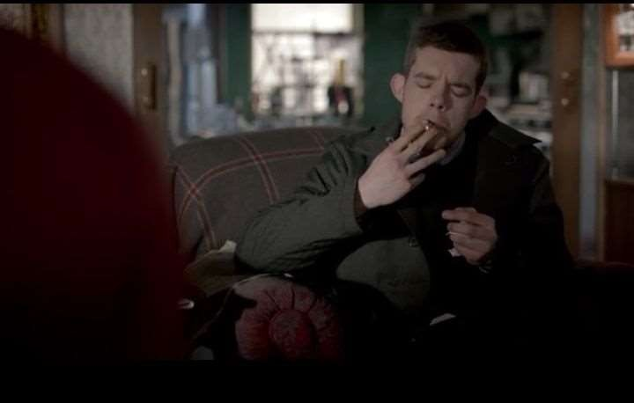

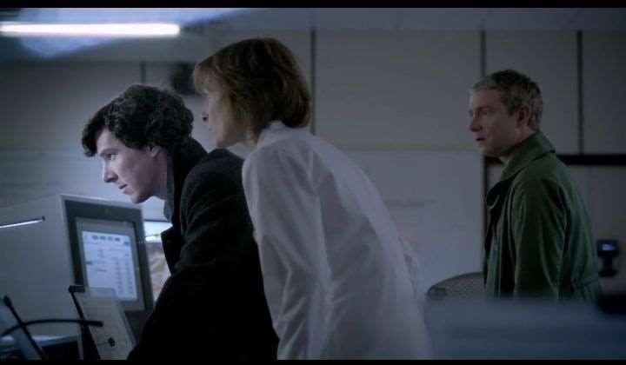

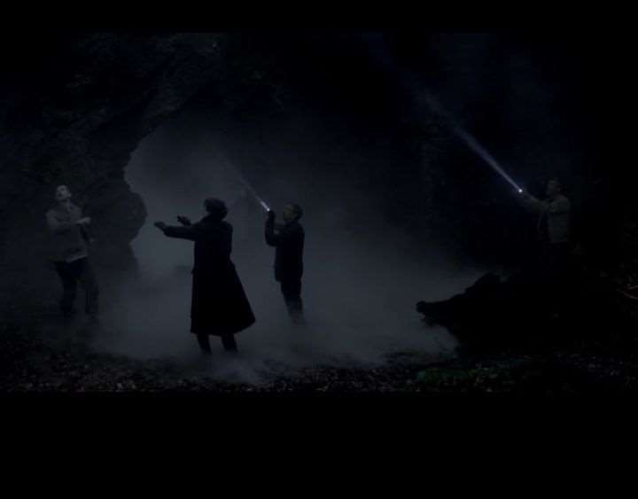

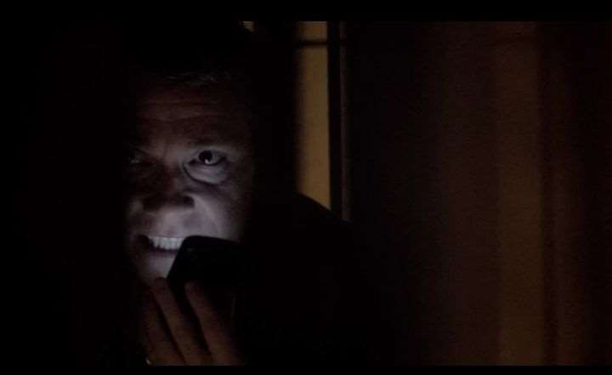

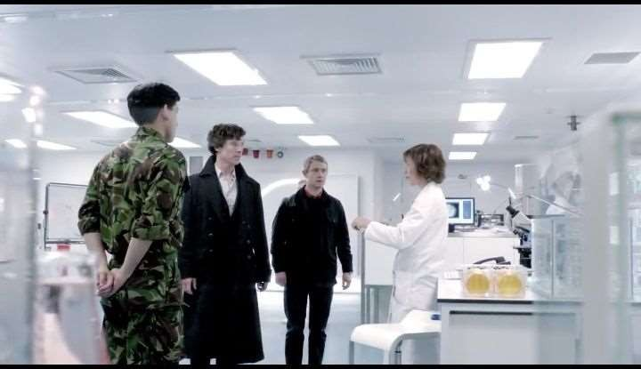

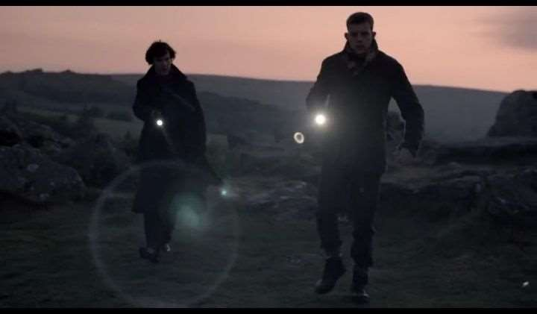

Find out whom the following words belong to:

1………………………..&.....................................

-My secret supply, what have you done with my secret supply? Cigarettes, what have you done with them?
-You never let me touch your things! Chance would be a fine thing.
-I thought you weren't my housekeeper.
-I'm not. How about a nice cuppa and perhaps you could put away your harpoon?
-I need something stronger than tea. Seven percent stronger. You've been to see Mr. Chatterjee again.
- Pardon?
-Sandwich shop. That's a new dress, but there's flour on the sleeve. You wouldn't dress like that for baking. Tiny traces of foil. Been at the scratch cards again. We all know where that leads.

2.………………………..&.....................................

-More wine, doctor?
-Are you trying to get me drunk, doctor?
-The thought never occurred.
-Because a while ago I thought you were chatting me up.
-Where did I go wrong?
-When you started asking about my patients.
-Well, I am one of Henry's oldest friends.
-Yeah, and he's one of my patients, so I can't talk about him. Although he has told me about all his oldest friends. Which one are you?
- A new one? OK, what about his father? He wasn't one of your patients. Wasn't he some sort of conspiracy nutter theorist?
-You're only a nutter if you're wrong.
-And was he wrong?
-I should think so.
-But he got fixated on Baskerville, didn't he? With what they were doing in there.

3.………………………..&.....................................

-I'm so sorry, Dad.
-No, ….., no, no! Get back!
-Get away from me! Easy, Henry, easy. Just relax. I know what I am, I know what I tried to do.
-Just put the gun down, it's OK.
-No, no! I know what I am!
-Yes, I'm sure you do.
-It's all been explained to you, hasn't it? Explained very carefully. Someone needed to keep you quiet, needed to keep you as a child, to reassert the dream you both clung on to, because you had started to remember. Remember now, , you've got to remember
what happened here when you were a little boy.
-I thought it had got my dad. The hound. I thought... Jesus! I don't I don't know any
more! I don't!
-For God's sake . Remember. "Liberty In." Two words .Two words a frightened little boy saw here 20 years ago. You'd started to piece things together. Remember what happened here that night. It wasn't an animal, was it, Henry? Not a monster. A man

4.………………………..&.....................................

-Henry's right.
-What?
-I saw it, too.
-Just just a minute, you saw what?
-A hound. Out there in the Hollow. A gigantic hound.
-Look, , we have to be rational about this. OK, now you, of all people, can't
just Let's just stick to what we know, yes? Stick to the facts.
-Once you've ruled out the impossible, whatever remains, however improbable, must be true.
-What does that mean?
-Look at me, I'm afraid. Afraid.

Match the following words with the characters whom they belong to:

- Sherlock
- John Watson
- Mrs. Hudson
- Dr.Frankland
- Corporal Lyons
- Henry Knight
- Jacqui Stapleton
- I have a lot of finger sin a lot of pies. I like to mix thing sup. Genes, mostly.
- It’s a couple of words. That’s what I keep seeing. “Liberty”.
- There was a dog, Henry. Leaving footprints, scaring witnesses. But it was nothing more than an ordinary dog. We both saw it.
- Mmm, listen, what happened to me in the lab?
- Ah, new faces! How nice. Careful you don’t get stuck here, though. I only came to fix a tap.
- One war ends, another begins, sir. New enemies to fight. We have to be prepared.

- Luminous
- Assume
- Hound
- Snore
- Reckon
- Coincidence

- to think that something is true, although you do not have definite proof
- to breathe in a noisy way through your mouth and nose while you are asleep
- when two things happen at the same time, in the same place, or to the same people in a way that seems surprising or unusual
- shining in the dark
- a dog that is fast and has a good sense of smell, used for hunting
- to think or suppose something

Match the following words with their description:

  - Tremendously
  - Omit
  - Cuffs
  - Glow
  - Compassion
  - Peaky
- Consider
- Darkness
- Obtuse
- Usually
- Indifference

Write your impression of the episode using at least 3 of the words above. (10 sentences)

- Answer the following questions:
  - What did the client tell Sherlock and Watson?

  - Where did they go then?

  - How did they get inside of the research base?

  - What happened at the base?

  - What words did Henry see in his dreams?

  - What did the vegetarian restaurant order?

  - What happened to Watson when they returned to the base?
_
  - How did Sherlock rescue him?

  - What did the words Henry saw in his dreams mean?

  - What did the word “hound” mean?

  - Where was the poison?

  - What did the antagonist do to himself?

  - What happened in the hollow?

“Sherlock” Season II

Ep. 3: The Reichenbach Fall

1. Find out the meaning of the following words:

- Proceed -

- Trial -

- Plea -

- Appalled -

- worm(verb) -

- rogue -

- riddle -

- trolley -

- relocate -

- spit -

- resentment -

- vanish -

- welfare -

- break-in -

- intruder -

- eloquent -

- warrant -

- queue up -

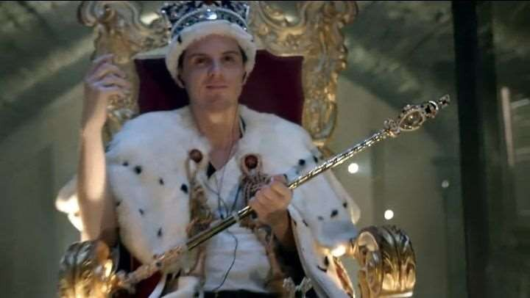

2. Describe the episode, using words from Activity 1:

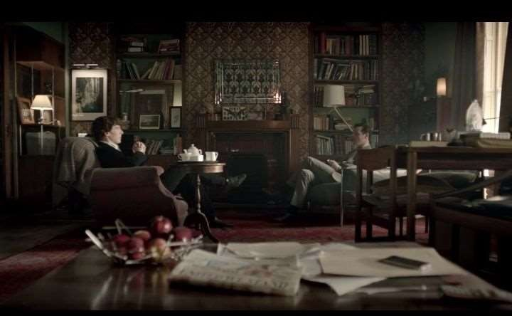

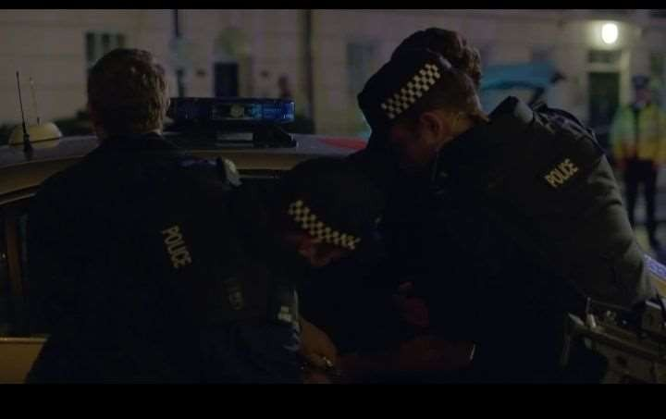

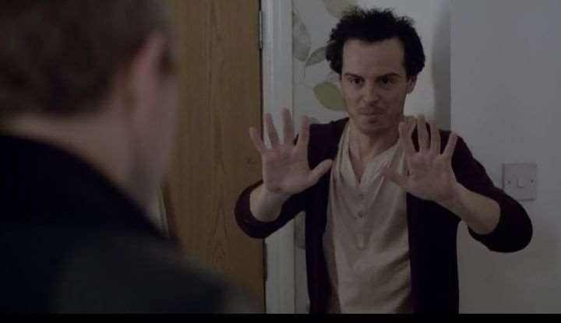

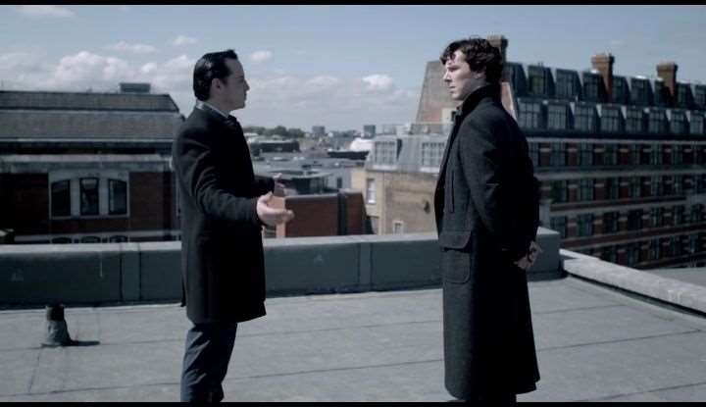

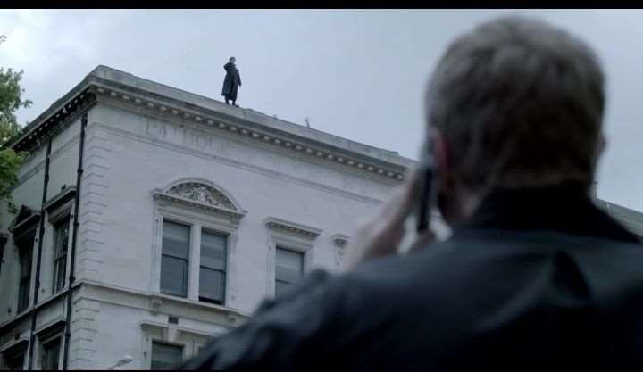

Find out whom the following words belong to:

1..………………………..&.....................................

-Why today?
-Do you want to hear me say it?
-18 months since our last appointment.
-You read the papers?
-Sometimes...
-And you watch telly? You know why I'm here. I'm here because...
-What happened, John?
-Sherl…My best friend...Sherlock Holmes...is dead. 2.………………………..&.....................................
-Hello, I'm just going out.
-No, you're not. I've got a lunch date.
-Cancel it, have lunch with me. I need your help.
-One of your old boyfriends, we're tracking him down.
-Jim wasn't my boyfriend, we went out three times. I ended it.
-Then he stole the Crown Jewels, broke into the Bank of England and organized a prison break. For the sake of law and order, I suggest you avoid all future attempts at a relationship,

3..………………………..&.....................................

-Have you seen your brother's address book lately? Two names... yours and mine and Moriarty didn't get this stuff from me.
- So how does it work, your relationship?
-Do you go out for a coffee now and then, you and Jim? Your own brother and you blabbed about his entire life to this maniac.
-I never intend... I never dreamt...
-This this is what you were trying to tell me, isn't it? Watch his back because I've made a mistake. How did you meet him?
-People like him, we know about them, we watch them. But James Moriarty. 4..………………………..&.....................................
-Well... here we are at last. You and me. And our problem the final problem. Staying alive! It's so boring, isn't it? It's just
staying. All my life I've been searching for distraction sand you were the best distraction and now I don't even have you because I've beaten you. And you know what? In the end, it was easy.
Now I've got to go back to playing with the ordinary people, and it turns out you're ordinary, just like all of them. Well. Did you almost start to wonder if I was real? Did I nearly get you?
-Richard Brook.
-Nobody seems to get the joke, but you do.
-Of course. Richard Brook in German is Reichenbach.
-The case that made my name.
-Just trying to have some fun.

Match the following words with the characters whom they belong to:

  - Sherlock
  - Dr. Watson
  - Jim Moriarty
  - Molly Hooper
  - Kitty Riley
  - Sally Donovan
  - Mycroft Holmes
- Eighteen months since our last appointment.
- I’m here because... Sher... My best friend, Sherlock, is dead.
- Sir, there’s been a break-in.
- You’re him. I’m a big fan. I read your cases. Follow the mall. Sing on my shirt, would you?
- What I’m trying to say is that if there’s anything I can do, anything you need, any thing at all, you can have me.
- Sulejmani. Albanian hit squad. Expertly trained killer, living less than 20 feet from your front door.
- Every fairytale needs a good old-fashioned villain.

Match the following words with their description:

  - Smudge
  - Appall
  - Trolley
  - Linseed
  - Comprise
  - Stunning
- a small table on wheels used for serving food
- to consist of particular parts, groups etc
- a dirty mark
- the seed of the flax plant
- extremely attractive or beautiful
- to make someone feel very shocked and upset

- Fetch
- Survive
- Nemesis
- Distraction
- Apology
- Contempt

- Concentration
- Respect
- Die
- Conviction
- Inaction
- Remuneration

Write your impression of the episode using at least 3 of the words above. (10 sentences)

- Answer the following questions:
- What event was shown in the beginning of the episode?

- Where did Moriarty break in?

- How did Moriarty escape the prison?

- Who moved next to Sherlock and Watson?

- Who was the girl that got scared by Sherlock?

- Where was Moriarty hiding?

- What did Watson learn from his phone call at the lab?

- How did Moriarty kill himself?

- What did Sherlock say to Watson on the phone?

- How did Sherlock die?

- What was Watson’s reaction to his death?

- Who was Watson telling about this to?

- What happens in the end?

“Sherlock” Season III

Ep. 1: The Empty Hearse

Find out the meaning of the following words:

  - Hearse -

  - Ridiculous -

  - Quiver -

  - Chatter -

  - Delighted -

  - Contraction -

  - Exceptionally -

  - Gaze -

  - rub off -

  - odd -

  - misplaced -

  - assurance -

  - alert -

  - irresistible -

  - halitosis -

  - adhering -

  - mawkish -

  - exceed -

Describe the episode, using words from Activity 1:

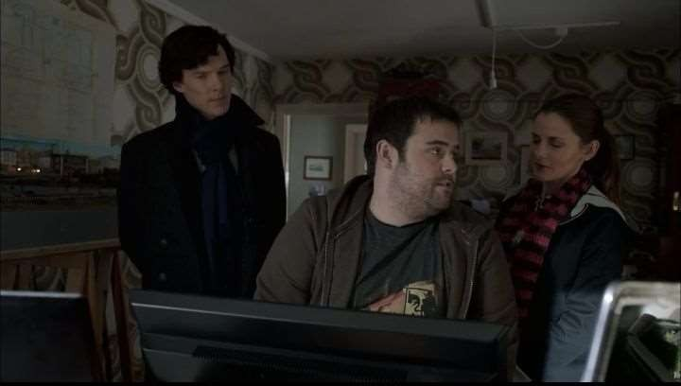

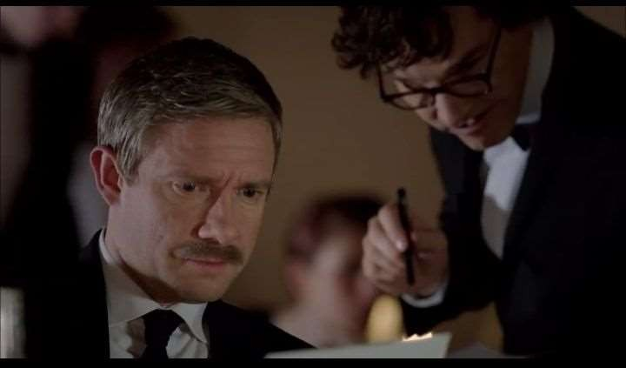

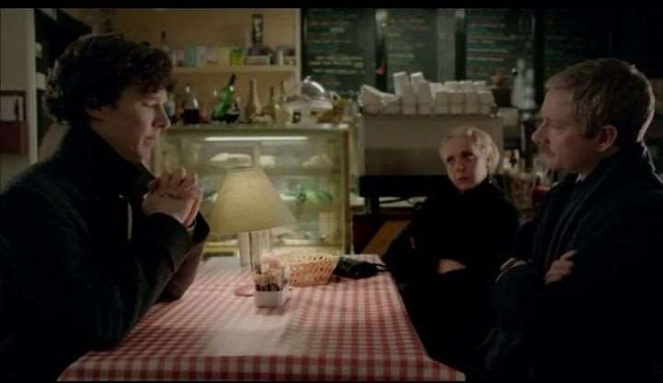

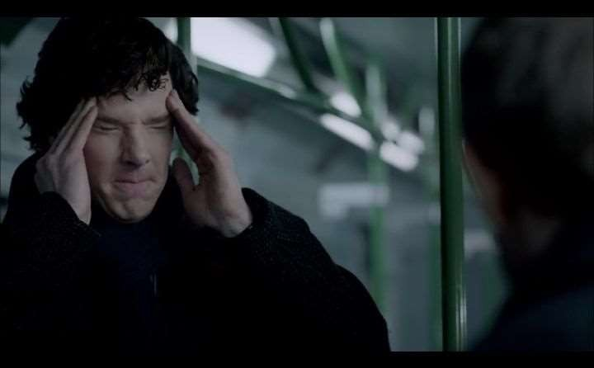

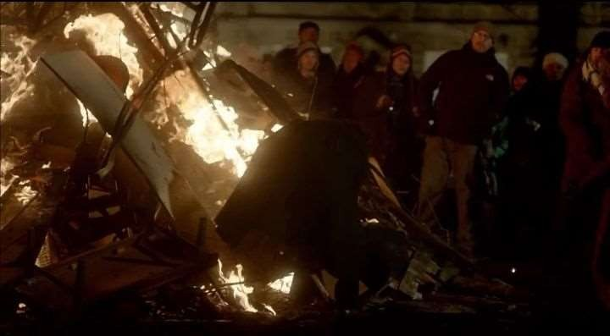

Find out whom the following words belong to:

1.………………………..&.....................................

-You have been busy, haven't you? Quite the busy little bee. Hmm.
-Moriarty's network. Took me two years to dismantle it.
-And you're confident you have?
-The Serbian side was the last piece of the puzzle.
-Yes. You got yourself in deep there with Baron Maupertuis. Quite a scheme. Colossal. Anyway. You're safe now. A small "thank you" wouldn't go amiss.
-What for?
-For wading in.

2.………………………..&.....................................

-Can I help you with anything, sir?
-Hi, yeah, I'm looking for a bottle of champagne. A good one.
-Hmm, well, these are all excellent vintages, sir.
-Oh, it's not really my area ,what do you suggest?
-Well, you cannot possibly go wrong, but if you'd like my personal recommendation...
Hmm? This last one on the list is a favourite of mine. It is, you might in fact say, like a face from the past.
-Great. I'll have that one please.

3………………………..&.....................................

-I don't understand, I said I'm sorry, isn't that what you're supposed to do?
-Gosh, you don't know anything about human nature, do you?
-Hmm, nature? No. Human? No.
-I'll talk him round.
-You will?
-Oh, yeah.

4………………………..&.....................................

-Why didn't you call the police?!Can you just...? Why do you never call the police?!
-Well, it's no use now.
-So you can't switch the bomb off?!You can't switch the bomb off and you didn't call the police!
-Go, John. Go now!
-There's no point now, is there, because there's not enough time to get away and if we don't do this, other people will die!

5.………………………..&.....................................

-How you jumped off that building and survived?
-You know my methods, John, I am known to be indestructible.
-No, but seriously. When you were dead, I went to your grave.
-I should hope so.
-I made a little speech. I actually spoke to you.

Match the following words with the characters whom they belong to:

- Sherlock Holmes
- John Watson
- Mycroft Holmes
- Mrs. Hudson
- Molly Hooper
- Mary
- Howard Shilcott
- One word, Sherlock, that is all I would have needed! One word to let me know that you were alive.
- But just one phone call, John! Just one phone call would have done.

- I agree. I’m the best thing that could have happened to you.
- I find nothing irresistible in the hat of a well-traveled anxious, sentimental, unfit creature of habit with appalling halitosis.
- I work on the Tube, on the District Line, and part of my job is to wipe security footage after it’s been cleared.
- He’s nice, we’ve got a dog, we, we go to pub on weekends and I’ve met his mum and dad and his friends and all his family. I’ve no idea why I’m telling you any of this…
- I hope you’ll be very happy, Molly Hooper. You deserve it.

Match the following words with their description:
1. | Sociopath | a) | a description, story etc that is lurid is
2. | Eventually |  | deliberately shocking and involves sex or
3. | Demolition |  | violence
4. | Vast | b) | someone whose behaviour towards other
5. | Lurid |  | people is considered unacceptable,
6. | Fraud | c)  d)  e)  f) | strange, and possibly dangerous  a process in which something is ended or ruined completely  the crime of deceiving people in order to gain something such as money or goods after a long time, or after a lot of things have happened  after a long time, or after a lot of things have happened
1. | Dismantle | a) | Inhabitant
2. | Endeavor | b) | Pleasant
3. | Tramp | c) | Compose
4. | Plausible | d) | Unbelievable
5. | Mawkish | e) | Unobtrusive
6. | Obsessive | f) | Inactivity

- Write your impression of the episode using at least 3 of the words above. (10 sentences)

Answer the following questions:
  - What was the name of Watson’s new girlfriend?

  - Where did Sherlock hide in the beginning?

  - What was the celebration, in which Watson was almost killed?

  - What text did Watson’s girlfriend receive?

  - How did the underground train carriage vanish?

  - How did Sherlock dissolve Moriarty’s network?

  - How many scenarios of his “death” did Sherlock plan?

  - How did he survive falling from the roof?

  - Why did Sherlock tell Watson about his feelings towards him? (in the tube)

  - How did Sherlock defuse the bomb?

  - Did Watson eventually propose to his girlfriend?

  - How did Watson end up on fire?

  - What happens in the end?

“Sherlock” Season III

Ep. 2: The Sign of Three

Find out the meaning of the following words:
  - Newlyweds -

  - Obligatory -

  - Ginger -

  - Usher -

  - Regardless -

  - current -

  - excluded -

  - acquaintance -

  - presence -

  - starve -

  - odor -

  - indicate -

  - complexion -

  - recluse -

  - bouncing -

  - troop -

  - legitimate -

  - regiment -

Describe the episode, using words from Activity 1:

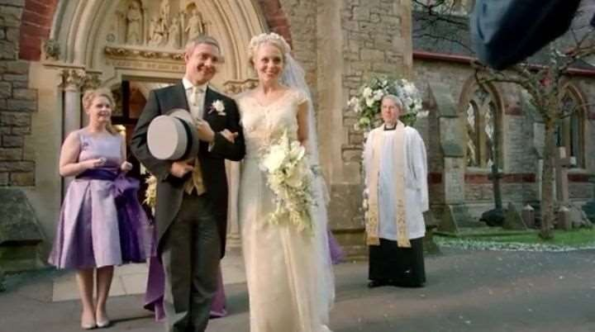
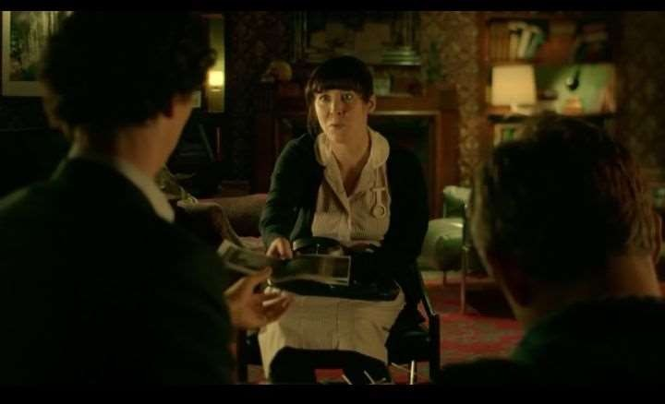

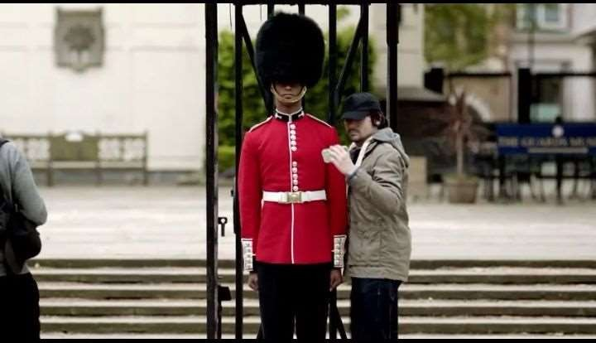

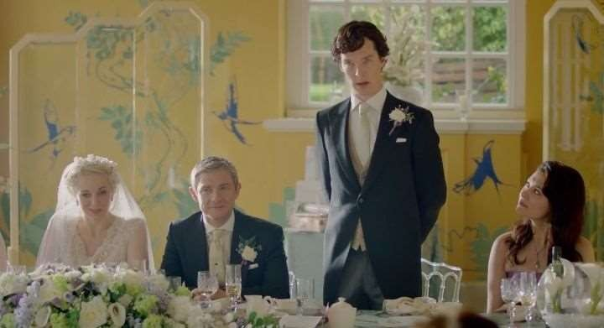

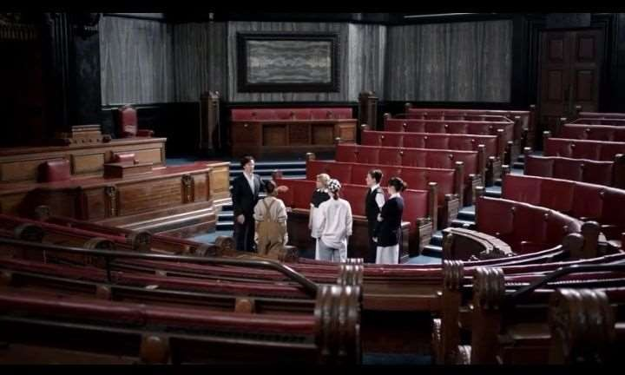

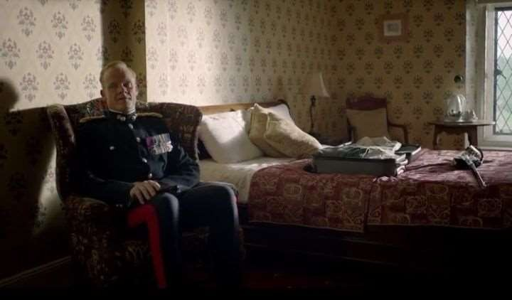

Find out whom the following words belong to:

1.………………………..&.....................................

-They just walked out of there!
-Yeah, I know, I was sort of sitting next to you.
-The whole Waters family. They just walked right out of there!
-Again, I was in the room.
- How do they always manage that?!
-They're good.
-They're greedy and they'll do it again ,and next time we're going to catch them in the act.

2.………………………..&.....................................

-Shut up, ………
-I haven't said a word.
-You're formulating a question, it's physically painful watching you think.
-I thought it was you playing.
-It was me playing. I am composing. Why are you here?
-I'm bringing you your morning tea. You're not usually awake.

3.………………………..&.....................................

-You have a big speech or something, don't you? Cakes, karaoke, mingling.
-This is what people do, k. They get married.
-I warned you, don't get involved.
-Involved? I'm not involved. No John asked me to be his best man, how could I say no? Absolutely. I'm not involved.
-I believe you. Have a lovely day and do give the happy couple my best.

4.………………………..&.....................................

-The wedding! John and Mary getting married.
-Two people who currently live together are about to attend church, have a party, go on a short holiday, then carry on living together. What's big about that?
-It changes people, marriage.
-Hmm, no it doesn't.
-Well, you wouldn't understand, cos you always live alone.

5.………………………..&.....................................

-How are you feeling? It's just like old times, having you back here. I thought I'd make your favourite, one last time.
-Oh. Don't sound so final about it, I will be visiting, you know.
-Ooh, I've heard that one before!
-No, it's different now, though, isn't it?
-It's different to when we thought we'd lost him. Well, marriage changes everything.
-Does it?

Match the following words with the characters whom they belong to:

- Sherlock
- John Watson
- Mary
- Tessa
- Mycroft Holmes
- Greg Lestraid
- Sally Donowan
- They’re greedy and they’ll do it again, and next time we’re going to catch them in the act.
- Very efficiently hacked. They must be bloody pleased with themselves.
- No, Sherlock, I will not be coming to the night-do, as you so poetically put in.
- Mary and John, whatever it takes, whatever happens, from now on, I swear I will always be there.
- No, look, this is a famous detective, it’s Sherlock Holmes and his partner, John Hemish Watson.
- But the rehearsal’s not for another two weeks, just calm down.
- “Priceless painting nicked.” Looks interesting.

Match the following words with their description:

  - Coincidence
  - Recruit
  - Vent
  - Construct
  - Cartel
  - Unifying
- to get people to join the army, navy etc.
- a hole or pipe through which gases, liquid etc. can enter or escape from an enclosed space or container
- a group of people or companies who agree to sell something at a particular price in order to prevent competition and increase profits
- when two things happen at the same time, in the same place, or to the same people in a way that seems surprising or unusual
- to build something such as a house, bridge, road etc
- if you unify two or more parts or things, or if they unify, they are combined to make a single unit.

- Complexity
- Possibly
- Bride
- Confess
- Flatter
- Fairness
- Groom
- Simplicity
- Scandalize
- Impossibly
- Conceal
- Injustice

Write your impression of the episode using at least 3 of the words above. (10 sentences)

- Answer the following questions:
  - Why did Sherlock call for help from Lestrade?

  - Why was Sholto living in seclusion?

  - Did Watson eventually save the guard from death?

  - How was the guard stabbed?

  - What did Watson and Sherlock get drunk for?

  - What did Sherlock deduce while being drunk?

  - Who was the killer?

  - What happened to Sholto?

  - How did Sherlock and Watson rescue him?

  - Why did the killer try to kill Sholto?

  - Why did Sholto try to remove his belt?

  - What made Sherlock think Mary was pregnant?

  - What happened in the end?
_
_
_

“Sherlock” Season III

Ep. 3: His Last Vow

Find out the meaning of the following words:

  - influence over -

  - explicit -

  - sprain -

  - intercede -

  - demolish -

  - sort it out -

  - simultaneously -

  - wrap up -

  - habit -

  - repository -

  - sensitive -

  - truly -

  - sprout -

  - ridiculous -

  - rely on -

  - extraordinary -

  - neat -

  - heritage –

Describe the episode, using words from Activity 1:

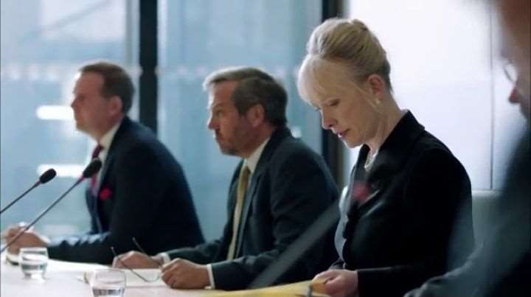

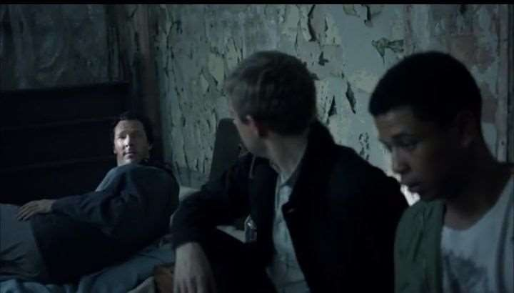

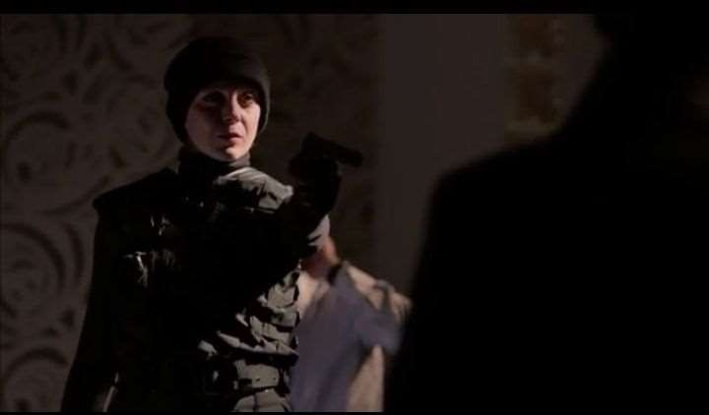

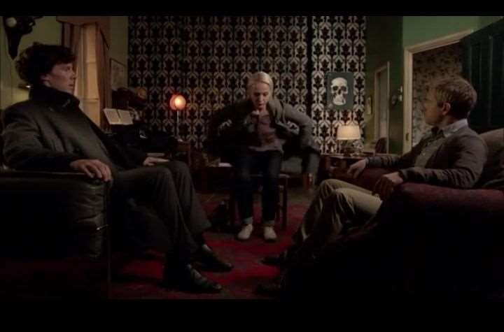

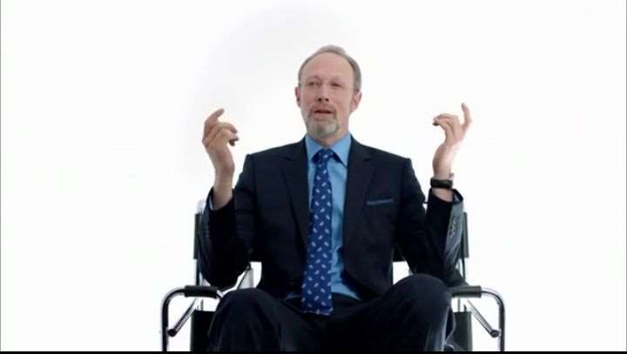

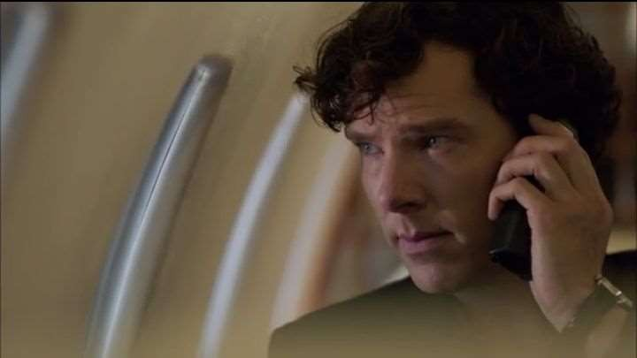

Find out whom the following words belong to:

1.………………………..&.....................................

-In 1982, your husband corresponded with Helen Catherine Driscoll.
-That was before I knew him.
-The letters were lively, loving some would say explicit. And currently in my
possession. Will you please move your hand?
-"I long, my darling, to know the touch of your body."
-I know what was in the letters.
-She was 15.
-She looked older.

2.………………………..&.....................................

-I want to know how good you are. Go on, show me. 'The doctor's wife must be a little bit bored by now. 'May I see?
-Huh, it's a dummy. Well, I suppose that was a fairly obvious trick.
-And yet, over a distance of six feet, you failed to make a kill shot. Enough to hospitalize me, not enough to kill me. That wasn't a miss, that was surgery.
-I'll take the case.
-What case?
-Yours. Why didn't you come to me in the first place?
-Because John can't ever know that I lied to him. It would break him and I would lose him forever.

3.………………………..&.....................................

-You know about mind palaces, don't you, Sherlock? How to store information so you never forget it, by picturing it. I just sit here, I close my eyes and down I go to my vaults. I can go anywhere inside my vaults. My memories. I'll look at the files on Mrs. Watson. Hmm. Oh, this is one of my favorites. Oh, it's so exciting. All those wet jobs for the CIA. Ooh, she's gone a bit freelance now, bad girl. Oh, she's so wicked .I can really see why you like her. You see?
-So there are no documents, you don't actually have anything here?

4.………………………..&.....................................

-The game is over.
-The game is never over. But there may be some new players now. That's OK, the East Wind takes us all in the end.
-What's that?
-It's a story my brother told me when we were kids. The East Wind is a terrifying force that lays waste to all in its path. It seeks out the unworthy and plucks them from the earth. That was generally me.
-Nice(!)
-He's a rubbish big brother.
-So what about you, then? Where are you actually going now?
-Oh, some undercover work in Eastern Europe.
-For how long?
-Six months, my brother estimates. He's never wrong.

Match the following words with the characters whom they belong to:

- Sherlock Holmes
- John Watson
- Mycroft Holmes
- Janine Hokings
- Lady Smallwood
- Charles Magnussen
- Mary

- Mr. Magnussen, how do you describe your influence over the Prime Minister?
- In 1982, your husband corresponded with Helen Katherine Driscoll. The letters were lively, loving, some would say explicit, and currently in my possession.
- Okay, you two bad boys, behave yourselves. You, Sherl, you’re going to have to tell me where you were last night.
- Everything about who I was is on there. If you love me, don’t read it in front of me. Because you won’t love me when you finished. And I don’t want to see that happen.
- And yet, over the distance of six feet you failed to make a kill shot. Enough to hospitalize me, not enough to kill me. That wasn’t a miss. That was surgery.
- Oh, dear God. It’s only 2:00. It’s been Christmas Day for at least a week now. How can it only be 2:00? I’m in agony.
- Sit. Because it’s where they sit. The people who come in with their stories. The clients. That’s all you are now, Mary. You’re a client. This is where you sit and talk and this is where we sit and listen. Then we decide if we want you or not.

Match the following words with their description

  - Befriend
  - Assignment
  - Treason
  - Vault
  - Clarify
  - Scan
- to behave in a friendly way towards someone, especially someone who is younger or needs help
- to make something clearer or easier to understand
- the crime of being disloyal to your country or its government, especially by helping its enemies or trying to remove the government using violence
- to examine an area carefully but quickly, often because you are looking for a particular person or thing
- a piece of work that is given to someone as part of their job
- a room with thick walls and a strong door where money, jewels etc are kept to prevent them from being stolen or damaged

1. Explicit 2. Sprain

- Witless
- Babble
- Drag off
- Underneath
- To talk distinctly
- O’er
- Embed
- Astringe
- Ambiguous

Write your impression of the episode using at least 3 of the words above. (10 sentences)

- Answer the following questions:
  - Where did Sherlock live in the beginning of the episode?

  - Who was Sherlock “dating”?

  - Who did his girlfriend work as?

  - Why did Mary attempt to kill Magnussen?

  - What was the name of Mary’s perfume?

  - Where did Mary and Sherlock meet?

  - Why didn’t Mary shoot Sherlock dead?
_
  - What did Mary tell Sherlock in the hospital?

  - What initials were written on the flash drive Mary gave John?

  - What deal Magnussen offered Sherlock?

  - How did Magnussen die?

  - Where did Magnussen store his “secrets”?

  - What happened in the end?

LITERATURE
    - Arthur Conan Doyle «The Adventure of Sherlock Holmes. Short stories». – Oxford University Press, 1993. – 112 с.
    - Chambers English-Ukrainian Dictionary of Idioms. – Київ: «Все увито», 2002. – 475 с.
    - Encyclopedia Americana. Vol.4, p.91.
    - Longman Dictionary of English Idioms. – 1996. – 387 p.
    - Mark Foley, Diana Hall. Longman Advanced Learners᾽ Grammar. – Longman, 2005. – 384.
    - Redman S. English Vocabulary in Use. Cambridge University Press,1997.
    - Short J. English for Psychology in Higher Education Studies. Course book. Garnet education, 2010.
    - Thomson A.J., Martinet A.V. A Practical English Grammar Exercises 1. Third edition. Oxford University Press, 2014.
    - Haines S., Nettle M., Hewings M. Advanced Grammar in Use Supplementary Exercises. Cambridge University Press, 2007
    - Cotton D., Falvey D., Kent D. Language Leader Course book. Upper intermediate. Pearson, 2013
    - Golman A. Oxford dictionary of Psychology. Oxford Paperback reference, 2009.
14..Mark Foley and Dianne Hall. Longman Advanced Learners’ Grammar.
Pearson Longman, 2010.
- Mark Powell, Simon Clarke with Pete Sharma. In Company. Second Edition. Macmillan Publishers Limited, 2011.

- Peter Strutt. Market Leader. Business Grammar and Usage. Pearson Longman, 2010.
- Roni S.Lebauer. Learn to Listen, Listen to Learn. Academic Listening and Note-Taking Books 1 and 2. Pearson Longman 2010.
- Rose F. Company law, London, Thompson, 2004.
- Santiago Remacha Esteras, Infotech Fourth Edition. English for Computer Users. CUP, 2009.
- Sue O’Connel. Focus on IELTS. Pearson Longman, 2010

