***Дім (будинок/квартира, домашні обов’язки).***

***HOME SWEET HOME***

**I would like to tell you a few words about my home. To begin with, I want to tell you that I live in Kyiv, one of the largest and oldest cities of Europe. It is one of the most ancient cities located on the picturesque banks of the Dnipro River.**

**Our family lives in a new flat in one of the largest newly built residential areas. We moved into our flat seven years ago. It’s a three-room flat on the fifth floor of an eight-stored building. It consists of a living room, a study, a bed-room, a kitchen, a bath-room, two closets and a lavatory. There are two balconies in our flat: the first one is in the living-room, the second – in the bedroom. Our flat has all modern conveniences, central heating, running cold and hot water, electricity, telephone and gas. Besides, there is a lift and a garbage disposal in our building. The layout is very good, I must admit. The rooms are light, though not very large. In my opinion, it’s quite a modern-looking flat. The windows face the park in front of the building and the view is really wonderful.**

**Our living room is quite a big room of about 19 square meters. It is the largest room in our flat. My parents don’t like much furniture in the house, so in the living room there are two comfortable armchairs and a sofa, a coffee table and a nice thick carpet on the floor. Opposite the window there is a wall unit, but it doesn’t take much space in the room. Of course, there is a color TV set, a computer in the living room. A nice chandelier is hanging from the ceiling and there is a standard lamp to the left of the sofa. During the day, the light comes in through the window but at night, when it gets dark, we switch on the light and draw the curtains across the windows.**

**We like to receive guests in this room.**

**Now I would like to describe our study. At first it was my daddy’s room but as I grew older, it became mine. To tell you the truth, I am very happy to have a room for myself, that’s why I always try to keep it tidy and comfortable. There is a sofa, a writing table, a bookcase and a wardrobe in my room. On the wall there are some shelves full of English and Ukrainian books. There is a radio set on the shelf too and I must confess that I like to listen to the radio in the evening. The dressing table is next to the sofa. In the chest-of-drawers I keep clean linen and handkerchiefs and in the wardrobe I keep my clothes, which I hang on coat hangers. I have two watercolors on the wall above the sofa. They are nice copies of my favorite paintings of Serov.**

**Our bedroom is the smallest room in our flat. At night when parents feel tired and sleepy, they share the room.**

**But the most popular and favorite place with all of us is the kitchen, as we spend most of our time there. We all are not big eaters, but use the kitchen as a place where we can have a chat about our problems and life.**

**In the kitchen there are some stools, a table, a cupboard, a sink with water taps, a fridge and a gas cooker. Of course, we usually have our meals there.**

**We like our flat very much. It is important that our house is rather close to the underground station and we can easily get to any place we like.**

***WORD LIST***

1. **To move into – переїжджати**
2. **To consist of – складатися з**
3. **Modern conveniences – сучасні зручності**
4. **Central heating – центральне опалення**
5. **Garbage disposal – сміттєпровід**
6. **Chest of drawers – комод**

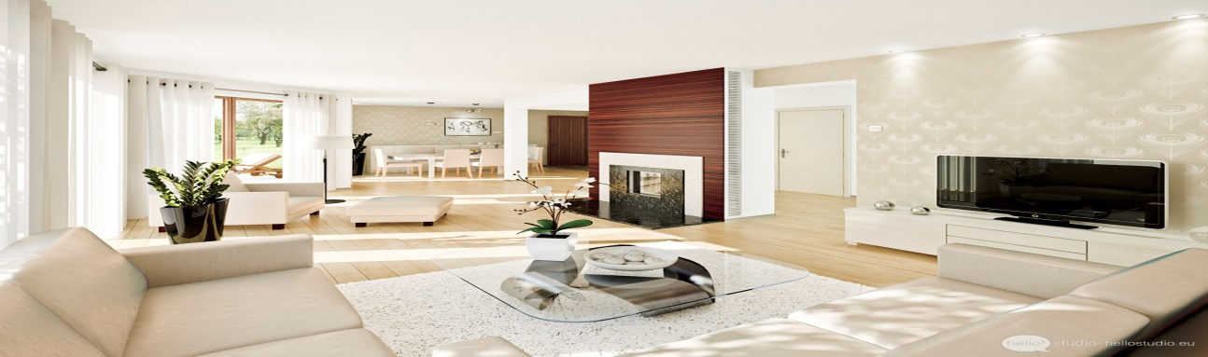

1. Living room [**ˈlɪvɪŋ** **ruːm ]** зал \ жила кімната
2. Sofa [**ˈsəufə**] диван
3. TV set [**tiːˈviː set**] телевізор
4. Arm-chair [**ˈɑːmtʃɛər**]  крісло
5. Low table [**ləu** **ˈteɪbl**] журнальний \ маленький стіл
6. Curtains [**ˈkəːtn**] штора
7. Fire place [**ˈfaɪər** **pleɪs**] камін
8. Wall [**wɔːl**] стена
9. Wall-unit [**wɔːl ˈjuːnɪt]** стінка (меблі)
10. Carpet [**ˈkɑːpɪt**] килим
11. Rug [**rʌg**]  коврик (маленький)
12. Table [**ˈteɪbl**] стіл
13. Chair [**tʃɛər**] стілець
14. Flower [**ˈflauər**] квітка
15. Window-sill [**ˈwɪndəu** **sɪ**l] підвіконник
16. Ceiling [**ˈsiːlɪŋ**] стеля
17. Floor [**flɔːr**]  пол

18. **Сhandelier**  [**ʃændəˈlɪər**] лю́стра

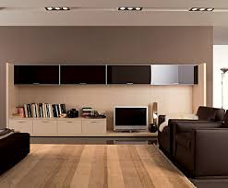

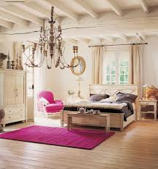

**You can see a bedroom on the picture. It is rather big and light. There are two big windows in the bedroom. You can see white curtains on the windows. The walls are of white color too. There is a wide bed near the window. You can see a beautiful arm-chair near the bed. A white wardrobe is near the window. There is a pink carpet in the middle of the bedroom. There is a low table next to the bed. You can see a white modern designed ceiling with a beautiful chandelier on it. The floor is brown and bright. It is very nice bedroom.**

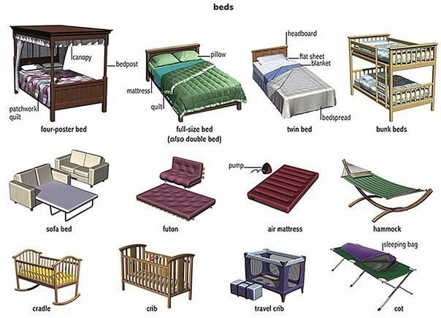

**Answer the questions.**

1. **What can you see on the picture?**
2. **How many windows can you see in the bedroom?**
3. **Where is the bed?**
4. **Where can you see a wardrobe?**
5. **Is there an arm-chair near the bed?**
6. **Where can you see a pink carpet?**
7. **Is there a low table near the bed?**
8. **What kind is a ceiling?**
9. **What kind is a floor?**

**Describe a picture.**

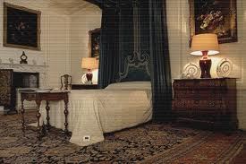

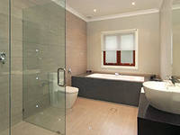 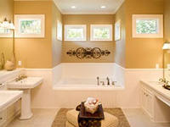

1. Bath-room [bɑːθru:m] ва́нна кімната

2. Tap [tæp] кран

3. Mixer tap [mɪksə(r) tæp ] кран-змішувач

4. Diverter [daɪˈvətə(r)] перемикач на душ

5. Sink [sɪŋk] ра́ковина

6. Toothbrush [tu:θ brʌſ] зубная щітка

7. Toothpaste [tu:θ peɪst] зубна паста

8. Soap [səʊp] мило

9. Soap dish [səʊp diſ] мильниця

10.Sponge [spʌndʒ] гу́бка \ мочалка

11.Towel [taʊəl] полоте́нце

12. Cistern [sɪst(ə)n] бачок

13. Shower [ſaʊə(r)] душ

14. Toilet [tɔɪlɪt] туале́т

15. Bath [bɑːθ] ванна

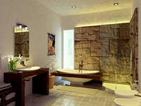

1. Fork [fo:k] вилка

2. Knife [naif] ніж

3. Spoon [spu:n] ложка

4. Coffe spoon [kɒfɪ spu:n] кофейна ложка

5. Teaspoon [ti: spu:n] чайна ложка

6. Soup-spoon [su:p spu:n] велика ложка

7. Carving knife [ka:vin naif] разкладний ніж

8. Cutlery [kʌtlərɪ] ножові вироби

9. Bowl [bəʊl] ча́ша, ва́за, ми́ска

10. Plate [pleɪt] тарілка

11. Cup [k ʌ p] ча́шка

12. Saucer [sɔːsə(r)] блю́дце

13. Tablecloth [teɪb(ə) klɒθ] скатертина

14. Napkin [næpkɪn] серветка

15. Tray [treɪ] підніс

16. Carafe [kəræf] графи́н

17. Goblet [gɔblit] бокал

18. Thumbler [θʌmbl ə®] фужер

19. China [tſaɪnə] фарфо́р

20. Crockery [krɒkərɪ] гли́няний /фая́нсовий посу́д

21. Glass [ɡlɑːs] стакан

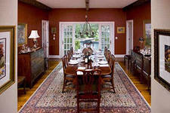 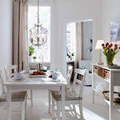

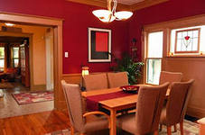

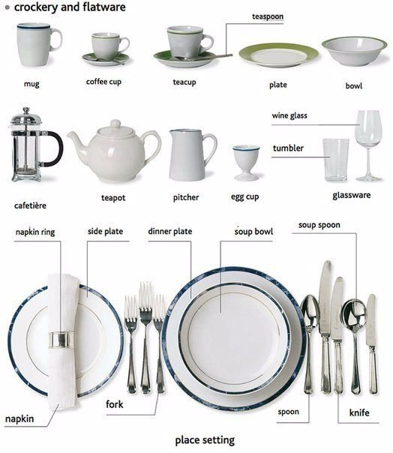

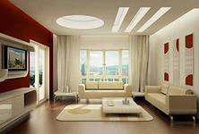 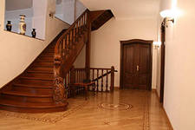

1. Coat rack [kəʊt ræk] вішалка

2. Coat hook [kəʊt hʊk] крючок

3. Coat hanger [kəʊt hæŋə(r)] плечики

4. Stair [steə(r)] східці

5. To go down stairs [daʊn steə(r)] йти вниз по східцям

6. To go upstairs [ʌpsteəz] підніматися вгору по східцям

7. Principle staircase [prɪnsɪp(ə)l steəkeis] центральні східці

8. Key [ki:] ключ

9. Doorway [dɔː(r)wei] вхід в приміщення

10. Door plate [dɔː(r) pleit] дощечка на дверях

11. Doorstep [dɔː(r) step] поріг

12. Doormat [dɔː(r)mæt] килим маленький

13. Backdoor [bæk dɔː(r)] задні двері \ «чорний» вхід

14. Sidedoor [saɪd dɔː(r)] бокові двері

15. Doorbell [dɔː(r) bel] дверний дзвінок

16. Doorhandle [dɔː(r) hænd(ə)l] ручка для дверей

17. Spyhole [spai həʊl] «глазок»

18. Dressing table [dresɪŋ teibl] тумбочка

19. Mirror [mɪrə(r)] дзеркало

20. Window sill [wɪndəʊ sil] підвіконник

21. Lift [lift] ліфт

22. Garage [ɡærɑːdʒ] гараж

23. Chimney [tſɪmnɪ] труба́, димохід

24. Antenna [æntenə] антена

25. Drainpipe [dreɪn paip] каналізаційна труба

26. Porch [pɔːtſ] крильце

27. Shutter [ſʌtə(r)] ставні

28. Roof [ru:f] дах

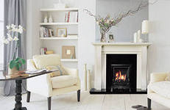

**Now I want to tell you about our hall. It is rather big, light and fashionable room. The walls of our hall are of white color. There is a big window in the left side of the hall. You can see beautiful curtains of silver color on it. There is a bookcase next to the window. You can see many interesting books and pictures on the shelves of the bookcase. There is a fire-place near the bookcase. You can see a vase with beautiful flowers in it. There are two arm-chairs opposite the fire-place. They are white and fashionably designed. You can see a beautiful table opposite the window with a vase of flowers on it. The floor of the hall is white. I like this room very much.**

1. **What can you see in the picture?**
2. **What kind of hall do we have?**
3. **What color are walls?**
4. **Where is the window?**
5. **What kind are curtains?**
6. **There is a bookcase next to the window, isn’t it?**
7. **What can you see on the shelves of the bookcase?**
8. **Where is a fire-place?**
9. **What can you see on the fire-place?**
10. **Where are the arm-chairs?**

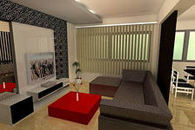

1. **Now I want to tell you about…………………………………**
2. **It is rather big, light and………………………………………**
3. **The walls of our hall are of…………………………………...**
4. **There is a TV set……………………………………………...**
5. **You can see a sofa…………………………………………….**
6. **You can see a red low table in the middle of…………………**
7. **The ceiling of the hall is……………………………………..**
8. **The floor is……………………………………………………**
9. **It is fashionably designed…………………………………….**
10. **You can see a vase with beautiful flowers on…………………**

