**TEXT**

**WHO ARE THE WORLD’S WORST TOURISTS?**

Some nationals are more unpopular than others when it comes to travel.

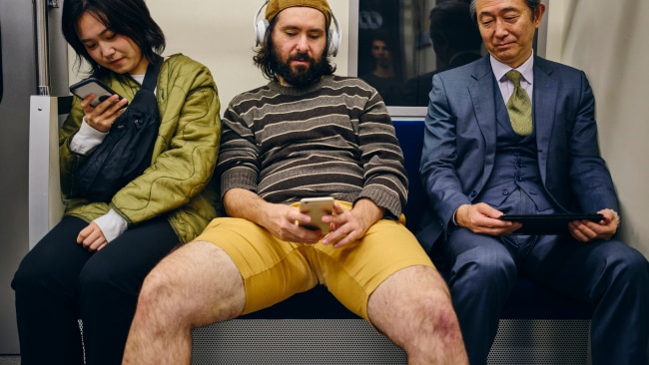

One of the great things about travel is meeting people from all over the world. And one of the worst things about travel can be getting stuck in the orbit of those very same people, if they're the type that do your head in. When it comes to other foreigners you meet when you're globe-trotting, there are some popular stereotypes: Aussies are usually drunk. Americans are loud and obnoxious, etc etc. At the end of 2019 - just before the pandemic squashed international travel - UK market research company YouGov surveyed 26 nationalities on which tourists they disliked most when travelling. That research, mixed with some feedback on internet travel forums sheds light on some commonly held perceptions. And just to be clear, we acknowledge that there are legends and d*ckheads in every country, and these are just broad opinions. But let's throw caution to the wind and dive into those survey results ...



**The Brits**

From the survey it was discovered that the Brits were fairly unpopular, particular in Spain where they flock during the warmer months. Asked to name up to three countries from which the worst tourists originate, almost half of Spanish people (46%) named Britain. As one poster on a Quora thread wrote, "British tourists are polite, friendly and considerate. But ply them with a few drinks and they’ll be running naked through the streets in no time."



**Chinese**

Chinese tourists were fairly unpopular in the survey, particularly in parts of Asia. They were named as the worst tourists in Australia, Indonesia, Malaysia, the Philippines, Singapore, Thailand, and Vietnam. One poster on Reddit wrote "the Chinese are the new 'Rude Americans'. Back in the 1950s and '60s middle class American families were traveling abroad on a regular basis for the first time. They had no idea how to act in different countries and didn't take into account other peoples cultures. This lead to the stereotype of annoying American tourist. Americans have now learned 'tourism etiquette' and now act fairly well in foreign countries (well most do). Now the Chinese are in the same boat as post WW2 America was in. An economic boom has allowed the average Chinese family to travel abroad. Chinese citizens aren't used to being in a different country. There culture isn't as used to tourism and they will need some time to learn 'tourism etiquette'".



**Russians**

According to the YouGov survey, Russians are particularly unpopular among Europeans, particularly in Denmark, Sweden, Finland and Norway. The general consensus seems to be that they think rules don't apply to them. "A friend of mine was recently in Thailand," wrote one poster on Reddit. "They were out on this tour on the sea, snorkeling ect. One place they stopped at had this small little Island in the middle of nowhere and the guide said very specifically not to go up there, it was a big no-no. Ten minutes later every Russian on the trip was up walking around, and the guide said that it happens every time with the Russians."

<h2>Australians</h2>
<p>Like the Brits, we have a reputation for letting our hair down a little too much when we travel. We can be particularly rubbish in Bali, where there have been instances of us getting too boozy and being disrespectful of the culture. But <a href="https://www.businessinsider.com.au/worst-behaved-tourists-2013-5#5-australia-at-any-given-time-a-large-proportion-of-australians-are-out-and-about-traveling-abroad-which-might-explain-their-performance-on-this-top-ten-list-6">when we ranked number 5 in a poll of the worst behaved international tourists in 2013, a journalist noted</a> "at any given time, a large proportion of Australians are out and about travelling abroad, which might explain their performance on this top 10 list ..." It&apos;s true, we do travel a lot (or rather, we did), and that is very gracious of them.</p>

**Australians**

Like the Brits, we have a reputation for letting our hair down a little too much when we travel. We can be particularly rubbish in Bali, where there have been instances of us getting too boozy and being disrespectful of the culture. But [when we ranked number 5 in a poll of the worst behaved international tourists in 2013, a journalist noted](https://www.businessinsider.com.au/worst-behaved-tourists-2013-5#5-australia-at-any-given-time-a-large-proportion-of-australians-are-out-and-about-traveling-abroad-which-might-explain-their-performance-on-this-top-ten-list-6) "at any given time, a large proportion of Australians are out and about travelling abroad, which might explain their performance on this top 10 list ..." It's true, we do travel a lot (or rather, we did), and that is very gracious of them.

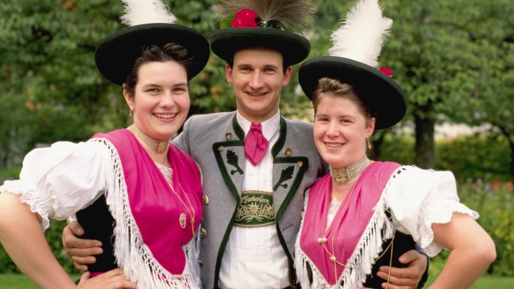

**Germans**

Our Germanic pals have long had a bit of a reputation for being a little unpopular on the tourist scene. According to a poster on a thread on Quora, "they have a reputation for being a bit selfish ... “reserving” a poolside lounger every morning by getting up at 6am to put a towel on it".

<h2>Americans</h2>
<p>Here's a fun thing to note - according to a survey by LivingSocial, Americans are the worst tourists ... according to themselves. 20% of Americans polled said they were the worst tourists. As <a href="https://www.continentscondiments.com/worlds-worst-tourists-which-nationality-causes-the-most-trouble-abroad/">this writer put it</a>: "There are a couple of things that Americans are known for. Speaking loudly is one. Expecting everyone to understand English is another one. Speaking loudly to someone who doesn't understand English and expecting that person to understand better because they're yelling is one of the worst." They also have a reputation for constantly comparing things with how they are back home. On the positive side? They're damn good at tipping.</p>

**Americans**

Here's a fun thing to note - according to a survey by LivingSocial, Americans are the worst tourists ... according to themselves. 20% of Americans polled said they were the worst tourists. As [this writer put it](https://www.continentscondiments.com/worlds-worst-tourists-which-nationality-causes-the-most-trouble-abroad/): "There are a couple of things that Americans are known for. Speaking loudly is one. Expecting everyone to understand English is another one. Speaking loudly to someone who doesn't understand English and expecting that person to understand better because they're yelling is one of the worst." They also have a reputation for constantly comparing things with how they are back home. On the positive side? They're damn good at tipping.

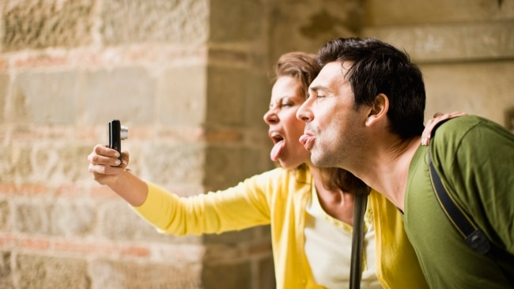

**Italians**

Italians and the French both represented on the list of unpopular tourists ... with the Italians just gaining the edge. As a colleague said "please put Italians on the list ... they love travelling to other countries, ordering Italian food, and then complaining that it's not as good as it is in Italy".



**And the award for the best tourists?**

Asked where the best tourists come from, one nation stands out above all others: Japan. With Japanese football fans having make headlines around the world during the World Cup by helping to clean the stadiums after matches, the nation is consistently cited as being home to the most gladly received tourists the world over.This is particularly the case in Finland, France, Germany, Indonesia, Malaysia, the Philippines, Singapore, and Thailand, all of whom placed Japanese tourists at the very top of their lists.