TEXT

INVICTUS GAMES

The Invictus Games, an international sporting event, represent resilience, determination, and camaraderie among military personnel who have sustained injuries or illnesses during their service. Established by Prince Harry in 2014, the Games draw inspiration from the Latin word "Invictus," meaning "unconquered."
The history of the Invictus Games traces back to Prince Harry's visit to the United States in 2013, where he witnessed the Warrior Games, a similar event for wounded American service members. Inspired by their spirit and the power of sports as a means of rehabilitation, Prince Harry envisioned a global platform where wounded, injured, or sick military personnel from various nations could compete and support each other.

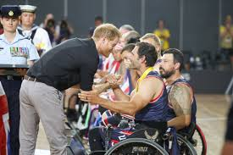

The primary objective of the Invictus Games is to harness the healing power of sports and provide a platform for wounded warriors to showcase their resilience and determination. Through adaptive sports, participants not only challenge themselves physically but also find camaraderie and emotional support among fellow servicemen and women. The Games promote inclusivity, recognizing the strength and courage of individuals who have overcome significant challenges.
Ukraine's participation in the Invictus Games underscores its commitment to supporting its military personnel and veterans. Since 2017, Ukrainian athletes have competed in various disciplines, including athletics, swimming, cycling, and wheelchair basketball. Their participation serves as a testament to Ukraine's solidarity with the global military community and highlights the importance of rehabilitation and reintegration for wounded veterans.

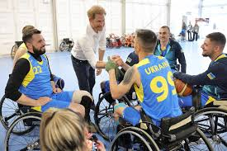

Each edition of the Invictus Games attracts participants from numerous countries worldwide. The number of athletes varies from year to year, reflecting the growing popularity and recognition of the event. With hundreds of competitors representing their nations, the Games offer a platform for individuals to demonstrate their strength, perseverance, and sporting prowess on an international stage.
In summary, the Invictus Games stand as a beacon of hope and inspiration, uniting wounded warriors from around the world in a celebration of resilience, courage, and determination. Through sportsmanship and solidarity, participants transcend physical limitations, embodying the spirit of "Invictus" as they strive for victory in the face of adversity.

