TEXT

RELATIONS BETWEEN GENERATIONS

Scientific and technical progress, technological development and social changes have a great impact on our lives. Therefore, what was correct and natural for the older generation is outdated and meaningless for the younger generation. In this connection, a generational conflict arises. Constant quarrels, misunderstandings, criticism and morals lead to the destruction of relations between family members.

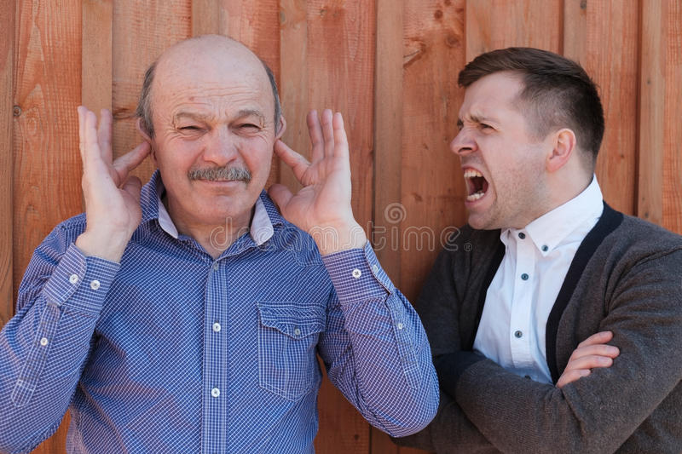

Not only fashion trends are changing, but also medical and pedagogical paradigms. Even the concept of what a person should be has changed. Over the past 20 years, huge transformations have taken place in our country, which cannot help but affect family relations. Such a rapid change of patterns at the level of the family, the family system led to the generation problem .
Conflict between generations is a difference of opinion between people of different ages. The most vivid examples are situations of communication between parents and children, as well as grandparents.
But not only the relationships between the older generation and teenagers, but also the communication of parents with their mothers and fathers play the main roles. Most often, such disagreements are called - conflicts between parents and children .
Conflict can arise for various reasons and there are many of them. However, the most common ones can be singled out from all of them. Basically, these are different views on the following nuances: parenting;
- recreation area;
- individual worldview (attitude towards family, studies, career);
- healthy; finances;
- comfort zone (techniques, clothes, food).

