TEXT

THE RUSSIAN INVASION OF UKRAINE

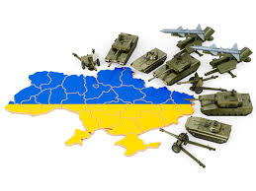
The Russian invasion of Ukraine in 2022 is an open military attack by Russia with the support of Belarus on Ukraine , launched at 5:00 on February 24, 2022. The invasion is part of the Russian-Ukrainian war waged by Russia in 2014, in which Russia has tried to deny participation. The media and documents view the Russian invasion of Ukraine in 2022 as Russia's aggressive war against Ukraine.
The military campaign began after a long increase in Russian troops in November 2021 along Ukraine's border with Russia and Belarus and the recognition by Russian authorities on February 21, 2022 of terrorist organizations in Ukraine - the so-called "DPR" and "LPR" - as state entities.

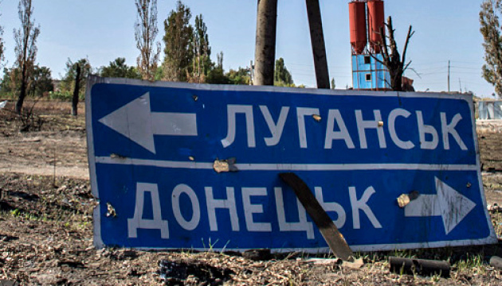

Various media outlets, Western and Ukrainian politicians have repeatedly viewed the accumulation of Russian troops near the border with Ukraine since November 2021 as Russia's preparation for war with Ukraine. Russian officials have strongly denied in their statements that Russia plans or intends to attack Ukraine. Almost simultaneously , the Armed Forces of the Russian Federation began the undisguised transfer of additional troops to the occupied territories of Donetsk and Luhansk regions.
At about 4 a.m. Kyiv time (UTC + 2), on February 24, Russian President Vladimir Putin announced a military operation aimed at allegedly "demilitarizing and denationalizing Ukraine"; a few minutes later, missile strikes began throughout Ukraine, including near Kyiv. Russian troops invaded Ukraine near Kharkiv , Kherson , Chernihiv, and Sumy, entering from Russia, Belarus , and the Russian-occupied Crimea . Belarus is waging war against Ukraine together with Russia: missile strikes are being launched on the territory of Ukraine from the border areas, carry out combat aircraft flights to launch missile and bomb strikes on the territory of Ukraine, there is a redeployment of troops and its provision. Russian-controlled Transnistria (Moldova) is also a potential threat.

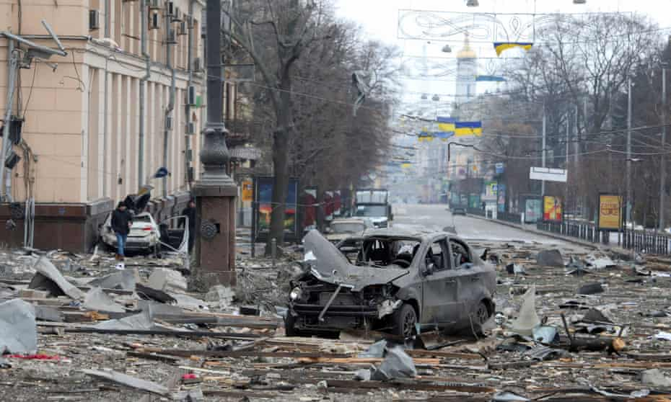

Due to the resistance of the Ukrainian army and self-defense forces, already in the first days of the aggression, the Russian army suffered significant losses in manpower and equipment. In its recent history, according to Ukraine, in all the wars it has waged, Russia has not suffered even such great losses in such a short time. According to Western intelligence, Russia met with stronger-than-expected resistance, leading to logistical problems for its troops, lack of fuel, ammunition and food, and undermining the fighting spirit of the attackers. The rapid unification of the world to help Ukraine, as well as the imposition of strong sanctions against Russia, was a surprise blow to the aggressor country .

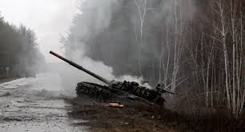

From the first day of the invasion, Russia violates the rules of war and commits mass war crimes . In addition, the Russian government is waging an information war and using propaganda .

