TEXT
MODERN HEROES OF UKRAINE
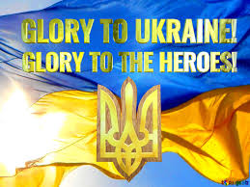
Ukraine, a nation with a rich history and a resilient spirit, has witnessed the emergence of modern heroes who stand as catalysts of change in the face of evolving challenges. These contemporary figures, spanning diverse fields, embody the spirit of resilience, courage, and a steadfast commitment to fostering positive transformations within their society.
The Russian-Ukrainian War is not merely a conflict shaping geopolitical maps; it is a stage giving rise to a new narrative of heroism in the hearts of Ukrainians.
The conflict initiated by Russia in eastern Ukraine has resulted in significant territorial and human losses. The escalation has given birth to a new generation of heroes who have defined themselves through their actions in defense of their homeland.
After the events that transpired post-February 24, 2023, the tragedy and losses for Ukraine have become even more poignant and palpable. The country has not only lost territories but entire facets of its society.
The heightened situation has led to significant human casualties, devastated cities, and damaged infrastructure. Families have been torn apart, and millions of people have been forced to leave their homes in search of safety.
In the contemporary context, discussing these modern heroes is not merely a recounting of valorous deeds; it is a reflection of a nation's unwavering spirit, a testament to the endurance of human will in the face of external aggression. Recognizing and understanding the role of these heroes is vital for shaping a narrative of hope, resilience, and the triumph of the human spirit over the challenges imposed by conflict. Their stories serve as beacons, guiding us towards a collective understanding of the significance of courage and sacrifice in the pursuit of freedom and justice.
These modern Ukrainian heroes symbolize the nation's resilience, adaptability, and the ongoing pursuit of a better future. As Ukraine continues to navigate its path, these figures serve as beacons of inspiration, embodying the spirit of positive change and progress.
Ukraine is grappling with economic and social challenges, coupled with extraordinary instability. Each story of loss becomes a drop in the abyss of sorrow that fills the heart of the nation.
This period of tragic events underscores the need for expressing solidarity and providing support to the Ukrainian people. It also defines our collective responsibility to preserve peace and the calling to join forces for the mutual reconstruction, stabilization, and restoration of Ukraine.
In this challenging period in Ukraine's history, numerous individuals have distinguished themselves through courageous defense efforts during the war. Their achievements and contributions to the struggle serve as examples of immense dedication and heroism.
Get to know the people who fight for Ukraine's freedom: soldiers, volunteers, medical workets etc. They are real defenders, each of them with their own history.
Ukrainians were shaken by another case of Russian brutality. A video has been circulating showing how the Russian invaders killed a Ukrainian prisoner of war simply for uttering the words “Glory to Ukraine / Slava Ukraini”.
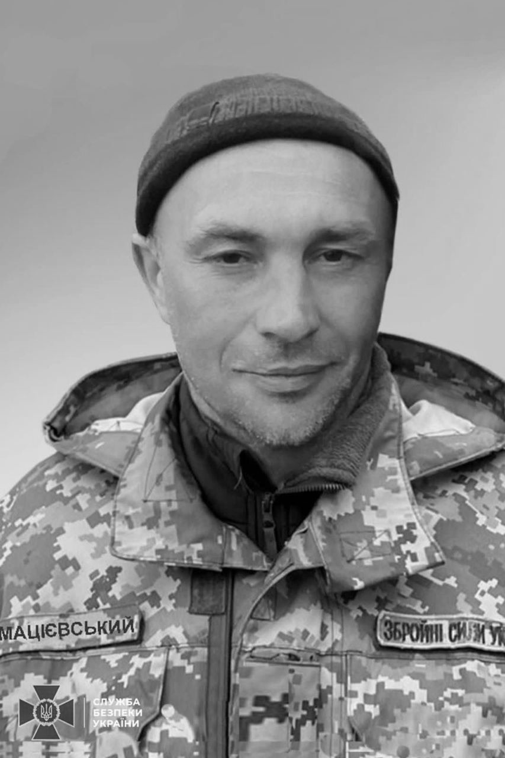

The investigators of the Security Service of Ukraine established that the Ukrainian soldier on the video was Oleksandr Matsiievskyi, a sniper of the 163rd battalion of the 119th separate brigade of the territorial defense of the Chernihiv region. Oleksandr was called up for military service in March 2022. Since the end of December, he was reported missing near the settlement of Krasna Hora in the Donetsk region.
A mural called ‘The Ghost of Kyiv’, dedicated to Ukrainian air force pilots who were defending the sky over Kyiv during the Russian attacks, was drawn from the photo of Juice. Andrii “Juice” Pilshchykov, a 30-year-old Ukrainian fighter pilot, was born in Kharkiv. He was a major in the 40th Tactical Aviation Brigade of the Ukrainian Air Force, operating a Mig-29.

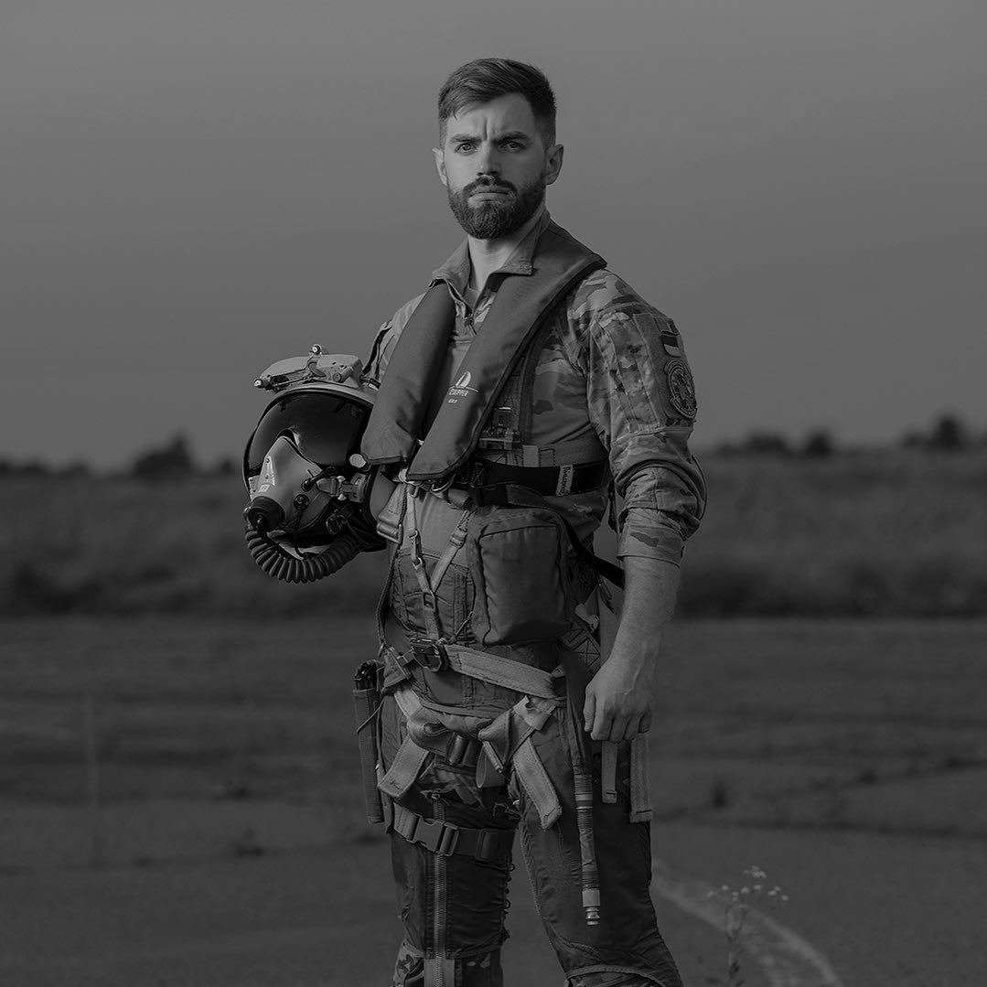

Since the beginning of Russia’s full-scale invasion of Ukraine, Juice had defended Ukrainian skies. By May 2023, he had racked up 500 hours of combat flights.

On March 15, 2023, Ukrainian defender Alen Dudnik shot down a Russian Su-24 aircraft in the Bakhmut direction. The accurate shot was fired from the “Igla-1” MANPADS.

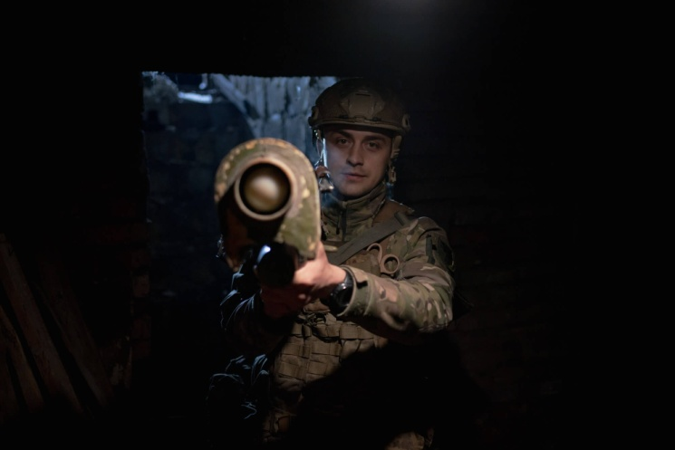

Alen is 28, and his call sign is “Promin”, the same as the village in the Dnipropetrovsk region where he was born. Currently, the man is fighting in the 93rd separate mechanized brigade “Kholodnyi Yar” in the Bakhmut direction.
The list of modern heroes of Ukraine is so long.....
In conclusion, these modern Ukrainian heroes represent the diversity and resilience of a nation in constant evolution. Through their leadership, advocacy, art, literature, environmentalism, sports, and technological innovation, they have become beacons of inspiration, guiding Ukraine toward a brighter and more progressive future. As the nation navigates its path of transformation, these heroes serve as living examples of the positive change that can be achieved through individual commitment and collective effort.
Modern heroes in this context are not just symbols of physical bravery but embodiments of the indomitable spirit that refuses to yield to adversity. They emerge from the struggles of common people, echoing the sentiments of a nation fighting for its identity and sovereignty.

