Education

School
- Secondary school – середня школа
- Nursery (infant school) – молодша школа від 5ти до 7ми років
- Primary school – початкова школа від 7ми до 10 років
- School specializing in England – школа з поглибленим вивченням англійської мови
- Boarding school – школа - інтернат
- Vocational school – професійно-технічна школа
- Specialized technical school – технікум
- To be at school together- навчатися разом у школі
- To leave school – закінчувати школу
- School leaving certificate – атестат зрілості
- Graduation – випуск
- School leaver – випускник
- Subject – предмет
- Key \ main subject – основний предмет
- General subject – основний предмет
- Compulsory subject – обов’язковий предмет
- Subsidiary subject – не обов’язковий предмет
- Term – семестр
- Timetable – розклад
- School uniform – шкільна форма
- Academic year – навчальний рік
- To admit to school – приймати до школи
- Enrolment in school – прийом до школи
- To attend school – відвідувати школу
- Attendance – відвідування
- Staff \ faculty – педагогічний колектив
- Headmaster – директор
- Staff head – завуч
- Staff meeting – педагогічна рада
- Regional teacher’s conference – районна нарада вчителів
- Parent – teacher’s association – батьківський комітет
- Teaching service \ teaching experience – педагогічний стаж
- Repeater – другорічник
- To repeat the year – залишатися на другий рік
- Transfer from one school to another – перехід з однієї школи в іншу
- Networks of schools – мережа шкіл
- School activities – робота в школі
- Classroom activities – робота в класі
- Social activities – громадська діяльність
- Practical and aesthetic activities – трудове й естетичне виховання
- Extracurricular activities – позакласна робота
- Out of school activities – позакласна робота
- Curriculum – навчальна робота
- Instruction – навчання
- To give instruction in smth. – навчати чого-небудь

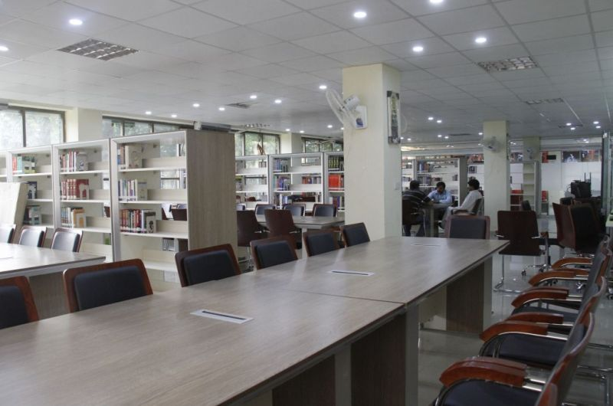
FURTHER\HIGHER EDUCATION
- Further \ higher education – подальша \ вища освіта
- University – університет
- Medical university – медичний університет
- Pedagogical University – педагогічний університет
- The humanities – гуманітарні науки
- The natural sciences – природничі науки
- The technical sciences – технічні науки
- Faculty – факультет
- Department – кафедра \ відділення
- Year – курс \ рік навчання
- First year student – студент 1го курсу
- Second year student – студент 2го курсу
- Third year student – студент 3го курсу
- Fourth year student – студент 4го курсу
- Full time Department – денне відділення
- Part time department – вечірнє відділення
- Correspondence department – заочне відділення
- Philology – філологія
- Philosophy –філософія
- Ecology –екологія
- Economics – економіка
- Research – дослідження
- Scientific supervisor – науковий керівник
- Higher degree – науковий ступінь
- Scientist – вчений
- Doctor – доктор наук
- Candidate of sciences – кандидат наук
- Thesis – дисертація
- Term – семестр
- Sessional examinations – екзаменаційна сесія
- Essay project – курсова робота
- Test credit – залік
- Graduation project – дипломна робота
- To enter the university – вступати до університету
- Rector –ректор
- Vice rector – проректор
- Dean – декан
- Head of department – завідувач кафедри
- Professor – професор
- Principal lecturer – доцент
- Junior lecturer – асистент
- Senior lecturer – старший викладач
- Head of the department – завідувач кафедри
- Tutor – викладач \ наставник
- Course member – слухач курсу
- University graduate –випускник університету
- To graduate – закінчувати університет
- Tuition – навчання
- Tuition fee – плата за навчання
- Scholarship – стипендія
- Holidays \ vocations- канікули
- On holidays \ on vocations – бути на канікулах

Examinations

1.Entrance examinations – вступний іспит
2.Final examinations –випускні іспити
3.To sit for an exam – складати іспит
4.To pass an exam – скласти іспит
5. re-examination – перескладання іспиту
6.To give \ set an exam – приймати іспит
7.To fail an exam – не скласти іспит
8.To pass an examination with distinction – скласти іспит із відзнакою
9. Sessional examinations – сесійні екзамени
10. to go through one’s exam – успішно скласти іспит
11. ordinary leave examinations – випускні екзамени на звичайному рівні
12. selective examinations – відбірні іспити
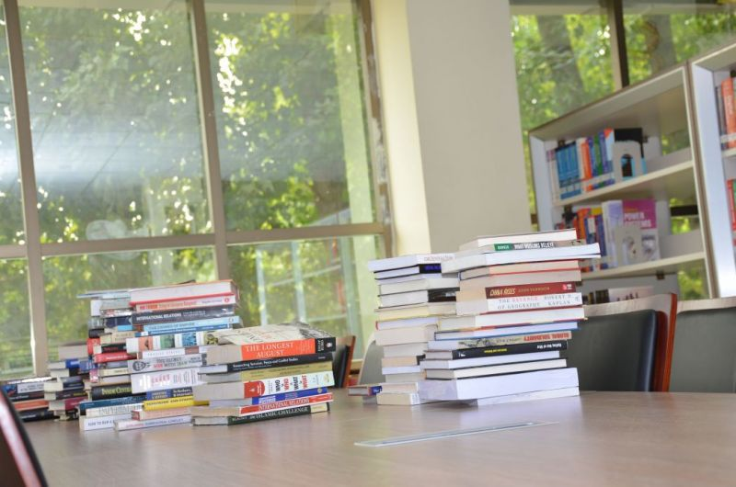
Education
- Universal secondary compulsory education – загальна обов’язкова середня освіта
- Full time education – освіта з відривом від виробництва
- Part - time education – освіта без відриву від виробництва
- Primary \ elementary education – початкова освіта
- Vocational education – професійно-технічна освіта
- All-round education – всебічна освіта
- System of public education – система народної освіти
- Free education – безкоштовна освіта
- Nursery education – дошкільна освіта
- Educational opportunities – можливість отримати освіту
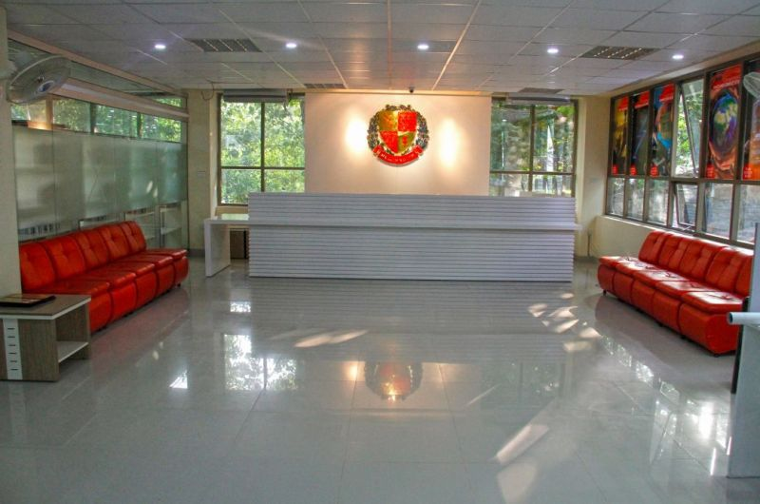

1.Read the text and put 15 questions to it.
Student’s life
College life – what can sounds more exciting for a young person? Many people have been waiting this time since school. Then the school-leavers shall pass the entrance exams. And finally, one turns from an applicant into a first-year student. I did it! I entered; I got in to the university! Do you remember this feeling? I do.
But just to pass the exams – it’s not quite enough, because we need to definite our objects in the life. Which college will be yours? The Teacher’s Training University? The Medical University? The Technical University? Or it will be the Art School? The world is full of specialties and professions, that’s why everyone can find something for himself.
Finally, all thoughts are left behind and everyone has chosen what he liked most. The first thing every student will face at the first of September is a teaching staff. How many people work for the sake of our education: professors, assistant professors, senior lectures, lectures, tutors, heads of departments, subdeans and the dean. What respectable people are they! And don’t forget about the rector or the vice-rector. All of them come every day for us.
Many people think that the university is much easier to study than school. But it’s a big mistake. From the very first classes the avalanche of home assignments falls on us. We have to keep late hours if we want to manage to keep pace with the curriculum. But if one accidental misses something, he has to catch up instead hanging out with his friends.
As for me, my studies keep me busy all day long. I have 10 hours of English a week, in spite of many seminars and lectures. My favorite subjects are history and English, because they make my brain in fit.
Then many students start to give up the education. At first they cease to do their home work, and then miss classes. Many of these people drop out of university, but, basically, they will be expelled. We need to make right decision and get through this time.
But even independently of one’s decision the examination period comes very soon. Someone will be crammed; someone will drill till late night. At that time we almost forget about sweet dreams because twenty-four hours a day we are preparing for our exams.
So, the first session is behind. Everyone is truly overexcited. It is always the day of smiles and tears: some may say I have passed, while someone is going to resit.
But it’s just the beginning. The summer session will be waiting for us, and if everything will be alright, we will be the sophomores. I always say: hard to learn, easy in a battle. I firmly believe that it’s undisputed truth. I wish good luck to every students.
2. Read and translate the text.

You are a Student Now
College life is a thing which you can hardly forget. This is the time when you become an adult, a more sensible person with the sober views on life.
First of all, to pass entrance exams and enter the university is a real challenge for a young person. It takes a lot of time, knowledge, patience and nerves. Besides, there is an avalanche of work expects you. A student ought to get accustomed to a new timetable, new subjects which are much more complicated than at school. Very often it is difficult to cope with the work load of college or university. You have to be a serious, attentive and responsible person concentrated on studying. Some new students soon understand that studying at university is hard work which takes a lot of time and strength, so they immediately start missing classes. This is not so good for them, because it is so difficult to catch up with the programme later. Besides, such students usually have a great number of debts before the beginning of examination session.
Another point is the relationships within a group and between students and teachers. It is not a secret that relationships play an important role in student’s life. You spend a lot of time at the university communicating with your group mates and trying to make a contact with other students. It is wonderful if you find a like-minded person who can become a real friend for all 5 or 6 years of studying or you just meet interesting people who are easy in communication. Sometimes an opposite thing may happen. When you see your group mates for the first time, it may seem to youthat they have nothing in common with you. Then the atmosphere within the group is just unbearable. Things get worse and it becomes difficult to find even a topic for conversation. Different things happen during your college life. Anyway, it is extremely important to have good relationships with your group mates and teachers and to show the best qualities and features of character.
In conclusion, it should be mentioned that students come across a lot of events during their studying in college or university. Some of them may disappoint you, some bring a lot of joy and even make you feel happy. That is why a lot of people say that their college or university years were the greatest and the happiest time in their life. They also say, that if they could go back in time, they would have taken a music band and joined choir, learned harder another language besides the English language, and improve the relationships between teachers who they have no special liking. They got in love for the first time in university, they went to party, got lots of joy and positive emotions, got in different competitions, and etc., but anyway, they think that the college life is the happiest time in their life.
I am a student too, and I think that my university life I can hardly forget. For me, it is time when I become an adult, a more sensible person with the sober views on life. Also I think that never forget to study and you can be a student for all the time.

