The Future Simple Tense

This Tense expresses an action which will occur in future: a single point action, an action occupying a whole period, or a succession of actions.
Words – appointments:
Tomorrow
Next
Structure
Subject. + shall\ will + verb-predicate +Secondary parts of Sentence.
For example:
We shall go to the cinema tomorrow
He will go to Kiev the next week.

AFFIRMATIVE FORM
I  WE | SHALL | WORK
HE  SHE  IT  THEY  YOU | WILL | WORK

- Tom will go to the health club tonight.
- I shall go to the country on Sunday.
- We shall translate this text together.
- My father and I will go fishing tomorrow.
- You will meet me at the bus station.
- They will come to see us very soon.
- The lessons will begin in 5 minutes.
- The train will arrive at 6 o’clock.
- You will have a fun if you come to the concert.
- I’ll remain in love with you all my life.
Question form

Shall | I  we | Work?
Will | He  She  They  You  it | Work?

- Shall I open the window?
- Will he call you from London, do you think?
- Shall we meet and go to the café tonight?
- Will you ring me up on Sunday morning?
- Who will go to the bakery with me?
- When will your cousin come back from Australia?
- What will you do if he doesn’t come?
- Will the soup be ready soon?
- Where will your friend spend his summer vocation this year?
- Will you come over for a chat with me?

Negative question
I  We | Shall not = shan’t | work
You  They  He  She  It | Will not = won’t | work

- I shall not go for a walk with them.
- He will not help you.
- We shall not take them with us.
- They will not go to the seaside next summer.
- You will not translate the text if he doesn’t help you.
- The concert will not begin at seven.
- He won’t be away for a long time.
- They will not play baseball tomorrow.
- They shall not be able to do the work themselves.
- I shall not take part in the conference.

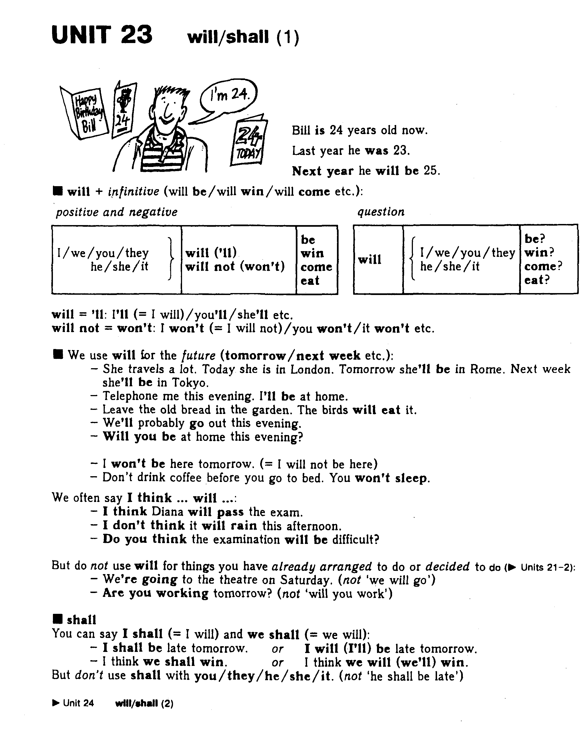
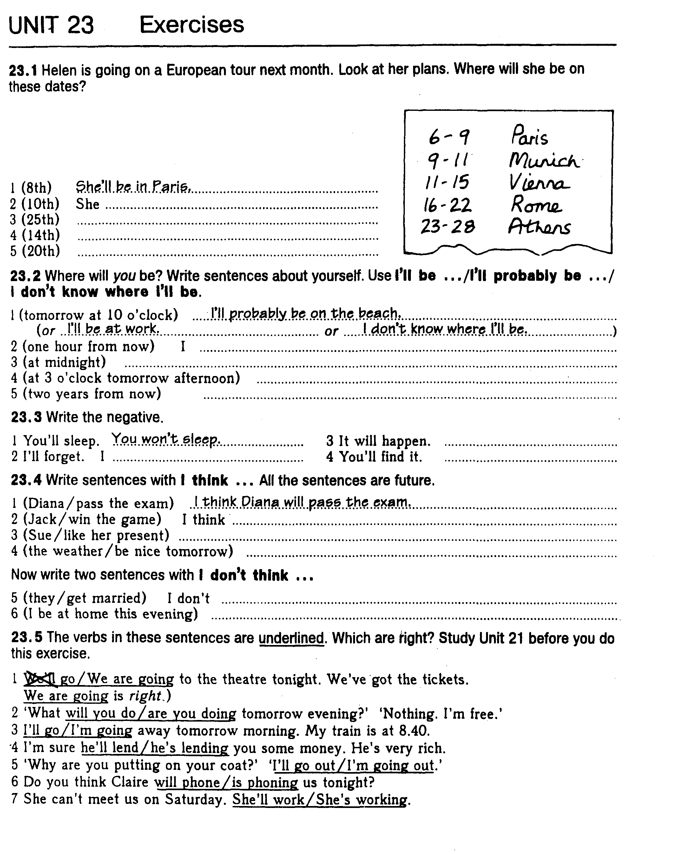
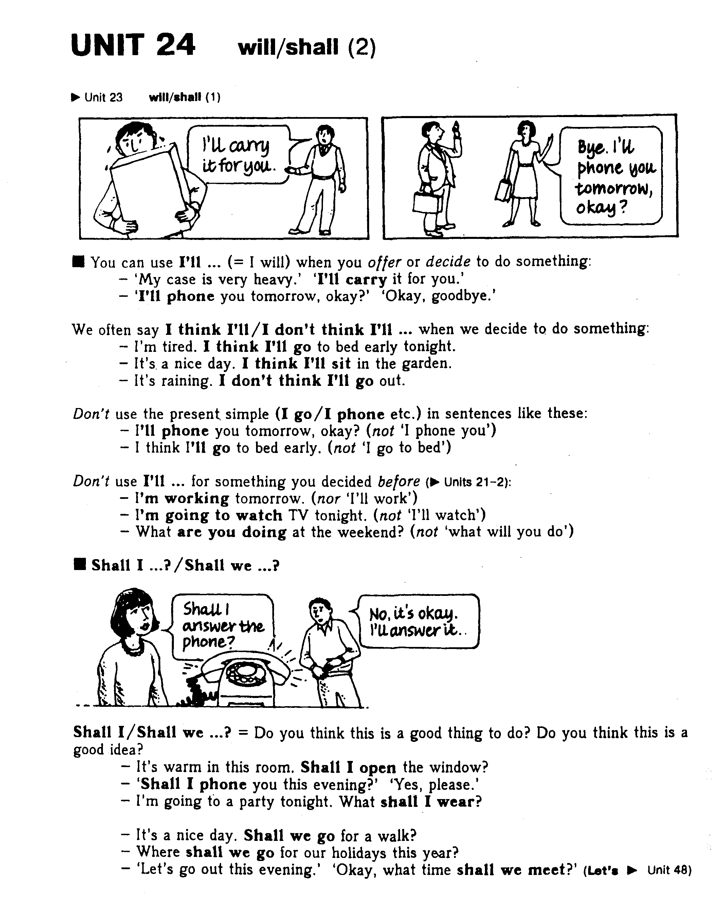
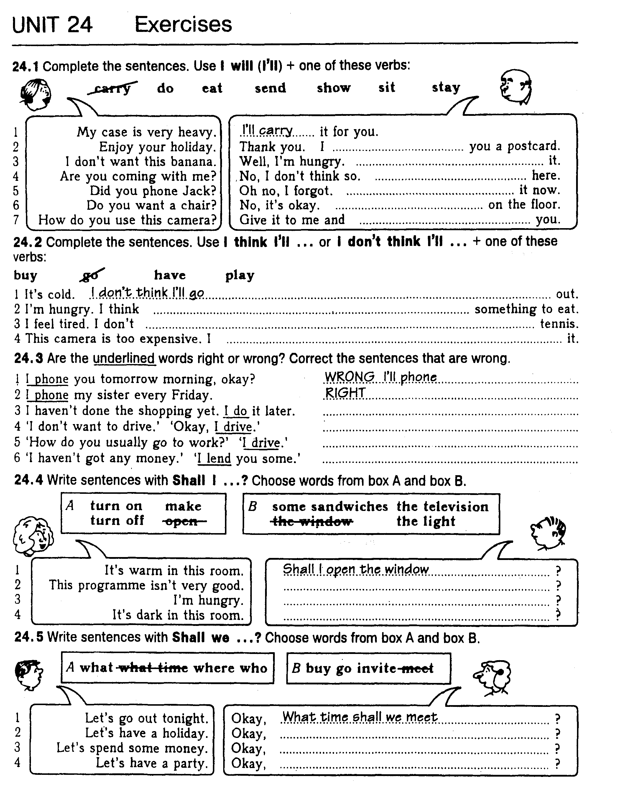

Negative form
Shall + not= shan’t
Will+ not =won’t

Structure

Subject. + shan’t\ won’t + verb-predicate +secondary part of sentence.

We shan’t go to the cinema tomorrow
He won’t go to Kiev the next week.

Common question \ General question
Shall \ Will+ Subject.+ verb-predicate + secondary part of sentence.

For example:
Shall we go to the cinema tomorrow?
Will He go to Kiev the next week?

Alternative question
Shall \ Will+ Subject.+ verb-predicate + secondary part of sentence.
. + or not?
For example:
Shall we go to the cinema tomorrow or not?
Will He go to Kiev or Kharkov the next week?

Disjunctive question (1)
Subject. + shall\ will +verb-predicate + secondary part of sentence.
., shan’t\won’t + Subject expressed by preposition.

We shall go to the cinema tomorrow shan’t we?
He will go to Kiev the next week, won’t he?

Disjunctive question (2)
Subject. + shan’t\won’t + verb – predicate +Secondary parts of sentence., shall\ will + Subject expressed by preposition.

We shan’t go to the cinema tomorrow, shall we?
He won’t go to Kiev the next week, will he?

Negative question
Shan’t\Won’t + Subject.+ verb-predicate +Secondary parts of sentence?

Shan’t we go to the cinema tomorrow, shall we?
Won’t he go to Kiev the next week, will he?

Special question

Wh\quest. + shall\ will+ Subject. + verb-predicate +Secondary parts of sentence.

We shall go to the cinema tomorrow
Who shall go to the cinema tomorrow?
What shall we do tomorrow?
When shall we go to the cinema?
Where shall we go tomorrow?

EXERCISES
1. I want to get a medical checkup. I (to go) to my doctor tomorrow. 2. He (to give) me a complete examination. 3. The nurse (to lead) me into one of the examination rooms. 4. I (to take) off my clothes and (to put) on a hospital gown. 5. Dr. Setton (to come) in, (to shake) my hand, and (to say) "hello". 6. I (to stand) on his scale so he can measure my height and my weight. 7. He (to take) my pulse. 8. Then he (to take) my blood pressure. 9. After he takes my blood pressure, he (to take) some blood for a blood analysis. 10. He (to examine) my eyes, ears, nose, and throat. 11. He (to listen) to my heart with a stethoscope. 12. Then he (to take) a chest X-ray and (to do) a cardiogram (ECG or EKG). 13. After the checkup I (to go) home and (to wait) for Dr. Set-ton's call. 14. Dr. Setton (to call) me tomorrow afternoon and (to say) to me: "Stop worring! Your blood analysis is excellent." He is a very good doctor.
2. Open brackets using verbs in Present Continuous, Present Simple или в Future Simple.
1. I (to play) chess tomorrow. 2. I (not to play) chess tomorrow. 3. You (to play) chess tomorrow? 4. He (to play) chess every day. 5. He (not to play) chess every day. 6. He (to play) chess every day? 7. They (to play) chess now. 8. They (not to play) chess now. 9. They (to play) chess now? 10. Nick (to go) to the park now. 11. Nick (to go) to school every day. 12. Nick (to go) to school tomorrow. 13.1 (to miss) your excellent cooking! 14. You ever (to buy) presents? 15. You (to think) it (to be) easy or difficult to choose the right presents for people? 16. What present your mother (to receive) for her next birthday?
17.A: The weather (to be) unpredictable these days. B: Well, maybe it (to be) warm and sunny. A: It (to get) cold, and look at those clouds. I (to think) it (to be) cold and damp. B: You (to be right). It (to get) cold. My feet (to freeze). You (to know), it might snow. A: You never (to know). They (say) fog (to cover) the area early tomorrow morning. It (to clear) and (to become) sunny by noon. So it might be beautiful this afternoon, too.

